NAME ______________________________
Go to the Phet website at https://phet.colorado.edu/en/simulation/waves-intro and choose the Water simulation.
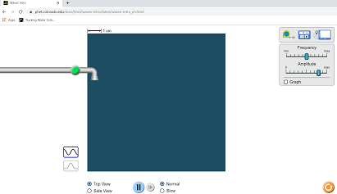
DATA:

Click on the green button and turn on the liquid water dropping into a container filled with liquid water (top view).
1. What does the dropping liquid create?

2. Describe what you see as the liquid continues to drop?

3. Increase and decrease the amplitude setting. What happens to the actual drops of liquid AND the waves created as you increase and decrease the amplitude? (2 questions here)

4. What is amplitude, according to your Hewitt textbook?

5. Increase and decrease the frequency setting. What happens to the actual drops of liquid AND the waves as you increase and decrease frequency?

6. What is frequency, according to Hewitt?

Attach the wave meter. Drag either one (of the two) probes into the wave matrix as shown.
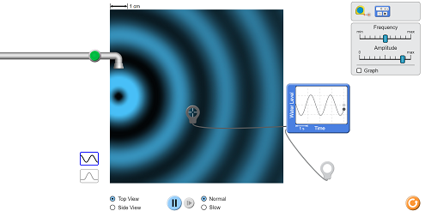
7. Using and viewing the wave meter, increase and decrease amplitude. What happens to the waves on the meter? Sketch two examples below and label them.

8. Using and viewing the wave meter increase and decrease frequency, what happens to the waves on the meter? Sketch two examples below and label them.

ANALYSIS:
9. The size of the water droplets represents the amount of energy applied to create a wave. What kind of relationship (direct, inverse) is there between the energy applied and the height of a wave?

10. Think about comparing the wavelength to the frequency. Go back and change these variables if you need to. What kind of relationship is there between wavelength and frequency?

11. What would be the mathematical relationship between wavelength and frequency? Use the abbreviations f for frequency and for wavelength.

12. According to Hewitt, in what units is frequency normally measured?

13. According to Hewitt, what is the common unit for measuring wavelength?

Optional extension: The band of frequencies originally allocated to the “CB” service was around 27 MHz. It is also called the “11-meter band”. Why might it be called this?

