PHET Introduction to Waves, Part I: Water
Answer Key and Scoring Notes
Go to the Phet website at https://phet.colorado.edu/en/simulation/waves-intro and choose the Water simulation.
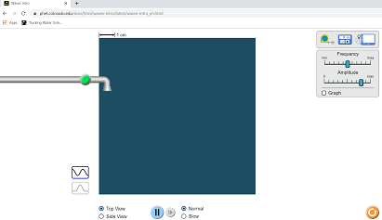
DATA:

Click on the green button and turn on the liquid water dropping into a container filled with liquid water (top view).
1. What does the dropping liquid create? Answers vary, something about creating waves, circles, or (best yet) disturbances in motion.

2. Describe what you see as the liquid continues to drop? Answers vary, something to the effect that these waves are moving outward.

3. Increase and decrease the amplitude setting. What happens to the actual drops of liquid AND the waves created as you increase and decrease the amplitude? (2 questions here)
The drops of water get larger,
The waves created get farther apart (try not to accept “bigger”.

4. What is amplitude, according to your Hewitt textbook? The maximum displacement on either side of the equilibrium (center) point.
5. Increase and decrease the frequency setting. What happens to the actual drops of liquid AND the waves as you increase and decrease frequency? 1) the size of the drops does not change (but the observant student will realize that they are falling faster with increased frequency).
2) The waves become compressed together, or there more of them in a given unit of time. Do not accept that they move “faster”, instead point out that the speed in this simulation is constant.

6. What is frequency, according to Hewitt? The number of vibrations or waves in a given unit of time.

Attach the wave meter. Drag either one (of the two) probes into the wave matrix as shown.
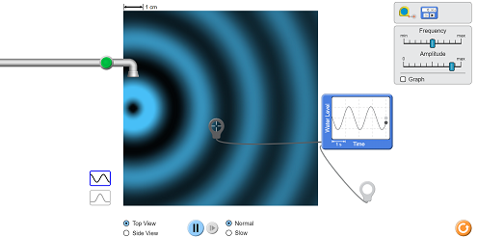

7. Using and viewing the wave meter, increase and decrease amplitude. What happens to the waves on the meter? Sketch two examples below and label them.
Answers vary, showing differences in vertical height only. Wavelength should remain constant.

Answers vary, showing that the wavelengths are now of different sizes . Amplitude should remain constant.

8. Using and viewing the wave meter increase and decrease frequency, what happens to the waves on the meter? Sketch two examples below and label them.

ANALYSIS:
9. The size of the water droplets represents the amount of energy applied to create a wave. What kind of relationship (direct, inverse) is there between the energy applied and the height of a wave?
Direct.
10. Think about comparing the wavelength to the frequency. Go back and change these variables if you need to. What kind of relationship is there between wavelength and frequency?
Inverse.
11. What would be the mathematical relationship between wavelength and frequency? Use the abbreviations f for frequency and for wavelength.
- = 1/ f

12. According to Hewitt, in what units is frequency normally measured?
There will some variability depending on the magnitude the student is looking at: Hertz, Hz, MHz, KHz, etc.
13. According to Hewitt, what is the common unit for measuring wavelength?
Meters, but they might also use variations of meters such as cm, nm, etc.
Optional extension: The band of frequencies originally allocated to the “CB” service was around 27 MHz. It is also called the “11-meter band”. Why might it be called this?
The equation that relates wavelength to frequency is generally = 1/ f but when we are talking about ratio waves the “1” is replaced with the speed of light, “C”. When this is done the wavelength for a 29 MHz signal is approximately 11 meters from crest to crest (or trough to trough).

