PHET Introduction to Waves, Part II: Sound
ANSWER KEY and TEACHING NOTES
Go to the Phet website at https://phet.colorado.edu/en/simulation/waves-intro and choose the Sound simulation.
SETUP
Also attach your wave meter and drag one probe into the wave-viewing area.
Click on Both Particles and Waves so you can watch how both vary.
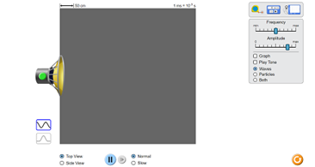 | 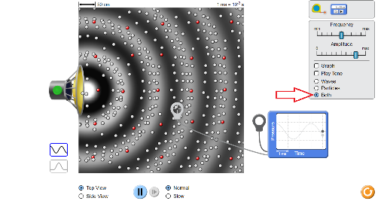

ANALYSIS
- Explore the sound simulation as you change the amplitude and frequency. Look for patterns and relationships. No answer needed

- Do the particles move in the same direction as the wave or perpendicular to the motion of the wave?
What do we call this kind of a wave? (transverse or longitudinal?) Same direction, longitudinal. Be careful that they might confuse this with a water wave which is a special case, not a pure longitudinal wave. Basically the water particles move in 2-dimensional circles while sound waves merely oscillate back-and-forth.

- Freeze and observe: are the particles closer together or farther apart in the white area of the wave-viewing area? Farther apart

- What is the name for this portion of a wave? Rarefaction (where the particles are more rare)

- Are the particles closer together or farther apart in the dark area of the wave-viewing area? Closer

- What is the name for this portion of a wave? Compression

- Follow one red dot as the waves cross it. After a number of waves have crossed it what happens to its net displacement? There is no net displacement, they keep coming back.

- Do the particles ever move permanently across the field of view? If the particles are not moving, what is moving? No, energy

- The graph is a graph of kinetic energy. How would you describe the difference between the energy at a peak and the energy at a trough? The amount of energy is the same but the direction is opposite.

- The graph is a graph of kinetic energy. How much energy is there as the graph hits the center point? Zero

- Pause your display and then drag the second probe from your wave meter into the wave-viewing area, and have these two probes at different parts of the same compression but of different waves. Let it play again and describe your results. Are the wave motions in phase? Answers vary, but the goal is to have to two waves on the graph exactly overlap; this is the point where they are in phase.

- While the application runs drag one probe until the two waves are precisely out of phase. Hit pause and describe the parts of the waves that each probe is in. Answers vary somewhat but the net effect is that the troughs (rarefactions) of one wave precisely overlap with the peaks (compressions) of the other wave.

- Turn on the sound and change the amplitude. What do we use in everyday language to describe the amplitude of a sound? Loudness, volume

- Change the frequency while watching the waveforms. Does changing the frequency change the amplitude? What kinds of sounds do we associate with higher frequencies? Lower frequencies?
Does not change the amplitude; other answers will vary.

- Alternate between the top view and the side view while some sound waves are running. In one word, describe the shape of a sound wave if there are no obstructions. Sphere !

EXTENSION: Set your application to run with the two probes in place. Again, set them so that the two wave peaks are exactly out of phase with each other. Assume the energy of the wave is zero when the wave hits the center (zero) line, how much net energy is on the graph when the peak of one wave is perfectly aligned with the trough of the other wave?

Zero

How much energy is there when the two waves are precisely overlapping?
Twice as much.
The purpose of this extension is to prepare them for the upcoming concepts of constructive and destructive interference.

