PHET Introduction to Waves, Part II: Sound
Name _____________________________________
Go to the Phet website at https://phet.colorado.edu/en/simulation/waves-intro and choose the Sound simulation.
SETUP
Also attach your wave meter and drag one probe into the wave-viewing area.
Click on Both Particles and Waves so you can watch how both vary.
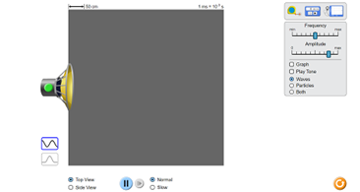 | 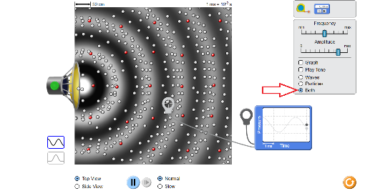

ANALYSIS
- Explore the sound simulation as you change the amplitude and frequency. Look for patterns and relationships.

- Do the particles move in the same direction as the wave or perpendicular to the motion of the wave?
What do we call this kind of a wave? (transverse or longitudinal?)

- Freeze and observe: are the particles closer together or farther apart in the white area of the wave-viewing area?

- What is the name for this portion of a wave?

- Are the particles closer together or farther apart in the dark area of the wave-viewing area?

- What is the name for this portion of a wave?

- Follow one red dot as the waves cross it. After a number of waves have crossed it what happens to its net displacement?

- Do the particles ever move permanently across the field of view? If the particles are not moving, what is moving?

- The graph is a graph of kinetic energy. How would you describe the difference between the energy at a peak and the energy at a trough?

- The graph is a graph of kinetic energy. How much energy is there as the graph hits the center point?

- Pause your display and then drag the second probe from your wave meter into the wave-viewing area, and have these two probes at different parts of the same compression but of different waves. Let it play again and describe your results. Are the wave motions in phase?

- While the application runs drag one probe until the two waves are precisely out of phase. Hit pause and describe the parts of the waves that each probe is in.

- Turn on the sound and change the amplitude. What do we use in everyday language to describe the amplitude of a sound?

- Change the frequency while watching the waveforms. Does changing the frequency change the amplitude? What kinds of sounds do we associate with higher frequencies? Lower frequencies?

- Alternate between the top view and the side view while some sound waves are running. In one word, describe the shape of a sound wave if there are no obstructions.

EXTENSION: Set your application to run with the two probes in place. Again, set them so that the two wave peaks are exactly out of phase with each other. Assume the energy of the wave is zero when the wave hits the center (zero) line, how much net energy is on the graph when the peak of one wave is perfectly aligned with the trough of the other wave?

How much energy is there when the two waves are precisely overlapping?

