PHET Introduction to Waves, Part III: Light
Name ___________________________________________________
Go to the Phet website at https://phet.colorado.edu/en/simulation/waves-intro and choose the Light simulation. Set it up with the Screen turned on.
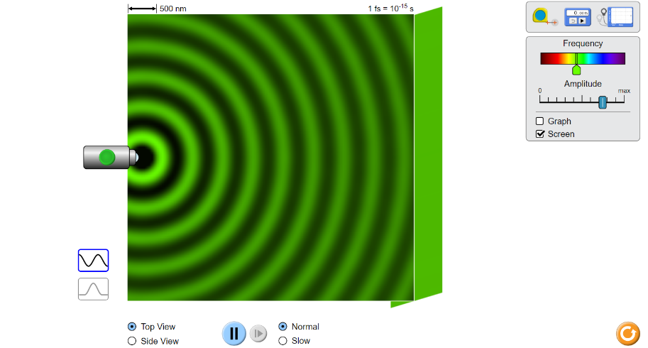

Experiments:
- Select frequency to a color of your choice and turn up the amplitude fairly high. It will take a while for the bright waves to hit the screen. When this happens is the screen bright or dark?

- Turn the amplitude down to almost zero wait for the waves to hit the screen. Why does the screen darken?

- Turn the amplitude totally down for a few seconds and then back up. What do you get when the amplitude is zero, and why?

- Let’s look at wavelength and frequency. Set the frequency to green, run it until the screen is filled, the freeze it. Use the tape measure to measure the wavelength. What is it, and in what units is it measured?

- Does it matter if you measure from one crest to another crest, or from one trough to another trough?

- Move the frequency to the deepest red you can get and measure the wavelength.

- The wavelength of the deepest red that humans can see is about 700 nm. Is this close to what you got? What would you call an emission that has an invisible wavelength just beyond red?

- To get a more precise answer, measure the distance across 5 wavelengths and divide that by five. Is your answer more precise? Use this method from now on.

- Now move the frequency to the farthest violet you can get. What is the wavelength?

- A typical figure for visible violet is around 280 nanometers. What would you call the emission that we cannot see that is beyond the violet that we can see?

- Flip back and forth between top view and side view. What is the shape of a light emission?

- The abbreviation for the basic colors of the spectrum is ROYGBIV. Does this go in order of increasing wavelength or increasing frequency?

- Extension I: What is the relationship between IR rays and heat?

EXTENSION: UV rays are more dangerous than IR rays because they have greater energy. What causes UV to have more energy?

