PHET Introduction to Waves, Part III: Light
ANSWER KEY and TEACHING NOTES
Go to the Phet website at https://phet.colorado.edu/en/simulation/waves-intro and choose the Light simulation. Set it up with the Screen turned on.
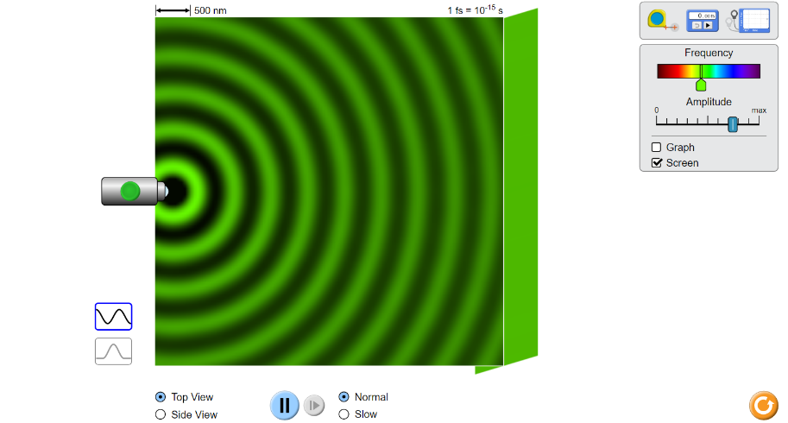

Experiments:
- Select frequency to a color of your choice and turn up the amplitude fairly high. It will take a while for the bright waves to hit the screen. When this happens is the screen bright or dark?
Relatively bright

- Turn the amplitude down to almost zero wait for the waves to hit the screen. Why does the screen darken? There is less light energy

- Turn the amplitude totally down for a few seconds and then back up. What do you get when the amplitude is zero, and why? There is no light energy

- Let’s look at wavelength and frequency. Set the frequency to green, run it until the screen is filled, the freeze it. Use the tape measure to measure the wavelength. What is it, and in what units is it measured? Answers vary with what shade of green they chose, generally around 530 nm +/- 5%

- Does it matter if you measure from one crest to another crest, or from one trough to another trough? No, either one defines a wavelength. They simply measure the same energies but in a different form.

- Move the frequency to the deepest red you can get and measure the wavelength. Answers will vary with their shade of red but will be in the range of 700 nm. Be sure they put the units, nm or nanometers. You can define nanometers here if you wish.

- The wavelength of the deepest red that humans can see is about 700 nm. Is this close to what you got? What would you call an emission that has an invisible wavelength just beyond red? Hopefully yes, and it would be IR or infrared.

- To get a more precise answer, measure the distance across 5 wavelengths and divide that by five. Is your answer more precise? Use this method from now on. Hopefully that would be more precise. It is up to the teacher to know if the class would benefit at this point with a discussion on accuracy vs precision or not, but this would be a great point to do so if they are ready.

- Now move the frequency to the farthest violet you can get. What is the wavelength? Around 280-300 nm

- A typical figure for visible violet is around 280 nanometers. What would you call the emission that we cannot see that is beyond the violet that we can see? UV, or ultraviolet

- Flip back and forth between top view and side view. What is the shape of a light emission? Sphere

- The abbreviation for the basic colors of the spectrum is ROYGBIV. Does this go in order of increasing wavelength or increasing frequency? The reds have the longer wavelengths and the shorter frequencies, so it goes in order of increasing frequency. Some electromagnetic radiation charts have the colors reversed and are showing the violets at the left –these have the emissions ranked by increasing wavelength. Have an example from the internet to show them.

Extension I: What is the relationship between IR rays and heat? One of the three ways of transfer of heat energy is by radiation of IR rays. So in a sense, heat that is not transferred by conduction is transferred by IR radiation.

EXTENSION 2: UV rays are more dangerous than IR rays because they have greater energy. What causes UV to have more energy? Primarily because UV light is given off when high-energy, outer electrons fall back into lower energy levels. There is also some difference in how these waves can interact with biomolecules in that they hit the molecules more often, sort of like a jackhammer. Both are advanced concepts.

