PhET Build an Atom
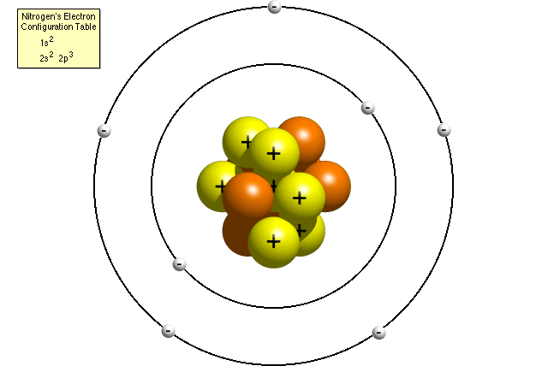
For this simulation, you will be using the PhET: Build an Atom

Introduction
- In the space below, list as many properties of atoms that you and your partner can.

- Draw a model of an atom, including all subatomic particles. (Your model can be any atom that you and your partner want to draw)

Build an Atom
For this section open up the build an atom simulation and click on the atom activity.

- Place 2 protons in the nucleus of your atom.

- Place 2 electrons in the orbitals of your atom

- Place 2 neutrons in the nucleus of the atom.

- What is the identity of the atom that you and your partner have built?

- What is the charge of this atom? Is this the charge for all atoms of all elements? What is the mass?

- What particles can you change without changing the identity of the atom? Manipulate the simulation to see how many different versions of this one particular element you can make.

- Build any element that you and your partner want for this final section of this activity, and fill in the information below:
- Number of protons _____
- Number of electrons _____
- Number of neutrons _____
- Atomic Mass ______
- Atomic Number _______
- Charge _______

Ions
- Place 8 protons in the nucleus of the atom. What is the identity of this atom?

- Place 8 neutrons in the nucleus of this atom? What is the identity of this atom? Did the identity change? Explain.

- Place 8 electrons around the nucleus of the atom. What is the identity of the atom? Did the identity change? Explain.

- Add 2 more electrons to your atom. What is the overall charge? What happens to atoms when they gain electrons? Is this change typical for all atoms when they gain electrons?

- Build one more atom of your choice and determine if adding electrons has the same effect on the overall charge.
New Ion
- Place 3 protons in the nucleus of the atom. What is the identity of the atom you’ve built?

- Place 4 neutrons in the nucleus of the atom. What is the mass number of this atom? Did your identity change?

- Place 3 electrons in the orbitals of the atom. What is the charge? Did the addition of the electrons change the identity?

- Remove one electron from the farthest orbital of the atom. What is the charge of this ion? Did the identity of the atom change?

Atomic Structure Properties
- Build any atom you and your partner want with 1-10 protons. What atom did you build?

- Fill in all electrons. Is there an order to electron filling? What is the order? Develop an explanation for the filling order that you observe.

- Fill in your atom with neutrons. Is there a limit to the number of neutrons you place in your nucleus? Click the stable/unstable box to see if you have created an isotope that is radioactive.

- Based on your model, what does it mean when we discover that an isotope is radioactive? Can you make a radioactive isotope (unstable) stable?

- What do radioactive isotopes need to do if they are to become stable?

