Open the program at https://phet.colorado.edu/sims/html/wave-on-a-string/latest/wave-on-a-string_en.html
Play with it awhile to get a feel for it. Pay special attention to making a wave manually with a wrench, with using the slow-motion button (you have to re-set it each time), and the orange re-set button.
See how to use the blue pause/pay button. Learn what differences to the damping and tension buttons make.
- Set it to manual, fixed end, high tension, low or no damping, slow-motion. These will be your settings for most of this lab. Reset the setting after each use. Do you understand this?

- Produce one quick wave by yanking the wrench down and back up. Which way does the waveform point (up or down)?

- What happens to that direction when the wave hits the clamp on the right and bounces back to you (up or down)?

- How does this show the principle of incident and reflected waves?

- Do it again, but this time make a positive wave by quickly yanking the wrench up and back down. Are the incident and reflected waves still opposites?

- Make a complete statement about what is happening, using the terms “reflected”, “incident” and “inverted”.

- Now it gets challenging. You want to make a destructive interference wave. Make a quick, large “up” wave as before, and when the wave gets to about the 3rd green ball marker make another large up wave.

- What happens when an inverted (negative) wave crosses an up (positive) wave? HINT: You might have to do this several times to get it to work. It helps visualize it by using the pause button. Did you ever get the waveforms to completely destroy each other?

- When the waves pass through each other they immediately regain their original form. Now, do you need to re-write your answer to #8?

- Finally, try to make a constructive interference. This is a little easier. You will make an “up” wave as before, and then about the time of the 3rd green ball, make a “down” wave. What will be the direction of the “down” wave after it reflects?

- What happens to the amplitude when two waves pass each other?

- Sometimes in the ocean a “rogue wave” will seemingly come out of nowhere, tower over small ships and quickly disappear. They can be quite dangerous. From what you have done, explain in a sentence or two what might cause rogue waves.

Extension 1: Not part of the assignment, but feel free to play with it on other settings. Here’s a good one – set it on oscillate, high tension, no damping, slow motion and set the frequency to 3 Hz. Will it make destructive interference? Constructive interference? Will the destructive ever reset all balls to zero at the same time? Hint – let it run through at least 33 cycles. There is a marker on the camshaft that you can use to count them.

Extension 2: Below is a Moire pattern. These patterns result from constructive and destructive interference between two different sources. Use your favorite mapping application, set it to satellite images, and navigate around a beach of your choice. Zoom in close enough to see the waves. Can you find interference patterns? You might have to look around some points, hooks or even small islands.

Extension 3: Moire patterns using two combs. https://www.exploratorium.edu/snacks/moire-patterns

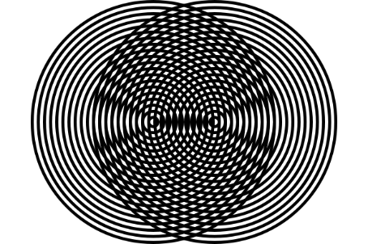

Extension 4: Read about “Gravity Waves” which have several meanings. One is a kind of cloud produced from an atmospheric disturbance. They can propagate for hundreds of miles. Be sure to search for “Gravity Wave Images” so you can start watching for them in the sky. The second kind of gravity waves has to do with large interacting galactic bodies and are very strange and complex.

