Name:_________________________________________ Period:______ Date:_____________
Level 6 Math Objectives:
- I understand and can describe the equals sign as a balance that states each side of the equation is equal to the other.
- I can use opposite operations (additive inverse) to make zero pairs.
- I can use opposite operations to isolate the variable (get it by itself).

1. Go to https://phet.colorado.edu/sims/html/equality-explorer/latest/equality-explorer_en.html?screens=1,2,3 and select basics. Explore the sim by trying all the different buttons and actions.

What do you notice? We will share out to the class in a few minutes.
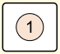
2. Click on the next to the apple. Drag objects onto the scales in order to fill in the blanks below.

__________>_________ _________$<$___________ _______$=$________
3. Click on the apple. Drag objects onto the scales to create at least one equality statement (like 6 lemons = 15 oranges) .

$____=____$
4. Then fill in the correct inequality sign for each of the statements on the right.
1 apple ____________ 1 orange
1 apple ____________ 1 lemon Which fruit is the heaviest?
1 orange __________ 1 lemon
5. Using the coin module or the turtle module create an equality statement.

$$____=____$$
6. Choose one of your equality statements. Discuss with your partner what it means in words. Write down your explanation here of your equality statement.

7. Fill in the blanks to make the statement true.
An equals sign means that the value of the left side of the equation is _______________ the right side.

CHECKPOINT. Call over the teacher to share your work and explanations. __________
Teacher Initials
8. Move on to the next screen in the bottom of your browser called “Numbers” 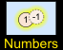 and play with it for about 2 minutes. Make sure you find a new feature that did not exist in the last module!
9. Create the following inequality: 3 < 5. Then put negative ones on the scale to change the inequality into an equation (with an equals sign!!).

- What did you add to the left side of the relationship?
- What did you add to the right side of the relationship?
- How did your steps help balance the relationship?

10. Create the equation $4=6+(-2)$. Why do the two negatives make the balance equal?

- Lock the equation $4=6+(-2)$. What can you take away from each side to get 6=6?

11. Create an equation (balanced scales) with different numbers of negative ones on each side of the scale. Then create another one. Write them below.

12. Move on to the next screen in the bottom of your browser called “Variables” 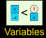 and play with it for about 2 minutes. What new tools does this screen have?

11. Consider $x+2=5$ . What do you think the value of $x$ must be? _____
- Build $x+2=5$. If your scale isn’t balanced yet, how can you balance it?

- Lock the equation . In order to have the scale show that x = 3, what would you do?

- Are there other values of $x$ that make $x+2=5$ true? How do you know?

12. Now read and talk through the steps below from Lin’s work. Next to each step, write her equation (the first step is provided for you). In addition, write the action Lin took to get from one step to the next.
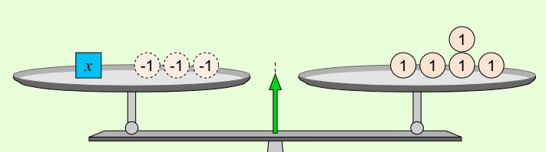 $x-3=5$

Lin ______________________________
_________________________________.
(write what Lin did to get from one step to the next)

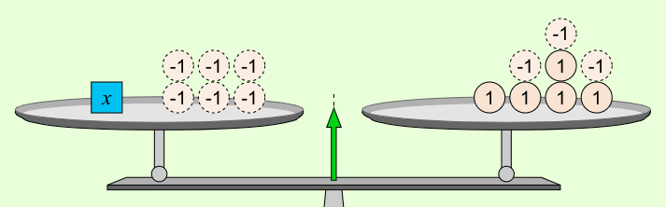 $______=______$

Lin ______________________________
_________________________________.
(write what Lin did to get from one step to the next)

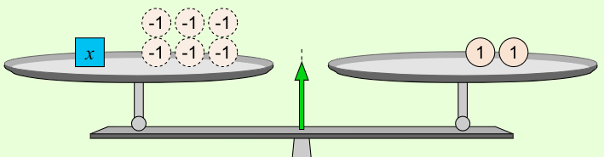 $______=______$

Lin thought that her steps would get her to an answer that showed $x=____.$ Discuss with your partner, what would you do differently? How would you explain the “why” of your idea to Lin?

Once you’ve discussed your idea, set up the problem in the sim and solve it. Make sure you start with a balanced scale (equation) by adjusting the value of $x$as necessary.

13. Read over the objectives at the top of the front side of this paper with your partner. Share out with each other what you think each one means. Find an example of each objective in the work you did on the activity sheet.

