Fraction TOPS and BOTTOMS

LEARNING TARGETS:

I can...
- use a variety of fraction models (such as circles, bars, and number lines) to develop an understanding of numerators and denominators and fraction equivalence
- define numerator and denominator in own my own words
- apply my understanding of numerator and denominator to compare fractions

1. Do Now - Would you rather have $\frac{3}{5}$ OR $\frac{9}{15}$of pizza? (Circle your answer). 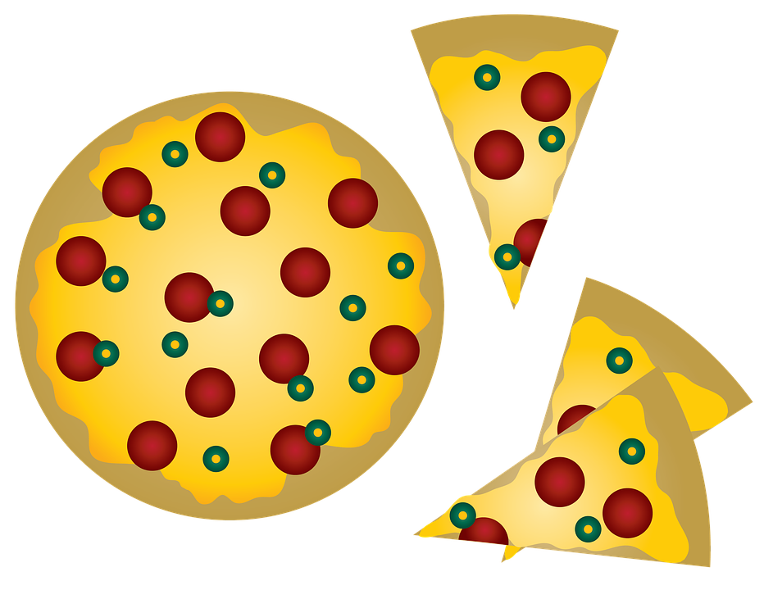

2. Play Time - Open the Fractions: Equality simulation https://phet.colorado.edu/sims/html/fractions-equality/latest/fractions-equality_en.html

What did you notice?

Create $\frac{1}{4}$ on the left. How many different equivalent fractions can you create? Explore all the models (circles, bars, number lines, etc.) and write three of your answers below.

1.

2.

3.

Share your equality statement with your table partner. Did you come up with the same answers? How many different answers could there be? Why do you think that is?

Create your own fraction where the numerator is greater than the denominator. Find two equivalent fractions.

1.

2.

What models do you like best? Which pictures make the most sense to you? Why do you think that is? (Make sure to try all the models: circles, horizontal bars, vertical bars, number lines)

3. Use the simulation to answer the DO NOW question.

4. Questions to consider:
- Is it possible to get the top number of the fractions (numerator) to be the same? Y N

- What about getting the bottom numbers (denominator) to be the same? Y N

- Is $\frac{2}{5}$ = $\frac{2}{10}$? Y N

- How do you know? Use the model to explain your answer.
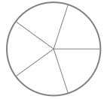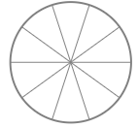

- Besides saying it’s the top number of a fraction, how would you describe a numerator? Use words and a model to explain your answer.
- When you change the numerator, what changes in the model?

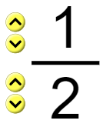

- Besides saying it’s the bottom number of a fraction, how would you describe a denominator? Use words and a model to explain your answer.
- When you change the denominator, what changes in the model?

5. Practice:
- Is $\frac{1}{3}$ = $\frac{2}{6}$?
Draw your own models (circles, horizontal bars, vertical bars, or number lines) to represent your thinking in two different ways.

- Is $\frac{3}{4}$ = $\frac{9}{10}$? Explain your thinking.

- Is $\frac{3}{4}$ = $\frac{9}{12}$? Explain your thinking.

- Is $\frac{1}{4}$ = $\frac{3}{4}$ ? Explain your thinking.

- Is $\frac{1}{8}$ = $\frac{8}{16}$? Explain your thinking.

- Is $\frac{6}{4}$ = $\frac{8}{12}$? Explain your thinking. Find a fraction that is equivalent to $\frac{6}{4}$

6. Assessment
https://phet.colorado.edu/sims/html/fractions-equality/latest/fractions-equality_en.html?screens=2

Complete each level and record your score below:

Level | Score | Level | Score
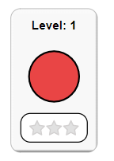 |  | 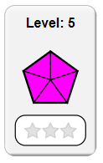
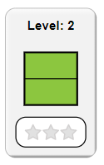
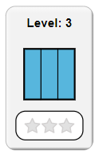 |  | 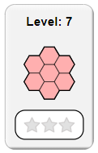
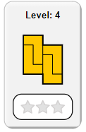 |  | 