Graphing Quadratics - Vertex Form - Day 1 Name: _________________________
Learning Goals:
Identify the location of the vertex, V(h, k) from the equation. | Identify the vertex, V(h,k) from a graph. | Describe the effect a has on the function if a = 1, a > 1, a < 0 (negative) , or a = 0.

Quadratic Parent Function: Vertex form of a Quadratic:

Phet Link: https://phet.colorado.edu/en/simulation/graphing-quadratics

- Open Play: Once you have opened the Graphing Quadratics Phet simulator, go to the 3rd screen vertex form. Take some time to play around with it.

- What information does a quadratic expression in the vertex form reveal? How does it show that information?

- What doesn’t it tell us?

- Why do you think this form is used?

Compare your results from questions 2-4 with your partner

- Using PhET again, complete the following table to describe what the a, h and k values do to the parent function.
a, h & k | Describe the effect (transformation) if any. | Example Equation | Vertex V(h, k)
a = 1

a > 1 (positive)
a = 0

a < 0 (negative)
a, h & k | Describe the effect (transformation) if any. | Example Equation | Vertex V(h, k)
h > 0 (positive)
h < 0 (negative)
h = 0
k > 0 (positive)
k < 0 (negative)
k = 0

PREDICT: Without graphing, predict the coordinates of the vertex of the graphs of these quadratic functions, and predict whether the graph is a U shape (“opens up”) or an upside-down U (“opens down”).

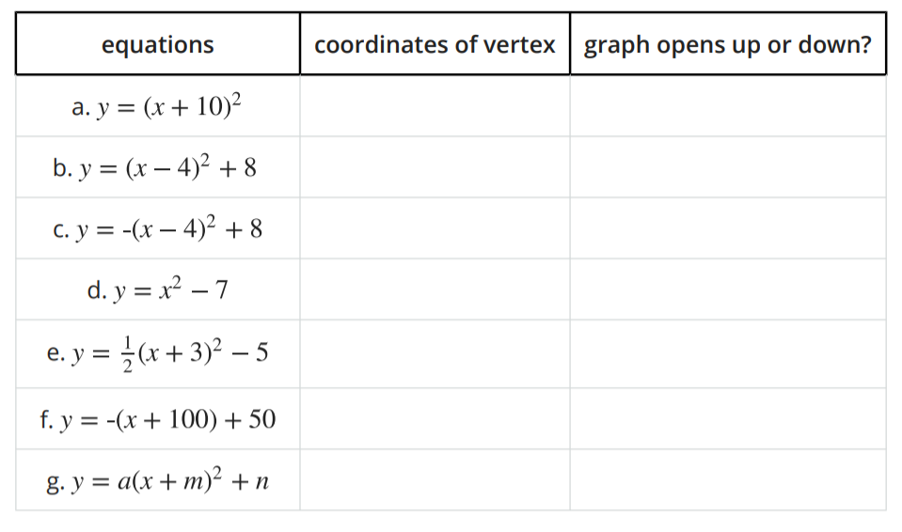

SUMMARIZE:
- When a quadratic equation is in vertex form of y = (x-h)² + k, the coordinates of the vertex are __________.
- When the equation is graphed, the graph opens upward if . . .
- The graph opens downward if . . .

