1. If line A is parallel to line B and perpendicular to line C, what must be true about lines B and C?

2. If line A is parallel to line B and parallel to line C, what must be true about lines B and C?

3. a. At how many points do parallel lines intersect?

b. At how many points do perpendicular lines intersect?

c. At how many points do two lines intersect if they are neither parallel nor perpendicular?

4. Below, graph a line that is perpendicular to $y=2x+3$ and goes through the point (2,1).

5. a. Are the lines below parallel, perpendicular, or neither?
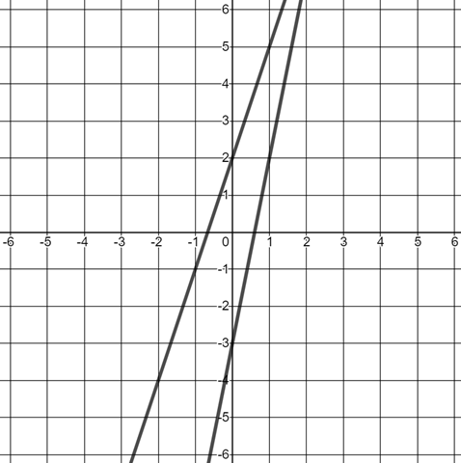

b. How many places do these two lines intersect?

