Describing Functions – Exit Ticket Name:________________________

- Fill in the function rule to match the verbal description.  “The function adds 3 to the inputs and then multiplies by 4.” | - Describe how the function changes the inputs.  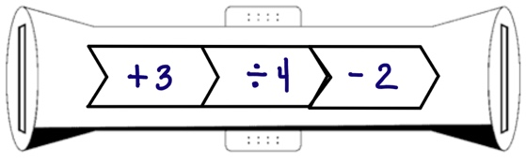
- Write an equation to model the function rule.  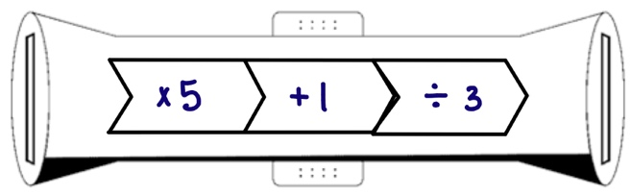 | - Fill in the function rule to match the equation.  $$y=3( \frac{ x }{4} -1)$$

