Name:___________________________________ Date:_______________ Period:______

Describing Functions
Learning Goals
- Describe a function rule using words.
- Compare the verbal description of a function to its algebraic form.
- Write function rules in algebraic form.

- EXPLORE – Open the Function Builder simulation and explore. What do you notice?
2. BUILD – Go to the Numbers screen and build 3 multistep functions. Describe your function.
*Use a variety of operations*
Function | Describe how the function rule changes the INPUTS.
3. SHARE – Compare your functions with a partner. Record one of your partner’s functions below and describe how the function rule changes the INPUTS.
*Choose a function that is different from the ones that you created*
Function | Describe how the function rule changes the INPUTS.
*Challenge – Can you build a function that always has the same output?

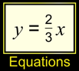
4. BUILD – Go to the Equations screen. Build functions using three different operations.
*DO NOT click simplify for the equation*
Function | Equation | Explain how the equation relates to each operation in the function.

- DISCUSS – With your partner, discuss how you think the function below changes the INPUTS. Fill in the function rule with the correct operations.
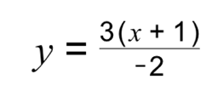

- CHALLENGE – On the Equations screen, create a three-step function using a variety of operations. Click the hide button. Can your partner guess your function rule?

- WRITE – Go back to the functions that you built in #2. Write an equation to model those functions.

