Title: Health and Exercise
Introduction
In this activity, you will investigate how health and exercise affects the human body by testing different variables and comparing health over a time period of one year.

Standard
5.3a Humans need a variety of healthy foods, exercise, and rest in order to grow and maintain good health.

Learning Objectives
- Compare the relationship between gender and health for two people of the same physical build and opposite genders.

- Discover the relationship between exercise and health by comparing two people of the same gender and physical build and different amounts of exercise.

________________________________________________________

- Click the link: https://phet.colorado.edu/en/simulation/legacy/eating-and-exercise

- Click the play button to launch the simulation. When you click the play button this screen will appear.
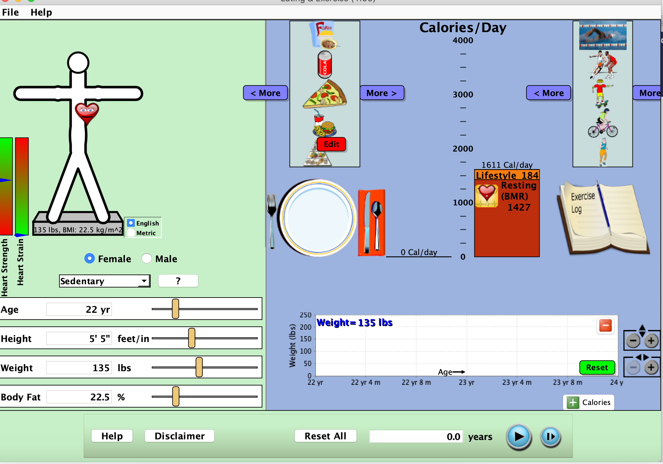

Exploration Phase:

- Select an age, height, weight, and body fat.

- Explore different diets that your person can consume in a day. Press play at the bottom of the screen to watch what happens to the person’s weight and calorie intake over a period of time.

- Add different exercises and explore what happens.

Questions:

- What are some factors that affect a person’s weight?
- What do you think is more important to a person’s overall health – exercise or diet? Why?

Explanation Phase:

Aim #1: Compare the relationship between gender and health for two people of the same physical build and opposite genders.

Activity 1 – Gender vs. Health

- Click the “Reset” button to revert your simulation back to its original settings.

- Set the gender to “Female”.

- Select an age, height, weight, and body fat. Keep all other variables the same. Write it down in the chart below. (MUST select an age between 25 and 35, a height between 5’0 and 6’0, a weight between 150 and 200 pounds, and a body fat percentage between 12% and 20%).

Age
Height
Weight
Body Fat

- Add food for breakfast, lunch, dinner, and 2 snacks (i.e 3 meals and 2 snacks -- you can choose more than one of each item if the person ate more than one). Write the foods that you chose down below.

Food Selection

- Click the play button at the bottom of the simulation to begin. Run the simulation for 1 year.

- Take a screenshot of your findings and paste below.

- Repeat simulation. Keep all variables the same (age, height, weight, body fat, food selection).

- Change the gender to “Male”.

- When you have all of your variables set, play the simulation. Run the simulation for 1 year.

- Take a screenshot of your findings and paste below.

Questions:

- Explain your findings. Did you see a difference in the female’s weight after one year vs the male’s weight after one year?

- What does this tell you about how male and female bodies respond to the same food selection?

Aim #2: Discover the relationship between exercise and health by comparing two people of the same gender and physical build and different amounts of exercise.

Activity 2 – Exercise vs. Health

- Reset your screen.

- Select a gender, age, height, weight, and body fat. Input into the chart below. (MUST select an age between 25 and 35, a height between 5’0 and 6’0, a weight between 150 and 200 pounds, and a body fat percentage between 12% and 20%).

Gender
Age
Height
Weight
Body Fat

- Add food for breakfast, lunch, dinner, and 2 snacks (i.e 3 meals and 2 snacks -- you can choose more than one of each item if the person ate more than one). Write the foods that you chose down below.

Food Selection

- Go to the exercise selections on the upper right hand side of the simulation. Select “15 minutes running moderate” and add this action twice to your person’s lifestyle. (i.e. 30 minutes of moderate running a day).

- Click the play button at the bottom of the simulation to begin. Run the simulation for 1 year.
- Take a screenshot of your findings and paste below.
- Repeat simulation with the same gender, age, height, weight, body fat and food selection. Remove the moderate running from the person’s lifestyle (i.e. 0 minutes of exercise a day).

- Click the play button at the bottom of the simulation to begin. Run the simulation for 1 year.

- Take a screenshot of your findings and paste below.

Questions:

- How did the two different people change from the start of the simulation to the end (1 year’s time)? Did their end results look the same?

- What does this comparison show you about the relationship between health and exercise?

- Do you think that the type of exercise a person does matters to their overall health?

Application Phase:

Aim: Your friend knows that you are now an expert on health. They have come to you because they want to lose 20 pounds over the course of the next year. You are now in charge of their food consumption, as well as daily exercise to help them achieve this goal. Their gender, age, weight, height, and body fat are listed below.

Gender | Male
Age | 25
Weight | 220
Height | 6’0
Body Fat | 20.0%

Below, list the food that you are suggesting for your friend, as well as any exercise.

Food
Exercise

Once you input food and exercise onto the simulation. Click “run”.
Record your friend’s weight at the various benchmarks below.

 | Age | Age + 3 months | Age + 6 months | Age + 9 months | Age + 12 months
Weight (lbs) | 220

If you are happy with your friend’s final results, copy and paste a screenshot below. If not, modify their food and exercise until you help them achieve their goal!

Questions:

- What did this simulation show you about the relationship between health and exercise?

- What about the relationship between health and diet?

- After completing the simulation, what do you think is more important in maintaining a healthy lifestyle – diet or exercise?

