Task Title/Description : Design simulation of spring oscillation experiment

1.2 Time Duration
1 hrs 30 Minutes

1.3 Format of Task -

Title : Spring oscillation experiment

- Practical Significance
- This experiment illustrates the value of collection and display of data in assisting thinking about the phenomenon of oscillation. Students can observe connections between features on the graph and the motion of the mass.
- Simulation Experiment learning Outcomes

- Determine the factors which affect the period of oscillation.
- Correlate the relationship between the velocity and acceleration vectors, and their relationship to motion, at various points in the oscillation.
- Examine conservation of Mechanical Energy using kinetic, elastic potential, gravitational potential, and thermal energy
- Analyse the damping effect on the natural frequency and amplitude.
- Calculate the spring constant of the springs using Hooke's Law.
- Determine the mass of an unknown object
- Theoretical Background

Hooke's Law: Elastic force occurs in the spring when the spring is being stretched/compressed or deformed (Δx) by the external force. Elastic force acts in the opposite direction of the external force. It tries to bring the deformed end of the spring to the original (equilibrium) position. (Fig. 1)
If the stretch is relatively small, the magnitude of the elastic force is directly proportionally to the stretch $∆x$ according to Hooke's Law:
$$F=-k∙∆x$$
where k is a constant, usually called spring constant, and $∆x$ is a stretch or change in a length of the spring. The minus sign in front of the spring constant indicates that the applied elastic force and restoring force produced by spring are in the opposite direction.

Simple Harmonic Motion:
If the hanging mass is displaced from the equilibrium position and released, then simple harmonic motion (SHM) will occur. SHM means that position changes with a sinusoidal dependence on time.
$$x=x_{m}\cos\left(ωt\right)$$
The following are the equations for velocity and acceleration.
$$v=-x_{m}ω\cos\left(ωt\right)$$
$$a=-x_{m}ω^{2}\cos\left(ωt\right)$$
$$∴a=-ω^{2}x$$
By substituting equations 2, 4 and 1 into Newton's Second Law, one can derive the equation for the angular resonant frequency of the oscillating system:
$$ω=\sqrt{\frac{k}{m}}$$

where k is the spring constant and m the mass of the system undergoing the simple harmonic motion. The unit of angular frequency is
$$radians per second =\frac{rad}{s}$$
The natural resonant frequency of the oscillator can be changed by changing either the spring constant or the oscillating mass. Using a stiffer spring would increase the frequency of the oscillating system. Adding mass to the system would decrease its resonant frequency.
Two other important characteristics of the oscillation system are period (T) and linear frequency (f). The period of the oscillations is the time it takes an object to complete one oscillation. Linear frequency is the number of the oscillations per one second. The period is inversely proportional to the linear frequency.
$$T=\frac{1}{f}$$
The unit of the period is a second (s) and the unit of the frequency is Hertz or $s^{-1}$ $Hz=\frac{1}{s}$
The angular frequency is related to the period and linear frequency according to the following expression.
$$ω=2πf=\frac{2π}{T}$$
$$T=2π(\frac{m}{k})^{0.5}$$
Energy:
In order for the oscillation to occur, the energy has to be transferred into the system. When an object gets displaced out of equilibrium, then elastic potential energy is being stored in the system. After the object is released, the potential energy transforms into kinetic energy and back. In the harmonic oscillator, there is a continuous swapping back and forth between potential and kinetic energy. For an oscillating spring, its potential energy $E_{p}$ at any instant of time equals the work (W) done in stretching the spring to a corresponding displacement x.
$$E_{p}=W=\frac{1}{2}kx^{2}$$
The kinetic energy $E_{k}$ of the oscillator for any instance of time will follow the well-known equation:
$$E_{k}=\frac{1}{2}mv^{2}$$
According to the law of conservation of energy: "The mechanical energy is conserved (neither destroyed nor created) in the frictionless oscillating system."

- Simulation Experimental Set-up

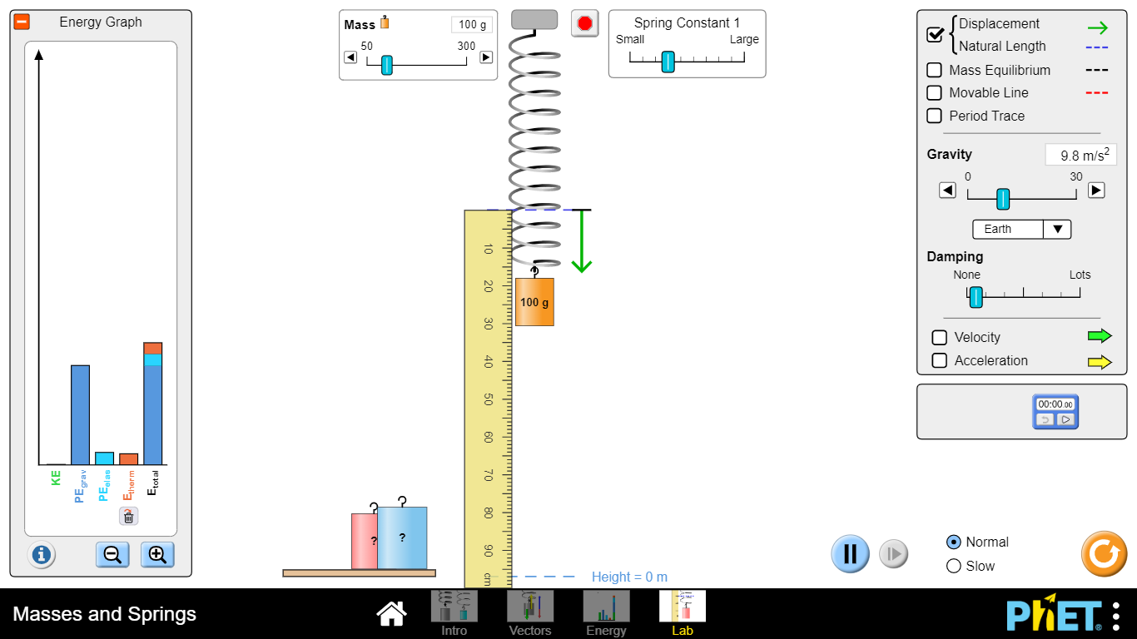

- Source
Spring, mass
- Procedure
- Launch PhET simulation.
- Open masses and spring simulation.
- Set the initial point at zero of scale.
- Set the Spring Constant.
- Set the Damping effect.
- Set the Mass.
- Find the displacement.
- Tick marks the box of the displacement, mass equilibrium, velocity and acceleration.
- Take the stop watch.
- Now oscillate the spring and measure time of five oscillations.
- Repeat the above step for different damping effect.
- Calculate the force constant.
- Repeat the above step for unknown mass.
- Observe and analyse the motion of the oscillator and energy graphs.

- Precautions
- Damping constant should be carefully chosen. (i.e. less than Spring constant)
- Set scale initially at zero value.

- Observations and Calculations

No. | Mass(m) kg | Force(F)= mg (N) | Displacement(d)  m | Spring constant(k) = F/d (N/m) | Time for 10 oscillation (t) s | Periodic Time (T =t/10) s
1 | 0.1 kg
2 | 0.15 kg
3 | 0.2 kg
4 | 0.25 kg
5 | 0.3 kg
6 | Unknown mass | - |  | -
 |  | Average:

- Unknown mass (m) = T²k/4 π² = kg
- Graph
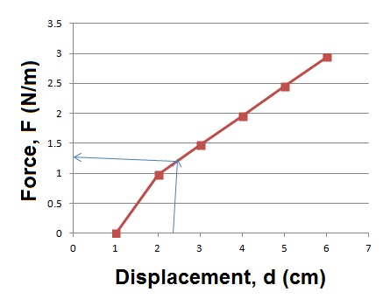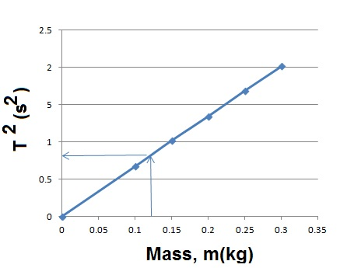

- Graph of Motion
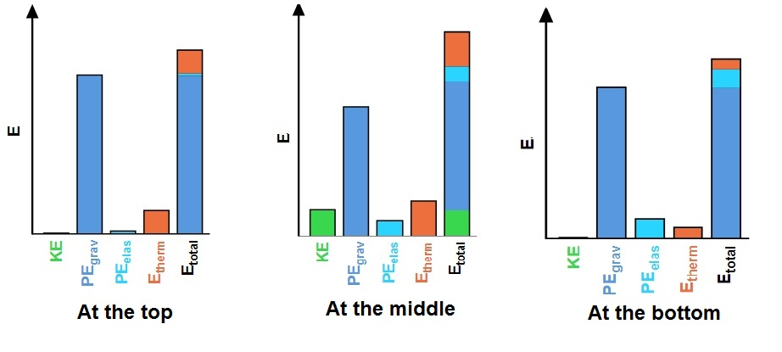
- Results
- Unknown mass, m = kg (From Calculation)
m = kg (From Graph)

- Interpretation of Results

- Conclusions ( comparison with real experiment)

- Simulation Related Questions

- What are the advantages/disadvantages of using this simulation?

- Was it easier/harder to use the sim over doing the hands-on investigation?

- How spring constant affect the result?

- How could you minimize error in your hands-on experiment? Sim experiment?

- Assessment Scheme
Process: 60
Sr. No. | Particulars | Marks | Obtained marks
1. | Follow the precautions | 10
2. | Follow the instructions | 10 | g
3. | Neatness in connections of circuit diagram | 10
4. | Attention during readings | 10
5. | Participation in group as member and leader | 10
6. | Safely use of instrument | 10
 | Total | 60

Product: 40

Sr. No. | Particulars | Marks | Obtained marks
1. | Timely submission of lab manual | 10
2. | Viva voice | 10
3. | Results and its interpretation | 10
4. | Submitted lab manual | 10
 | Total | 40
- Rubric to assess Process and product

Scales  Criterion | Unsatisfactory (0) | Satisfactory (1) | Good (2)
Determination of slope | Does not plotted graph | Graph plotted without labelling | Proper graph plotted
Find the Spring constant | Does not plotted graph | Taken slope of graph | Taken slope of graph and find Spring constant
Setup of experiment and taking observation | Setup of experiment is not proper | Setup of experiment is proper but does not take observation. | Setup of experiment is proper and takes observations.
Precautions | Does not take care | Takes care | Takes care dissembles the setup after experiment
Team work | Does not participate in experiment and also not interact in the group | Participate in experiments and interacted very less | Participate in experiment and interacted actively in group
Total (out of 10)

