Name_____________________________________________________________ Date____________ Per.____
Forces and Motion Basics: Simulations
https://phet.colorado.edu/sims/html/forces-and-motion-basics/latest/forces-and-motion-basics_en.html
The Website that we will be using has 4 different sections 1. Net force 2. Motion 3. Friction 4. Acceleration.
Take 5 minutes to explore the different areas of the site before completing the guided activity below.

Part 1 Use the NET FORCE Section CLICK ALL THE BOXES
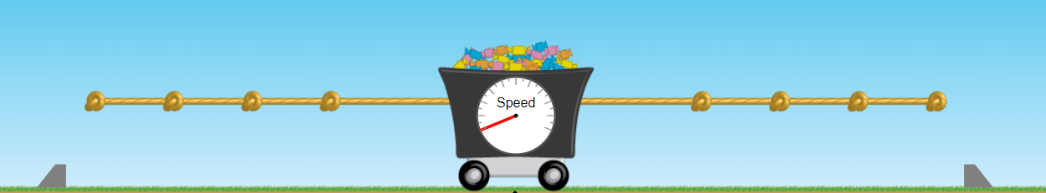
- Draw a scenario where the net force is 50N to the left and there is at least 1 member on each side.
- Draw a scenario where the net force is 0N and there is at least 1 member on each side

- Challenge: Create and describe a situation where the force is 0N but the cart moves.

Part 2: Use the MOTION Section CLICK ALL THE BOXES
1. Find the time it takes for each object to accelerate from 0m/s to 40 m/s when pushed with 100N of force.
2. Then calculate the acceleration for each object. When you finish you should know the mass of the mystery object.
Object | Mass (kg) | Time (s) | Acceleration (m/s²)
Child | 40 |  | a = V_{f} – V_{i} a = 40 m/s – 0m/s  t t  or use F = m x a 100N = m x a
Adult | 80
Box | 50
Trash can | 100
Mystery item
(WHAT IS ITS MASS?)
- When you increase the mass of an object (while keeping the applied force the same) what happens to the rate of acceleration? Explain why this occurs using your understanding of Inertia (an object’s resistance to a change in motion).

- When you apply a constant force to an object does the object move at a constant velocity or does its velocity increase? Explain why this occurs using your understanding of acceleration/force (gravity).

Part 3 Use the MOTION Section CLICK ALL THE BOXES
Pick one object find the time it takes to reach 40m/s when pushed with 100N, 200N, 300N, 400N, and 500N.
Name of Object: _____________________________________________ Mass of Object (kg): __________________
Force | Time (s) | Acceleration (m/s²)
100N |  | a = V_{f} – V_{i} a = 40 m/s – 0m/s  t t  or use F = m x a 100N = m x a
200N
300N
400N
500N
- When you increase the applied force, what happens to the acceleration of the object? Explain.

Part 4 Use the FRICTION Section CLICK ALL THE BOXES
With the friction bar set in the middle, what is the least amount of force needed to get each object to start moving?
Object | Minimum Applied Force (N) needed to cause the object to begin moving | Frictional Force (N) Acting on the Object | Sum of Forces (Net Force to the right) to cause the object to begin moving | Minimum Applied Force (N) needed keep it moving at a constant velocity once it starts moving | Sum of Forces (Net Force) needed to keep object moving at a constant velocity once it starts moving
Child
Adult
Box
Trash can
Refrigerator
Mystery item

1. As the amount the object’s of mass increases, what happens to the amount of force needed to begin moving the object? Explain.

2. Do you need to continue applying force on an object to keep it moving? Explain why.

