ACTIVITY TOPIC: | NEWTON’S SECOND LAW OF MOTION

NAME: |  |  |  | SECTION:
TEACHER: |  |  |  | DATE:

INSTRUCTION: Use your mobile learning device to accomplish this activity. This task involves the use of an online simulation for you to gather information that you need to answer the guide questions. Accomplish all the specific steps that follow and refer to the scoring rubric below in answering the questions.
POINTS | DESCRIPTION | SCORING RUBRIC – CONCEPTUAL QUESTION
3 | Explanation shows a clear understanding of the concepts. Two (2) key concepts about the topic are appropriately cited.
2 | Explanation shows a quite clear understanding of the concepts. One (1) key concept about the topic is appropriately cited.
1 | Explanation is unclear. No key concepts are cited.
0 | No answer or wrong answer.

PART A:

1. Using your mobile learning device, open this link:
https://phet.colorado.edu/sims/html/forces-and-motion-basics/latest/forces-and-motion-basics_en.html

2. You will see four icons on the screen. Click the second one which says “Motion”. You will see the simulation on “Motion” as shown below:

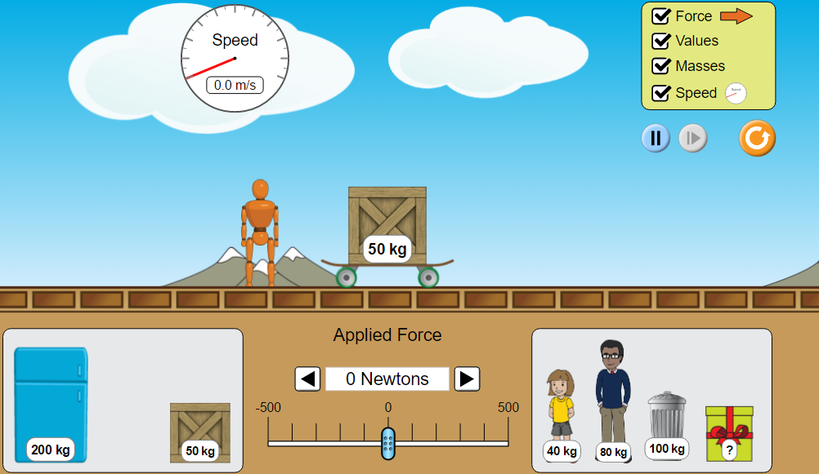

3. Keep all the items inside the yellow box (upper right-hand corner) ticked.

4. Choose a particular item from bottom left/right boxes and position it on top of the skate board.

5. Set the “Applied Force” as 50 N (“N” stands for “Newton”, a unit of force) by clicking/tapping on the right arrow once. Observe the motion of the box within 10-15 seconds. You may look at how fast the value of speed changes, as shown in the circle on the upper left corner.

6. Without changing the chosen item on the skateboard, set the applied force into higher values (from 50 N, to 100 N, 150 N, 200 N…) by clicking/tapping on the right arrow. Observe the motion of the object for at least 10 seconds for each value of applied force. Carefully notice how fast the value of the speed changes for each value of force applied.

PART A - GUIDE QUESTIONS:

a. What happens to the change in the value of the speed as you increased the amount of force applied on your chosen item?

____________________________________________________________________________________________________________

b. What does this observation tell you about the relationship between the external force applied and the object’s acceleration (the rate of change in velocity)?

___________________________________________________________________________________________________________
PART B:

1. Click the “reset” button (the round, orange button on the upper right-hand corner) of the same simulation to clear all the current settings.

2. Tick all the items (force, values, masses, speed) inside the yellow box. Remove the crate from the top of the skateboard and place it inside the box (lower left).

3. Position the 40-kg child on top of the skateboard. You have to observe its acceleration within a 5-second time interval by referring to Step 4. Use a digital stopwatch as a timer.

4. Set the force at 50 N. The skateboard and its load will then start moving. Stop the motion of the body by pressing the “pause” button AFTER FIVE (5) SECONDS (starting from the time you set the force as 50 N). Check the speed (refer to the speed shown in the circle, upper left) reached by the body within the 5-second time interval. Record this value in Table 1 as the final velocity of that particular item.

5. Do the same for all the other items listed in the table below. Click “reset” every time you start with a new item, and always tick all the items inside the yellow box. Remove the crate (the default setting) on top of the skateboard before placing a new item, unless the crate itself is the item you need to select. The force must be the same (50 N) for all these items.

6. Compute for the acceleration of all the items considered and record the data in the last column. The acceleration is equal to final velocity – initial velocity divided by time (time equals 5 seconds for all the items).

TABLE 1: ACCELERATION OF DIFFERENT BODIES AT 50-N FORCE

ITEM | MASS  (kg) | INITIAL VELOCITY  (m/s) | FINAL VELOCITY  (m/s) | ACCELERATION  (m/s²)
child | 40 | 0
crate | 50 | 0
man | 80 | 0
metal trash bin | 100 | 0
refrigerator | 200 | 0

PART B - GUIDE QUESTIONS:

c. What did you notice with the acceleration values obtained by the different items? What do you think caused the variations in these values?
________________________________________________________________________________________________________________________________________________________________________________________________________________________

d. What variable/s can you manipulate in the simulation to make all the items get the same proximate values for their acceleration? Explain how this idea will work.
________________________________________________________________________________________________________________________________________________________________________________________________________________________
____________________________________________________________________________________________________________

CONCEPT CHECK:

Complete the concepts below by filling in the blanks with the appropriate terms and underlining the appropriate word inside the parentheses.

At constant mass, the __________________ of an object varies (directly, inversely) with the net external force applied. That is to say, that an object’s acceleration increases as the force applied is (decreased, increased), but its acceleration decreases if the force applied is (decreased, increased).

At constant force, acceleration varies (directly, inversely) with mass. When subjected to the same amount of net external force, a heavier object will experience (less, greater) acceleration than a lighter one.

Newton’s Second Law of Motion states that:

________________________________________________________________________________________________________________________________________________________________________________________________________________________
____________________________________________________________________________________________________________

worksheet prepared by:
Ms. Leah L. Lecerio
Licensed Professional Teacher

