**Phet Simulation Gene Expression** Name:

Goal: Students can describe the process and effects of gene expression

**Go to the “Expression” Tab. Start on Gene #1**

1. What molecule is all of this based on?
2. What do you think the difference in color of strands represent? Are they really that color?

*For the next several questions: think about what/where things are at the start, and what/ where things are at the end of the process. Explain both of those parts when explaining what the biological macromolecule/enzyme does.*

1. What does the “Positive Transcription Factor” do?
2. What does the “RNA Polymerase” do?
3. What does the “mRNA destroyer” do?
4. What does the “negative transcription” factor do?
5. What does the “Ribosome” do?

**Go to Gene #2**

1. What does Gene #2 have to have to make mRNA, that gene #1 didn’t?

**Go to Gene #3**

1. Can you have more than one type of molecule working? Why would that be helpful?

**After all Genes are explored**

Fill in the blanks below.

1. Gene _____ is more complex than Gene _____ because_________________________________
2. What is the difference between the “regulatory region”/origin and the “transcribed region”/code?
3. A student says that “ALL DNA codes for proteins.” Do you agree with her? Why or why not?

Claim-

Evidence-

Reasoning-

1. In your own words, write a short paragraph below that explains the sequence of how DNA codes for protein.

**Go to the Next Tab that says “mRNA”**

1. Try out all of the tabs. What does the term “affinity mean”?
2. What are the circumstances that make the most mRNA?
3. What are the circumstances that make the least mRNA?
4. Why would a cell need to have the option to make or not make protein?

**Go to the next tab that says “Multiple Cells”**

1. Mark where the slider should be on the controls for the amount of protein requested:

**LOTS**  **None**

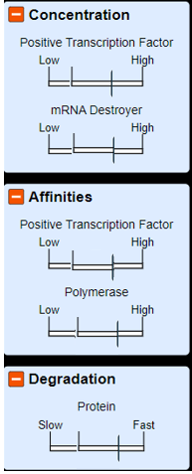 



1. In your own words, what does “degradation” mean?