PhET LAB 3-1 Velocity – Time Graphs Name(s): __________________________________

Background – Graphs are a means of communication.
Learning Goals – Analyze velocity – time graphs, relate these to position - time graphs, and distinguish the means for determining whether a person is standing, moving forward (or backwards), or accelerating. Also, relate the slopes of position – time and velocity – time graphs and the area to the time axis for the velocity – time and acceleration – time graphs.
Procedure – Go here: https://phet.colorado.edu/en/simulation/legacy/moving-man . Then, click PLAY, or download then, keep and double click to activate “The Moving Man.”

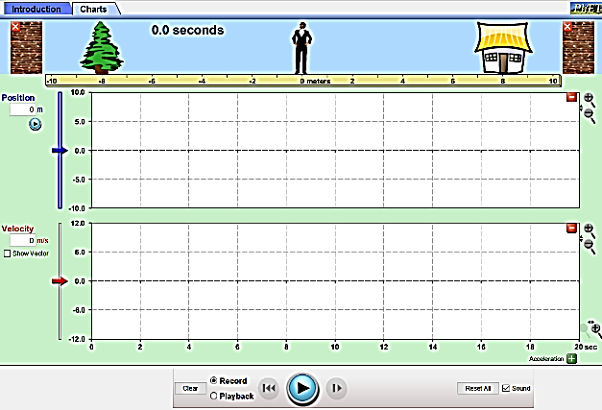
1. START. After “Moving Man” is open, choose Charts. Leave the position – time graph, and the velocity – time graph open, but close the acceleration-time graph. Your screen should look like this. Please, turn the sound off.

2. EXPLORE. Press PLAY, then click and drag the man to move him forward and backward. Observe what shows up on the graphs.

3. Without using Moving Man, sketch what the motion graphs will look like if the man starts at the tree and moves toward the house with constant velocity. Briefly explain your reasoning.
GRAPH  (starting at the tree, moving toward the house with at a constant velocity) | Explanation  (reasoning for its shape)
Position - Time | __________________________________________  __________________________________________  __________________________________________  __________________________________________
Velocity - Time | __________________________________________  __________________________________________  __________________________________________  __________________________________________
Now, check your graphs using the Moving Man simulation. If they need repaired, sketch the correct curve in a different color pencil or pen. Also, confirm and/or mend your explanation.
4. Using Moving Man, sketch the motion graphs will look like if the man leans against the wall by his house without moving. Write down the reason why these graphs appear as they do.
GRAPH  (leaning against the wall by his house without moving) | Explanation  (reasoning for its shape)
Position - Time | __________________________________________  __________________________________________  __________________________________________
Velocity - Time | __________________________________________  __________________________________________  __________________________________________
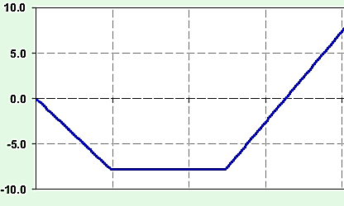
Position (s_{x}/m)
Time (t/s)
0 2 4 6 8
7.0
-8.0
5
5. Suppose this position – time graph represents the Man’s motion, starting at 0.0 m. To draw the velocity – time graph, we need the slope (velocity) from 0 to 2 seconds.

List the other two velocities including their time intervals required to draw an accurate velocity – time graph of this motion.
a. ${\vec{v}}_{0-2s}=slope from 0-2 seconds$
b. _____________________________
c. _____________________________
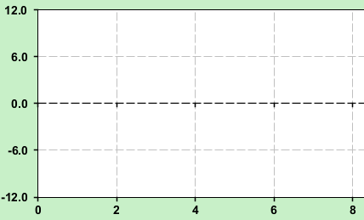
Time (t/s)
Velocity (v_{x}/ms⁻¹)
6. Determine the values listed in a, b, and c.
a. ${\vec{v}}_{0-2s}=$__________
b. _______ $=$ _________
c. _______ $=$ _________
Calculation of a. goes here!

7. Now, sketch the velocity – time graph that matches the Man’s motion (on the right).

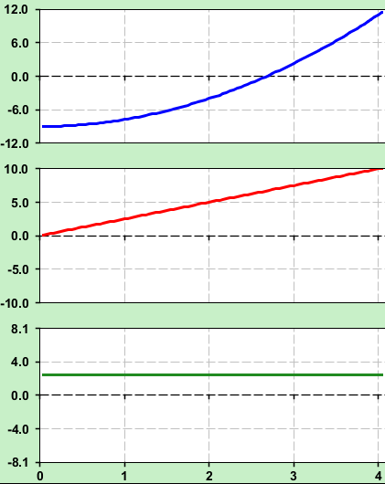
8. Here are the motion graphs showing the person moving forward for 4.0 s, starting at -9.0 m, traveling to 11.0 m. Find values and write the units for the following (2 SF):
Position (s_{x}/m)
Velocity (v_{x}/ms⁻¹)
Acceleration (a/ms⁻²)
Time (t/s)
-9.0
11.0
a. initial position ($x_{i}$): ___________

b. final position ($x_{f}$): ___________

c. total displacement ($\vec{s}$): ___________
(shade the area relating this on the v-t graph)
v
(show the calculation of that area )

d. time interval ($t$): ___________

e. initial velocity ($\vec{u}$): ___________

f. final velocity ($\vec{v}$): ___________

g. acceleration ($\vec{a}$): ___________
(draw the rise over the run on the v-t graph)
(show a calculation of that slope)

h. change in velocity ($∆\vec{v}$): ___________ 9. We know that a velocity – time graph allows us to
(shade the area linked to this on the a-t graph) generate an object’s instantaneous acceleration,
v
(show a calculation of this area) (and change in velocity). But, what can it NOT convey?

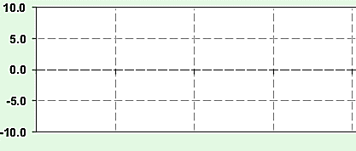
10. Draw the velocity – time graph for a person, starting at rest, who moves from 11.0 m to -9.0 m with an acceleration of -5.0 m/s² in 4.0 s.
Velocity (v_{x}/ms⁻¹)
Time (t/s)

Loeblein, King, and Forbes 2018

