Projectile Physics – H Physics 1 10/2/18 NAME:___________________
Shelton School – Mr. Hanson
Some ‘science facts’ to keep in mind:
An object in ‘free fall’ is accelerating only because of gravity, plus what ever velocity
it initially had to set it flying. An object traveling upward is still in ‘free fall’.
Vectors that point up are positive; vectors that point down are negative.
- The y-axis is associated with up/down vectors
- Displacement, velocity, force, and acceleration are the important vectors.
Usually we’ll let vectors that point to the right be positive, and left negative.
Objects in free fall will accelerate at a rate of 9.8 m/sec² regardles of their mass or size.
Since the acceleration is always down (towards the Earth), we’ll use -9.8 m/sec² for a.
The number -9.8 m/sec² is so important that it gets its own symbol, g: g=-9.8 m/sec²
Use the PhET simulation ‘Projectile Motion’, and your knowledge of vector components to answer these questions:
If an object is dropped from some height, what is it’s initial velocity in the y-direction? In the x-direction?
If you knew the height, could you find an equation for the time until it hits the ground (fall time)?
Could you find an equation for the final velocity? (V_{f} is the moment before it hits the ground)
Use the kinematic equations to find expressions for fall time and final velocity.
If you fire a cannonball horizontally, what are the important variables that determine how far it will fly before hitting the ground (the range)?
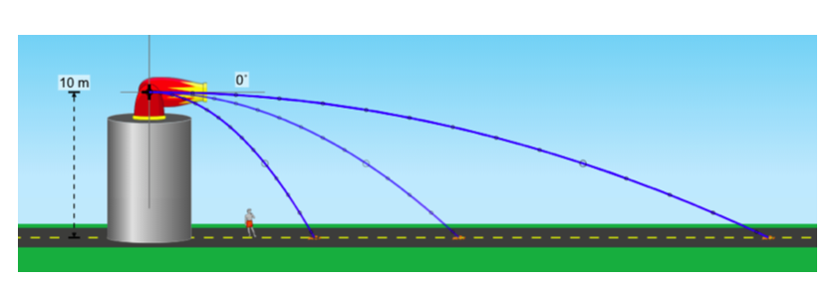
Simplifying Assumption: If we assume there is no ‘drag’ or air resistance, then horizontal velocity is constant, but vertical velocity is always changing.

Turn on the ‘show vectors’ and watch how the v_{x} and v_{y} change during the object’s flight. When is V_{y} the largest smallest? When is V (the total velocity) largest?

Does changing v_{i} for a horizontal cannonball affect the flight time? (Use the measurement tools to be sure; your intuition is probably wrong.)

Since v_{x} is constant, could you develop an equation for the range (∆x for the landing spot?). What would be the important input variables for the range? Could you develop a formula or equation for the range of a horizontally fired projectile, given V_{i} and the height ∆y?

