

expanding and factoring algebraic expressions

Author: Amanda McGarry

# Pre-Planning

## LEARNING GOALS

* Use the distributive and commutative properties to make an equivalent expression
* Use a common factor to write an algebraic expression in factored form.

## Standards Addressed

* [CCSS.Math.Content.7.EE.A.1](http://www.corestandards.org/Math/Content/7/EE/A/1/)  
  Apply properties of operations as strategies to add, subtract, factor, and expand linear expressions with rational coefficients.

* [CCSS.Math.Content.7.EE.A.2](http://www.corestandards.org/Math/Content/7/EE/A/2/)  
  Understand that rewriting an expression in different forms in a problem context can shed light on the problem and how the quantities in it are related.

## Curriculum Alignment

Digits Grade 7, Lesson 7-1 and 7-2

## Prior Knowledge

* Write algebraic expressions to represent the information in a verbal expression.
* Use the commutative property to simplify expressions
* Use the distributive property to expand and combine like terms
* Identify the greatest common factor of two or more numbers

## Materials

* Technology: 2:1 or 1:1 laptop, chromebook, or iPad
* PhET sim: [Area Model Algebra](https://phet.colorado.edu/sims/html/area-model-algebra/latest/area-model-algebra_en.html)
* Activity sheets

# Lesson Plan (45 minutes)

## Warm-up

|  |  |
| --- | --- |
| **8** MINUTES | Share the URL for [Area Model Algebra](https://phet.colorado.edu/sims/html/area-model-algebra/latest/area-model-algebra_en.html) or instruct students to go to phet.colorado.edu and search for Area Model Algebra. Allow students to play with the sim for 5 minutes without any direct instruction.  After students have played for a while, facilitate a whole-class discussion where students can share out features that they found.   * Be sure students find the partition lines on the Explore screen. The red and blue triangles can be dragged to create partition lines.      * What is the difference between these different ways of displaying partial products?      * Be sure students find this dropdown menu on the Generic and Variables screens, which sets up the partition lines before adding numbers. |

## Sim-based lesson

|  |  |
| --- | --- |
| **10** MINUTES | Have students work on #2-4 on their activity sheet.  As you walk around observing students working on #2-3, you can help push their thinking with questions such as   * where does 6x come from? * where does -30 comes from? * what does it mean when a number like 6 is multiplied outside of parentheses?   After students have finished #4, pause for a whole-class discussion about area models. Call on students to share their answers for #4:  a) The outside numbers are being multiplied together to form the partial products,  b) the product is the same as the total area, which is the **sum** of the partial products |
| **10** MINUTES | Have students work on #5. Encourage students to make predictions, then use the sim to verify. Look around to see if any students got different answers.   * Some example answers could be 4(x+3), 2(2x+6), 1(4x+12), and even negatives like -4(-x–3). * If students find the answer quickly, encourage them to find multiple correct solutions.   After students have finished thinking about #5, facilitate a class discussion about what it means to factor.   * What math did you have to do in this problem to find the outside numbers? * We call this type of problem **factoring**. * If distribution is multiplying, what is factoring? (student responses might include: reverse distribution, division, etc.) * Distribution and factoring are kind of like opposites.   Ex: 4(x+3) = 4x+12  We call [the left] factored form and we call [the right] expanded form. |
| **10** MINUTES | Have students work on #6-7, and even play the game if they finish early (the variables game). |

## Summary

|  |  |
| --- | --- |
| **5** minutes | Have students answer the following question on an exit ticket:  **How are expanding and factoring related?**  *Sample answer: Expanding takes an expression with parentheses and turns it into an expression without parentheses. Factoring takes an expression without parentheses and turns it into one with parentheses.*  *Sample answer: You multiply numbers or expressions when expanding an expression. You divide terms in an expression when factoring. Since multiplication and division are opposites, expanding and factoring are opposites.* |

Name: ___________________________ Date: ___________ Class: _______________

# expanding and factoring Expressions

1. Play with the Area Model sim for 5 minutes. Write down three questions or observations that you have.
2. Use the sim to explain why $6(15) = 6(10) + 6(5).$

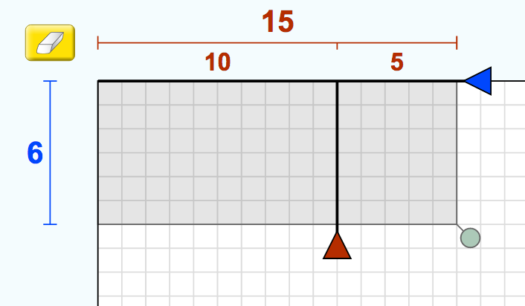

1. Use the sim to explain why $6\left(x-5\right)=6x-30$.

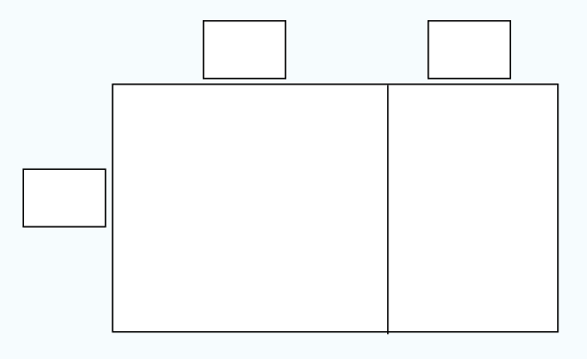

1. Understanding an area model:
   1. How do the interior numbers (partial products) get calculated?
   2. How does total area get calculated?
2. The Area Model sim is playing tricks on you! It gives you the interior numbers, but not the exterior numbers. What numbers must be on the outside of this area model? 

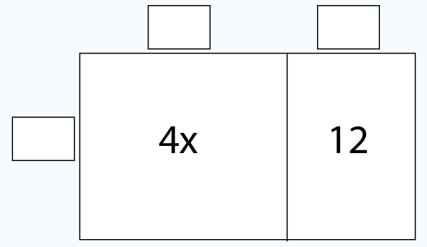

1. Complete the table below *without using the sim*. Use the Variables screen to check your answers.

|  |  |
| --- | --- |
| * **Factored form** | * **Expanded form** |
| $$3(x + 2)$$ |  |
| $$7(x+5)$$ |  |
|  | $$2x+12$$ |
|  | $$8x+4$$ |
| $$-2(2x+4)$$ |  |
|  | $$5x-25$$ |

1. For your birthday party, you plan to buy 2 cupcakes for each guest and 5 additional cupcakes to have as extras. Cupcakes cost $2.25 each. Let $x$ represent the number of guests you invite to your party. Use this factored expression: $2.25(2x+5)$
   1. What does each *factor* of the expression represent? What does the *expression* represent?
   2. Use the distributive property to expand the expression. What does each term of your new expression represent?