Title: Building Area and Perimeter
Definition: Area is known as the number of square units needed to cover an object/figure. Perimeter refers to the distance around these shapes.
Objective: In this activity, you will investigate how to identify and compare the area and perimeter of 2-D composite figures.
Important Questions:
1. How can we find the area of figures without using the formula, A = L x W?
2. How can we build shapes with the same area but different perimeters?
3. How can we build shapes with the same perimeters but different areas?
Instructions:
You will complete this activity by filling in the tables and writing responses. The three phases of this investigation are: Exploration, Explanation, and Application. You will have to work between this document and the following computer simulation.
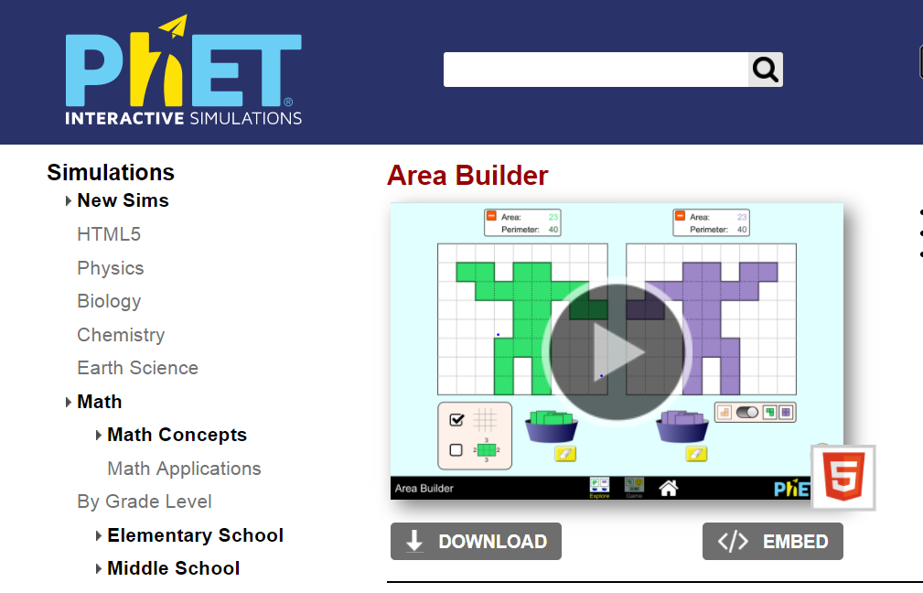
1. Click this link: https://phet.colorado.edu/en/simulation/area-builder
Your screen should look like this:

2. Click the play button.
3. Click the Explore button.

Exploration Phase (5 – 7 minutes)
1. Briefly explore the Area Builder simulation.
2. You may drag and drop various orange squares from the middle basket onto the grid.
3. Explore building figures with different combinations of areas and perimeters.
4. Try building the letters, “H” and “I”. Determine how their areas and perimeters compare to one another.
Questions
1. What is the area and perimeter of one unit square?

2. How does the area and perimeter change when two unit squares are connected horizontally?

3. What do you think the area of the entire grid might be, if all the orange squares are placed onto the grid?

Now that you have some experience working with area and perimeter. Write a definition for each:
Area: ________________________________________________________
_______________________________________________________
Perimeter: _____________________________________________________
_____________________________________________________
Explanation Phase (15 – 20 minutes)
Aim: Create shapes that have the same area but different perimeters.
State your hypothesis: Is it possible for shapes to have the same areas but different perimeters (and vice versa)?
_________________________________________________________
_________________________________________________________
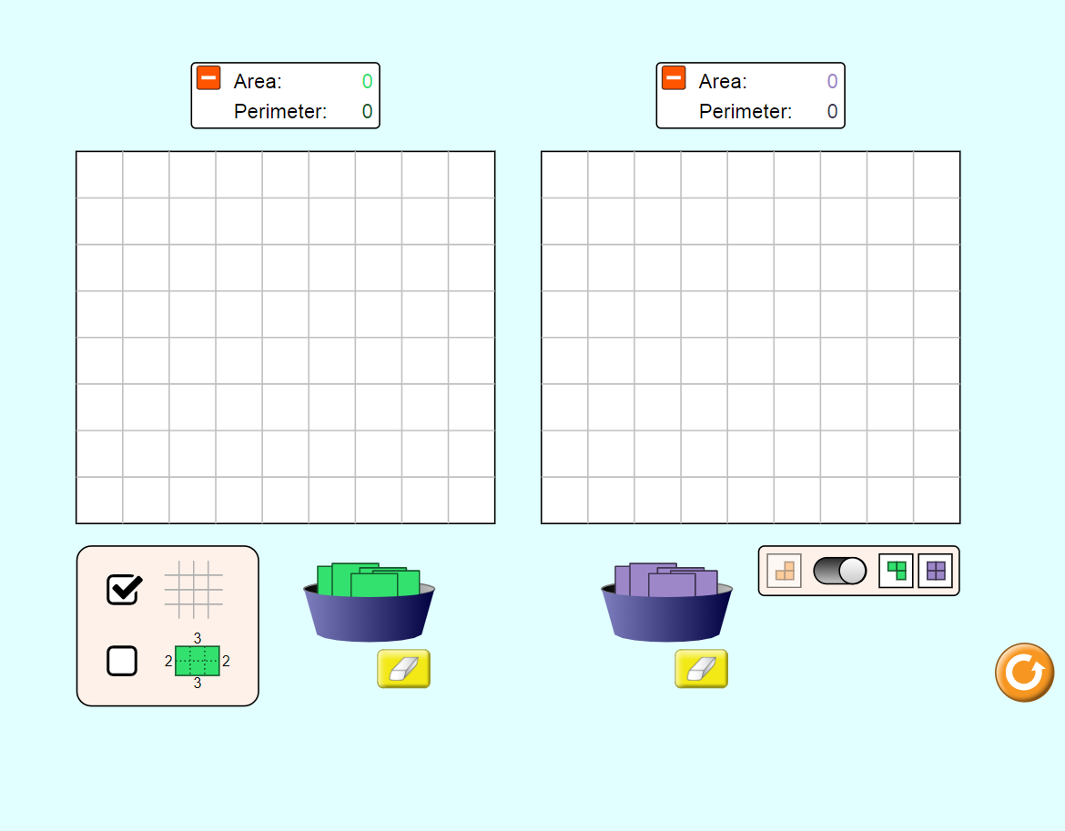
Click on the toggle on the bottom righthand corner. This should place two grids that are side-by-side on your screen. Here is a screenshot of what it should look like:

Below is a table of values consisting of the number of square units needed, area, and perimeter of various figures you will build. Fill in the missing information in the data table.
Build this Shape | Number of Squares | Area (sq. units) | Perimeter (units)
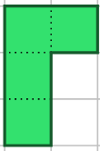
A.
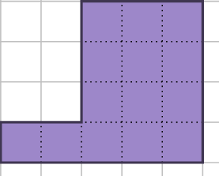
B.
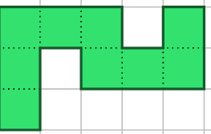
C.
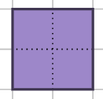
D.

1. Did any of the shapes have the same area but different perimeters?

2. How do the number of squares relate to the area measured in square units?
Write an equation to show the relationship:

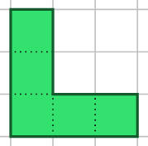
3. Build this next shape using green squares. Record the area and perimeter.

Area: ____ square units
Perimeter: ___ units
4. Build a shape using purple squares that has the same perimeter but different area next to the green one you have already built (see picture above).
Screenshot it and paste it below:

5. Why do you think it is possible for these shapes to have the same perimeter but different areas?
______________________________________________________________
______________________________________________________________
______________________________________________________________
Application Phase (10 minutes)
Click the “Game” tab. Complete each level and record your scores below.
Your screen should look like this:
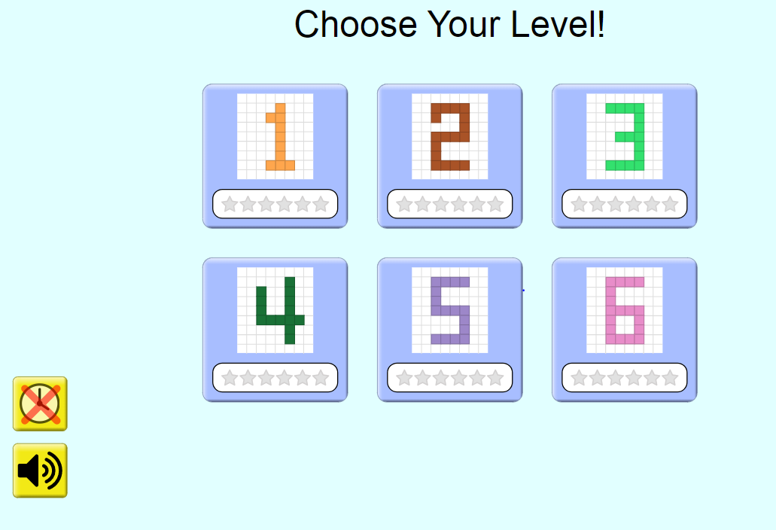

Level 1 Score:
Question: To build an area of 36 square units. How many unit squares should you use?
___________________________________________________________
___________________________________________________________
___________________________________________________________
Level 2 Score:
Screenshot the figure you built for Question Number 1 in this level. State the area and perimeter:
Area: _____ square units
Perimeter: _____ square units

Level 3 Score:
Extension Question: The area of a figure is 36 square units. What could be a possible perimeter?
__________________________________________________________
__________________________________________________________
(Optional) Level 4 Score:
(Optional) Level 5 Score:
(Optional) Level 6 Score:

