Long-Run Probability Through Plinko
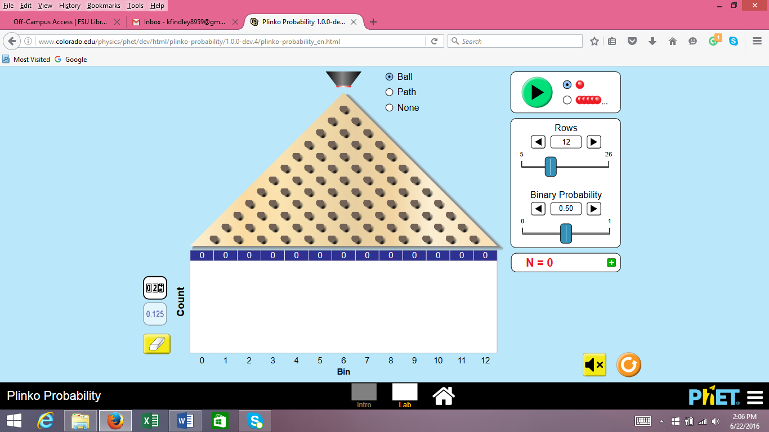

LESSON SUMMARY
This lesson builds from students’ prior knowledge of probability by strengthening their understanding of probability as a value between 0 and 1, associating probabilities with likelihoods of single and multiple trials, using theoretical probability to make predictions about results from a large number of trials, and recognizing experimental probability as a reliable predictor of theoretical probability as we complete more trials.
Grade: 7 Statistics: Probability
PRIOR KNOWLEDGE
Exposure to the probability of a chance event is a number between 0 and 1 that expresses the likelihood of the event occurring. Larger numbers indicate greater likelihood. A probability near 0 indicates an unlikely event. (i.e., CCSS.Math.Content.7.SP.C.5).

Familiarity with the terms “trial,” “event,” and “sample space” and finding the probability of an event by determining the number of trials that produces that event divided by the total number of equally likely trials in the sample space. (i.e., some of CCSS.Math.Content.7.SP.C.8)
LEARNING GOALS
- Students will deepen their understanding of probability including more familiarity with probability being represented as a decimal and converting back and forth between fraction and decimal (All Days)
- Students will use a tree diagram to organize outcomes from multiple trials (Day 1)
- Students will learn to differentiate a sample space in which outcomes are all equally likely and a sample space where outcomes are not all equally likely (Day 1, and continued Days 2-3)
- Students will learn to assign probabilities to different outcomes based on the number of equally likely paths that produce that outcome divided by the total number of equally likely paths possible (Day 1)
- Students will use the theoretical probability to make predictions for results from multiple trials (e.g., if the ball bounces right 25% of the time, it should bounce right about 5 out of 20 times) (Days 2-3)
- Students will begin to think about Central Tendency and how experimental probabilities generated from more trials is more trustworthy than experimental probabilities from few trials (Day 3)
Content Standards | Practice Standards
CCSS.Math.Content.7.SP.C.5: Understand that the probability of a chance event is a number between 0 and 1 that expresses the likelihood of the event occurring. Larger numbers indicate greater likelihood. A probability near 0 indicates an unlikely event, a probability around ½ indicates an event that is neither unlikely nor likely, and a probability near 1 indicates a likely event. (Reinforced All Days)  CCSS.Math.Content.7.SP.C.6: Approximate the probability of a chance event by collecting data on the chance process that produces it and observing its long-run relative frequency, and predict the approximate relative frequency given the probability. For example, when rolling a number cube 600 times, predict that a 3 or 6 would be rolled roughly 200 times, but probably not exactly 200 times. (Days 2-3)  CCSS.Math.Content.7.SP.C.7: Develop a probability model and use it to find probabilities of events. Compare probabilities from a model to observed frequencies; if the agreement is not good, explain possible sources of the discrepancy. (tangentially addressed in Day 1, but should be addressed elsewhere in your probability unit)  CCSS.Math.Content.7.SP.C.8a: Understand that, just as with simple events, the probability of a compound event is the fraction of outcomes in the sample space for which the compound event occurs. (All Days)  CCSS.Math.Content.7.SP.C.8b: Represent sample spaces for compound events using methods such as organized lists, tables (Days 2-3) and tree diagrams (Day 1). For an event described in everyday language (e.g., “rolling double sixes”), identify the outcomes in the sample space which compose the event. | CCSS.MATH.PRACTICE.MP5 Use appropriate tools strategically. (All Days)  CCSS.Math.Practice.MP6 Attend to precision. (Day 3)  CCSS.MATH.PRACTICE.MP8 Look for and express regularity in repeated reasoning. (Days 2-3)
MATERIALS
- Activity Sheet
- Plinko Probability. http://phet.colorado.edu/en/simulation/plinko-probability
- Pennies/coins (A single die can work if each student/group uses even and odd rolls as heads and tails)
- Chromebooks/tablets/etc. (suggestion, one chromebook per pair to make the game easier to manage)

Day 1 (Teacher Notes)

“INTO THE WOODS” (~16 minutes)
- For this game, give each student or small group a coin (Note: if coins are difficult to acquire you can use a dice where odd rolls act as heads and even rolls act as tails). Briefly read instructions.
  - Have students “take a route” through the woods at least 5 times. Students should use the space to below to record their results however they want. They might make a table or even recreate the path.
  - Orient students to questions 1-2 on the back of the page
    - Talk to groups during this time, and have students articulate their own findings and what they noticed. Don’t impose any ideas yet (e.g., landing at B is more likely), but do ask them if they think they are all equally likely and why/why not.

DISCUSSION OF INTO THE WOODS (~14 minutes)
- Bring class back together to discuss where each group landed.
  - Go group by group and ask students how many times they landed at each destination. Create table on whiteboard as students tally in results on their worksheet.
  - Ask if students if it looks like all destinations are equally likely are not. Why might we land at destination B more often than A or C? What do we think the theoretical probability is of landing at each of these places?
  - Ideally, students will bring this up, but if necessary, point students to the different possible paths and ask if each path is equally likely, or if some paths are more likely than others.
  - Create tree diagram on whiteboard (FYI, tree diagrams don’t require actual trees like our activity does. It just references a diagram with branching paths. Ours is just a particularly TREE-ful diagram!). Ask what percent of the time we would go left at the first fork in the road and what percent of the time we would go right (50% and 50%). Now what about the second set of forks? These would be 50%’s on top of the previous 50%, so then 50% of 50% (half of half) is 25%. Then the middle paths would combine to make 50% landing at destination B.

COMPUTERS AND OPEN PLAY IN PLINKO (~8 minutes)
- Pass out computers (1 per student or 1 per pair are both fine). Instruct students to search for “phet plinko probability” and open the first option. Have students go to the LAB screen and set ROWS TO 1. (remind every student/pair to do this as they open up the sim)
  - Instruct students to play freely, and be sure to ask them if they have tried adjusting the “binary probability” value.

DISCUSSION OF PLINKO (~15 minutes)
- Discuss “coming back together” question
  - What’s the relationship between the binary probability value and where the ball lands? Push students to articulate this, but don’t be afraid to just come out and say it after a few attempts. “The binary probability is the probability the ball bounces RIGHT when it hits a peg.”
- Going from 1 to 2 rows
  - Give students a minute or two to play with this new setting
  - Ask what they think the probability is of landing in the middle bin (Bin 1) if we leave the binary probability at 50% (Ideally this should connect to reasoning from “Into the Woods”).
    - Probabilities for Bin 0 and 2?
  - If time, you might have students try 3 rows and predict the probabilities of landing in each bin within this space.
Day 2

INTRODUCTION & OPEN PLAY (~12 minutes)
- We encourage you to have one computer for every pair. Have computers already out, but instruct students not to open them until instructed to do so
- Display question on board and ask: Have you ever heard of Plinko?
- Allow students to discuss what they think Plinko is or where they have heard of it before.
- Play this video or one like it to get students excited about Plinko! https://www.youtube.com/watch?v=oDl6jYV-re4
- Ask students to open their computers and play around with the simulation and write down things they notice. (Distribute handout when students begin playing). Direct students to the LAB screen, and let students know they can set play around with the number of rows.
- Teacher will ask students to volunteer questions and observations
- Features of the sim
- What bins do the balls land in when binary probability is high? Low? (teacher may make table on whiteboard with two columns “left” and “right” and list binary probability values that led the ball to land on the left or right side of the gameboard. Students may continue playing to call out values to list on each side).

ACTIVITY (~10 minutes)
- Teacher needs to thoroughly discuss directions, asking students to restate what they are to do. Ideally have students work in pairs, but a group of 3 is ok if necessary. (Emphasize 10 rows)

DISCUSSION (~10 minutes)
- Class will come back together, teacher may ask who got a ball in the winning bin at least once? Twice? Etc.
  - Ask students to Think about just the first peg: If I were to release 100 balls, how many do you think would bounce to the right (off the first peg) if I set my binary probability to 50%? (set rows to 1 on the main screen to help clarify the question)
- REMIND students that the binary probability is the probability a ball will go right each time it hits an individual peg. This is a reminder from previous day, but some students will have forgotten or been absent.
- Ask previous question again regarding 100 balls with probability at 50%. What about if binary probability is 70%?
- What about if I have 10 rows, and the binary probability is 70%, how many times out of 10 do I expect 1 ball to bounce right? (students will likely struggle with this. At least push them to recognize it is likely to land on the right side of the gameboard).

ACTIVITY (~10 minutes)
- Plinko revisited. Now rows are set to 20

DISCUSSION (~8 minutes)
- Class will come back together, teacher may ask who got a ball in the winning bin at least once? Twice? Etc.
- Highlight successful strategies
- Discuss final questions as a group, pointing to students that our best guess is based on the theoretical probability (p=80% means we expect ball will go right off of 80% of pegs it hits).
Day 3
INTRODUCTION & OPEN PLAY (~7 minutes)
- Display warm up question: Yesterday when the probability-slider was set to 0 or 1, we could predict with exact certainty which bin the plinko ball landed in every time. What does a probability of 0 or 1 mean? Were there any other instances that you could predict exactly where the ball would land? Why/why not?
  - You might answer this second part by pointing out that games like Plinko involve randomness; however, there is still an underlying probability that helps us make reasonable predictions!
- Set bins to 20, ask students what probability range you would expect to lead balls into bins 0-5? 5-10? Etc.
- Students will have free play in the sim to start to refresh their memory about previous class (3 min); Encourage students who were absent to ask a friend who was present about what occurred yesterday.
- Teacher will bring everyone back to make sure everyone understands the probability value as the probability that a ball falls to the right each time it hits an individual peg (demonstrate on screen).

OPPPOSITE PLINKO (~10 min)
- Students will play OPPOSITE PLINKO
- Thoroughly discuss directions.
- Tell students the secret values for the probability value cannot be 0 or 1 because we already know how to figure that out.

DISCUSSION (~10 min)
- Class will come back together to unpack winning strategies and have students share thoughts about predicting with more accuracy.
- Examples for probing questions:
  - Did anyone guess the binary probability exactly? Close? How did you do it?
  - Did anyone split the probability scale diagram from the warm up to find the bins for 0-0.25, 0.25-0.5, etc.
  - Did anyone find the average bin for their trials?
- Students might realize they can use experimental probability (how many times it hits a peg and goes right out of total) to predict it. Highlight this strategy if it comes up, or mention this idea if no one used this strategy.
- Pose question 3 as a summary of what has been discussed.

ACTIVITY (~15 min)
- Students will have focused play to record experimental probability results and compare to theoretical.
- Remind students that the theoretical probability is the actual binary probability (80% means 80% of the time, ball will go right off of a peg).
  - They will probably need help understanding how to calculate the experimental probability. Remind them that each time the ball hits a peg, that is a trial. The experimental probability is the proportion of “Right” bounces divided by the total pegs hit. Students can combine peg counts for ALL balls together to come up with one experimental probability for each round.
DISCUSSION (~8 min)
- Remaining time will be spent addressing concluding question
  - The more trials we run, the more information we have, and the more our experimental probability should align with the theoretical probability.
Day 1
It’s time to play…
Let go over the rules…
- We’re traveling through the woods, and each time we hit a fork in the road, we have the choice of going left or right
- To make that choice, we’ll flip a fair coin. If it lands head, we’ll go right, and if it lands tails, we’ll go left
- The following picture shows the different path options we have and different destinations possible
- Using your coin, try making your journey through the woods several times
  - TIP! Remember that heads means go to the right from the perspective of the traveler (if you were to turn your paper upside-down).
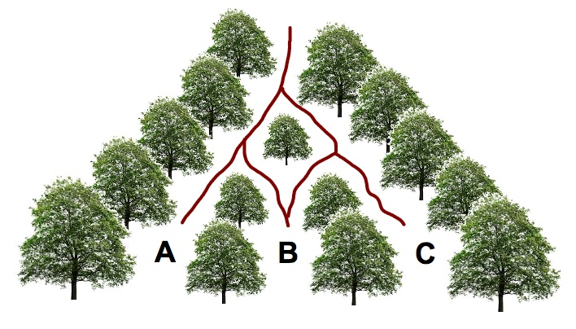
Simulate moving through the woods 5 or more times and use the space below to record what happened each time.

- Let’s call the destinations A, B, and C the sample space. Do you think you are equally likely to arrive at each destination? How do you know?

- What is the theoretical probability of ending at each destination?

A | B | C
Coming Back Together
Which destinations did the class land at the most? Record class results in the Table!

Focused Play
Open up Plinko Probability and go to the Lab screen. Set rows to 1
- Make some observations about what’s going on with this sim!

Coming Back Together
- How does the binary probability value relate to where the ball lands?

- Let’s play around with 2 rows instead of 1
  - How many destinations are there now for the ball to land in?

  - What is the probability the ball will land in Bin 0? Bin 1, Bin 2?

Day 2
It’s time to play…

Open Play:
Open up Plinko Probability and go to the Lab screen. Then play around for a few minutes.
What do you notice?

Let go over the rules…
- Hit the refresh button and SET ROWS TO 10. Pick one person to be the host and the other(s) to be the contestant(s).

- Have the host pick a winning bin number (between 0-10). Write down the Winning Bin here: _____ (share this with the contestant!)

- The contestant(s) should pick a binary probability that they think will give them the best chance of landing a ball in the winning bin number. Record the contestant’s choice for the binary probability here: _____

- Run 10 balls down the board and record the bin numbers each one falls in
Ball | Bin |  | Ball | Bin
1 |  |  | 6
2 |  |  | 7
3 |  |  | 8
4 |  |  | 9
5 |  |  | 10

- Now switch and have someone else be the host
- Write down the Winning Bin: _____
- Contestant’s choice for the binary probability: _____
- Run 10 balls down the pyramid and record the bin numbers each one falls in

Ball | Bin |  | Ball | Bin
1 |  |  | 6
2 |  |  | 7
3 |  |  | 8
4 |  |  | 9
5 |  |  | 10

Coming back together:
- Who landed a ball in the winning bin the most? Did anyone have a great strategy?

More…
Hit the refresh! SET ROWS TO 20. Have the host pick a winning bin number (between 0-20)
Write down the Winning Bin: _____ (share this with the contestant!)
The contestant(s) should pick a probability value that they think will give them the best chance of landing a ball in the winning bin number
Contestant’s choice for the probability value: _____
Run 10 balls down the board and record the bin numbers each one falls in

Ball | Bin |  | Ball | Bin
1 |  |  | 6
2 |  |  | 7
3 |  |  | 8
4 |  |  | 9
5 |  |  | 10

Now switch and have someone else be the host
Write down the Winning Bin: _____
Contestant’s choice for the probability value: _____
Run 10 balls down the pyramid and record the bin numbers each one falls in

Ball | Bin |  | Ball | Bin
1 |  |  | 6
2 |  |  | 7
3 |  |  | 8
4 |  |  | 9
5 |  |  | 10

Coming Back Together:
- Let’s say that we had a weighted coin (a coin that is weighted to favor landing a certain way) that landed heads 80% of the time. If we flipped it 100 times, what would be our BEST GUESS for the number of times it will land heads? How about if we flipped it 200 times?

- Using the same strategy from #2, what would be the BEST GUESS for the number of times the ball should bounce right off a peg across 20 trials with the binary probability value your group used last?

- If you were to run a ball down the plinko board with 500 rows, and the ball lands in Bin #200, then what is your best guess for the binary probability that was set?

Day 3
Partner Talk:
- Recalling the previous lesson, talk with your partner to remind yourself what the binary probability value represents in the Plinko game.

It’s time to play…
OPPOSITE
Hit Reset and set rows to 10. Have one person in your group be the host and the other(s) to be the contestant(s). (Only Host can look at the screen for this game!!!)
Have the host set a secret probability value that won’t be revealed to the contestant(s)
The host will run 10 balls down the pyramid and tell the contestant(s) which bin it landed in. The contestant(s) will try to predict the probability value after filling in the bin # for all 10 balls.
Round 1
Ball | Bin |  | Ball | Bin
1 |  |  | 6
2 |  |  | 7
3 |  |  | 8
4 |  |  | 9
5 |  |  | 10

Prediction: = _____ Actual: = ______ % Error ($\frac{actual-prediction}{actual}$): ______
Round 2 (Switch roles)
Ball | Bin |  | Ball | Bin
1 |  |  | 6
2 |  |  | 7
3 |  |  | 8
4 |  |  | 9
5 |  |  | 10

Prediction: = ______ Actual: = ______ % Error ($\frac{actual-prediction}{actual}$): _____

Coming back together:
- Who was closest? What were the winning strategies?

- If we had 200 rows, and the binary probability was set to 32%, then where should we expect the ball to land?

Focused Play:
Hit Refresh and pick a binary probability value. This will be your theoretical probability
Theoretical Probability = _____
Find the experimental probability by finding the total number of times the balls bounce to the right off of a peg, then dividing that number by the total number of pegs hit.
HINT: the bin number a ball lands in IS the # of times the ball bounced right.

Round 1
Set rows to 10
Ball | # Right
1
2
3
4
5

Theoretical probability: ____ Experimental probability: ____ % Error ($\frac{actual-prediction}{actual}$): ____

Round 2
Set rows to 20
Ball | # Right
1
2
3
4
5

Theoretical probability: ____ Experimental probability: ____ % Error ($\frac{actual-prediction}{actual}$): ____

Round 3
Set rows to 25
Ball | # Right |  | Ball | # Right
1 |  |  | 5
2 |  |  | 6
3 |  |  | 7
4 |  |  | 8

Theoretical probability: ____ Experimental probability: ____ % Error ($\frac{actual-prediction}{actual}$): ____

Coming back together:
- If one classmate computed an experimental probability from 100 trials and another classmate computed an experimental probability from 1000 trials, who would you trust more to predict the theoretical probability? Why?

