Molecule Design Challenge
Pre-Activity
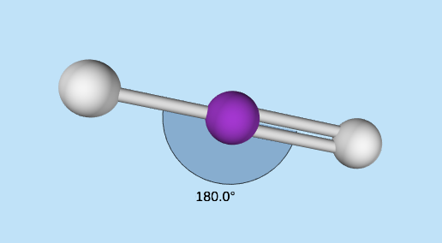
TSW explain how electron clouds that repel each other still attached to an atom.
TSW explain how electrons are used to predict the shape of the molecule.
TSW explain the effect of electronegativity on the shape of a molecule.

1. Open the Molecule Shapes: Basics PhET Simulation.

2. Choose “Model.”

3. Check the box “show bond angles.”

4. Try to move one of the gray atoms.
What do you notice about the bond angle when you try to do this?

5. Try to move the purple center atom.
What do you notice about the bond angle now?

6. Rotate the molecule so that you can see all sides.
Provide a geometric shape that describes this molecule.

7. Add/Remove atoms to create each of the 4 angles below. Be sure to rotate the center atom and observe the molecule from all points of view.
Fill in the chart below to record your observations about each molecule.

Bond  Angle | # of Atoms on the Central Atom | Geometric Shape
180 °
109.5 °
120 °
90 °

8. Create a molecule with 5 atoms on the central atom. Rotate the center atom and observe the molecule.
How is this molecule different from the 4 molecules above?

9. Sketch a model of a carbon atom based on your knowledge from the previous 3 units. Be sure to label the number and location of all 3 subatomic particles (including their charge).

10. Examine your response to #4 above and your model from #9. Imagine 2 carbon atoms were near each other.
Why do you think the atoms of the molecules like to stay in one position?

Please carefully explain your reasoning.

How sure were you of your answer? (circle one)
Basically Guessed Sure Very Sure
1 2 3 4 5 6 7 8 9 10

11. Which subatomic particle determines the behavior of atom- how it bonds, when it bonds, if it bonds, what colors it produces, etc.? Why?

Please carefully explain your reasoning.

How sure were you of your answer? (circle one)
Basically Guessed Sure Very Sure
1 2 3 4 5 6 7 8 9 10

