Exploring Pressure
Objectives
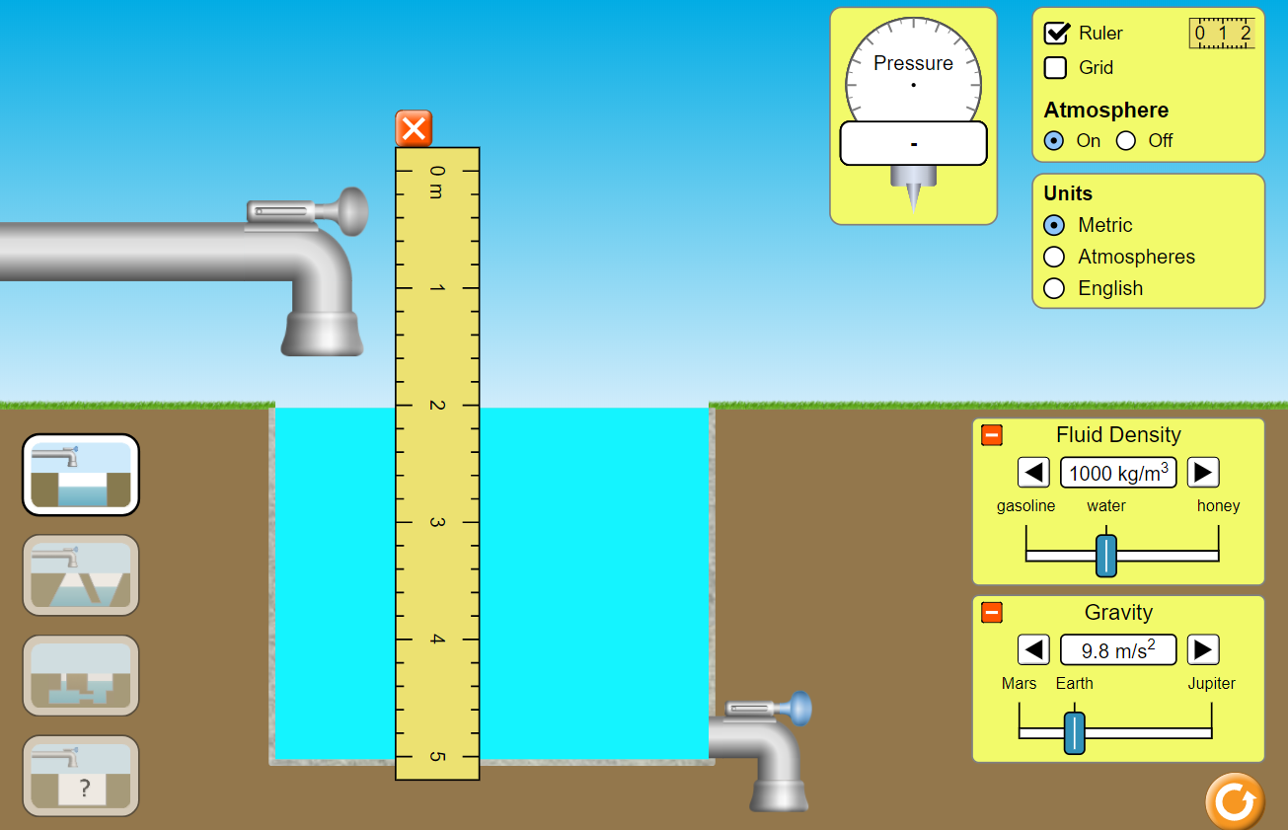
- Determine the relationship between pressure and depth.
- Determine the relationship between pressure and density.
- Determine the density of an unknown fluid.

Directions
- Go to the PhET simulation “Under Pressure” https://phet.colorado.edu/en/simulation/under-pressure
- Push the big Play arrow. Start with the default settings. In addition, fill the tank with water and select “Ruler”, like the diagram to the right.
- Click on the pressure gauge to move it toward the water. Measure the pressure in the water at every 0.50 m from the surface to the bottom. Record your results on the table below. Note that the simulation will give you kPa. Convert to Pa before entering the values on the table.
Depth (m) | Pressure (Pa = N/m²)
0 | 1.02*10⁵ Pa
.5 | 1.06*10⁵ Pa
1 | 1.11*10⁵ Pa
1.5 | 1.16*10⁵ Pa
2 | 1.22*10⁵ Pa
2.5 | 1.26*10⁵ Pa

- Use Excel, or similar, to make a graph of pressure vs depth. Do a linear best fit and include the equation on the graph. Copy and paste your graph and equation below.

  - What is the physical meaning of the slope?
It describes the trend in the pressure change as you go further down in the fluid. Numerically, it is equal to the product of the density ρ and free-fall acceleration g.

  - What is the physical meaning of the y-intercept?
This is the push of the atmosphere on the fluid, called atmospheric pressure. Note that most of the pressure below the surface comes from the atmosphere.

- Now, pick a depth and vary the fluid density from 700 to 1,400 kg/m³. Record your results on the table below. Note that the simulation will give you kPa. Convert to Pa before entering the values on the table.
My chosen depth was: 1m .
Density (kg/m³) | Pressure (Pa = N/m²)
700 | 1.08*10⁵ Pa
800 | 1.09*10⁵ Pa
900 | 1.10*10⁵ Pa
1000 | 1.11*10⁵ Pa
1100 | 1.12*10⁵ Pa
1200 | 1.13*10⁵ Pa

- Use Excel, or similar, to make a graph of pressure vs density. Do a linear best fit and include the equation on the graph. Copy and paste your graph and equation below

  - What is the physical meaning of the slope?
It describes the trend in the pressure change as you test fluids of greater and greater densities. Numerically, it is equal to the product of the depth you chose h and free-fall acceleration g.

  - What is the physical meaning of the y-intercept?
- This is the push of the atmosphere on the fluid, called atmospheric pressure. Note that most of the pressure below the surface comes from the atmosphere.

- How would your two graphs differ if you gathered data from Mars? Jupiter? Explain why. Try to come up with the answer before testing it.

The graphs from Mars or Jupiter would have different slopes than they do on Earth because the free-fall acceleration g is different on each planet. The graphs from Mars or Jupiter would have different y-intercepts than they do on Earth because the atmospheric pressure would be different for each.

- Determine the density of a mystery fluid. If your last name starts with A-H, test Fluid A. If your last name starts with I-N, test Fluid B. If your last name starts with O-Z, test Fluid C. Describe your method and results below.

This is the easiest method, computationally. Turn the atmosphere off. Measure the pressure at a depth of 1.0 m.
p = p₀ + ρgh. Thus, ρ = (p - p₀)/gh. Since you turned off the atmosphere, ρ = p/gh.
Fluid A: ρ_{A} = p/gh = 17,300 Pa/[(9.8 m/s²)(1.0 m)] = 1,800 kg/m³.
Fluid B: ρ_{B} = p/gh = 8,560 Pa/[(9.8 m/s²)(1.0 m)] = 870 kg/m³.
Fluid C: ρ_{C} = p/gh = 11,100 Pa/[(9.8 m/s²)(1.0 m)] = 1,100 kg/m³.

- Based on what you learned in this activity, what is the formula for determining the pressure p in a fluid?

p = p₀ + ρgh where p₀ is the pressure of whatever is pushing down on the fluid (the atmosphere in this activity), ρ is the density of the fluid, g is the free-fall acceleration of the planet, and h is the depth at which you are measuring.

