Name(s): ________________________________ Period:_____________ Date:_____________
Pendulum Lab
Learning Objectives: Students will be able to design experiments to describe how variables (length, mass, angle and gravity field) affect the motion of a pendulum.
Language Objectives:
Understand and correctly use the terms “pendulum” and “period.”
Accurately describe and apply the concepts described in this section using appropriate academic language.

Materials: Computer, internet.
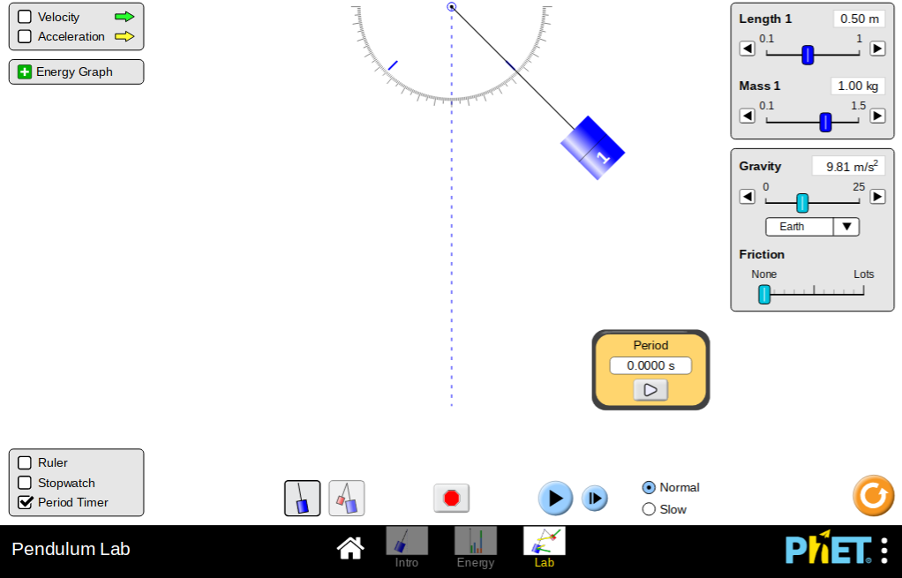

Part 1: Length

Procedure

- Go to https://phet.colorado.edu/en/simulation/pendulum-lab.
- Click on the Pendulum Lab and then select “Lab.”
- Set the string length to 0.5 m, the gravity to Earth (9.81 ㎨), the friction to 0, and the mass of the object to 1 kg.
- Drag the object to 45° and release.
- Click the period timer button in the bottom left corner. Click on the play button and record the period in the data table.
- Reset the system by clicking the stop sign button repeating Step 3.
- Decrease the length of the string by 10 cm (0.1 m).
- Repeat Steps 4 and 5.
- Repeat Steps 6-8 three more times.
- Compare the periods of the object’s motion for each length of string and make a conclusion on the effect of additional string length on the period.

Data:
Length (m) | 0.5 | 0.4 | 0.3 | 0.2 | 0.1
Period (s)

Conclusion:
What can you conclude about the relationship between length and period?

What do you think the period would be of an object in the same scenario but with string length of 60cm?

Part 2: Mass

Now we will see how the mass affects the period.
Procedures:
- Set the string length to 0.5 m, the gravity to Earth (9.81 ㎨), the friction to 0, and the mass of the object to 1 kg.
- Drag the object to 45° and release.
- Click on the play button and record the period in the data table.
- Reset the system by clicking the stop sign button repeating Step 3.
- Decrease the mass of the object by 0.1 kg.
- Repeat Steps 2 and 3.
- Repeat Steps 4-6 three more times.
- Compare the periods of the object’s motion for each mass of object and make a conclusion on the effect of additional mass on the period.
Data:
Mass (kg) | 1 | .9 | .8 | .7 | .6
Period (s)

Conclusion:
What can you say about the relationship between mass and period?

What would the period be of an object with mass 1.1 kg?

Part 3: Gravity

Now we will see how the gravity affects the period.
Procedures:
- Set the string length to 50 cm, the gravity to 10 ㎨, the friction to 0, and the mass of the object to 1 kg.
- Drag the object to 45° and release.
- Click on the play button and record the period in the data table.
- Reset the system by clicking the stop sign button repeating Step 3.
- Decrease the gravity of the object by 1 ㎨.
- Repeat Steps 2 and 3.
- Repeat Steps 4-6 three more times.
- Compare the periods of the object’s motion for each gravitational force and make a conclusion on the effect of gravity on the period.
Data:
Gravity (㎨) | 10 | 9 | 8 | 7 | 6
Period (s)

Conclusion:
What can you say about the relationship between gravity and period?

What would the period be of an object with gravity 11 ㎨?

