Name:
Objective: Explore transverse and longitudinal waves as well as examples of each.
Part 1: exploring amplitude and pulse waves
Simulation: https://phet.colorado.edu/sims/html/wave-on-a-string/latest/wave-on-a-string_en.html
Instructions: Draw a pulse wave at the following amplitudes. Use your ruler to measure the amplitudes.
Drawing in google docs. https://youtu.be/WBy9ne0eHFA
Demonstration: https://www.youtube.com/watch?v=q4hFKNI0k08
Amplitude | Illustration
0cm
.25cm
.50 cm
.75 cm
1 cm
1.25 cm

- Based on your observation, what does pulse mean?

- What type of wave is the string making, Mechanical or electromagnetic? (google it!)

- What type of wave is the string making, longitudinal or transverse? (google it!)

- Based on your observations, what does amplitude mean?

Part 2: Measuring frequency, periods, and wavelength
Instructions: Select ocelate, slow motion, timer, and rulers.
- Set frequency to .5Hz.
- Set the amplitude to 1 cm.
- Pause the simulation when the oscillator at the bottom of it’s cycle.
- Click play on your timer. It should not start yet.
- Click unpause. The waves and the timer will start.
- Click pause when the oscillator is back at the bottom of the cycle. This means you have made one wave.
- Use the ruler to measure wavelengths.
- A period is how long it takes to make one wave. Record your data in the table below.
- Repeat steps 1 - 7 for 1Hz, 2Hz, and 3 Hz.

Demonstration: Measuring the period. https://www.youtube.com/watch?v=QRzSha78gPc
Demonstration: Measuring the Wavelength: https://www.youtube.com/watch?v=P-3PEbpIsww
Frequency | Period | Wavelength
.5
1
2
3

- Based on observations, What is wavelength?

- Based on observations, What is a period?

- Based on observations, what is frequency?

- Based on observations, What is the relationship between frequency in period. (compare and contrast). Give an example to defend your answer.

- Based on observations, what is a question you still have about waves?

Part 3: Exploring Light
Light also travels in waves. When light passes through a prism it bends. Use the prism simulation to explore how light with shorter wavelengths, such as violet, are slowed more than longer wavelengths, such as red, when they pass through a prism.
Simulation: https://phet.colorado.edu/sims/html/color-vision/latest/color-vision_en.html
Instructions: https://www.youtube.com/watch?v=0yzCB0jPc00
- What type of wave is the light, Mechanical or electromagnetic, why? (Google it!)

- What type of wave is the light, longitudinal or transverse, why? (Google it!)

- Use the simulation to bend the light until you see the entire light spectrum. What do you think the wavelengths of lights are from shortest to longest?

- Use evidence from the simulation to defend your answer with a screen shot:

Because different color lights have different wavelengths, we can use filters to absorb them. In this next simulation you will explore different colors of light.
Simulation: https://phet.colorado.edu/en/simulation/bending-light
Instructions: https://www.youtube.com/watch?v=mfHZcHOwrDc

- What do waves have to do with color of light? (Google it!)

- Based on your observations, What happens when you combine all the colors of light?

- What happens when you combine red and green?

- What happens when you combine red and blue?

- What happens when you combine blue and green?

- What is one question that you have about light based on your observation?

Go back to the beginning and select a single bulb and the white light and the particle option. Your simulation should look like this:

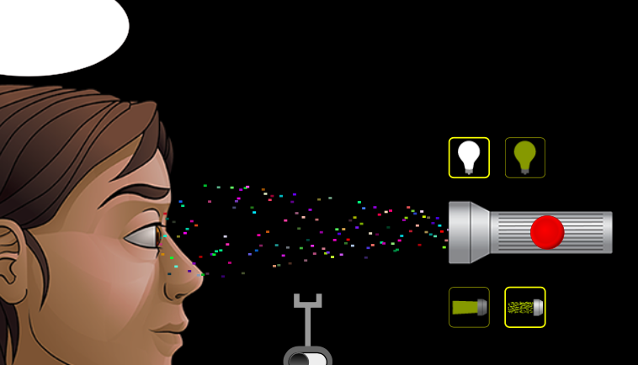

Select three different color filters and describe what happens to the light when it hits the filter in the table below. Use the words absorbed and transmitted in your answer. Now experiment using the lights and the filters. Once you are done experimenting, what happens when you put a red filter on a green light?
Instructions: https://youtu.be/61Rej3cgyQI

Light color | Filter color | Observations.
Example  Red light | 1. Blue. | Blue light waves are filtered out and no light is transmitted through the
 | 2. Red. | The red light is transmitted through the red filter.
1. | 1.
 | 2.
2. | 1.
 | 2.
3. | 1.
 | 2.

Part 4: Longitudinal waves
Simulation. https://phet.colorado.edu/sims/normal-modes/normal-modes_en.html
Instructions: https://youtu.be/n0ho3hADQzM
- What do you observe about longitudinal waves?

- How are Longitudinal waves different from transverse waves?

- What is a common example of longitudinal waves? (Google it!)

Part 5: Exploring Sound
Simulation: https://phet.colorado.edu/en/simulation/legacy/sound
Instructions: https://www.youtube.com/watch?v=eBdEaBNqs8s

- What do waves have to do with sound? (google it!)

- What type of wave is sound, mechanical or electromagnetic, why? (google it!)

- What type of wave is sound, longitudinal or transverse, why? (google it!)

- Use headphones to answer the following question. How does amplitude affect sound?

- Use headphones to answer the following question. How does frequency affect sound?

If you have feedback for improving this doc. Send it to sciencepersonified@gmail.com

