Name: _______________________________________ Date: ________________________ Period: _______

Making STABLE Atoms

This lab will help concretize the makings of a stable atom. If it is unstable, it will be radioactive.

Procedure
1. Go to my website, jonathanjohnsonchemistryandphysics.weebly.com, go to Integrated Chemistry-Physics, Unit 3 Chapter 4 or go to http://tinyurl.com/hk9dlud
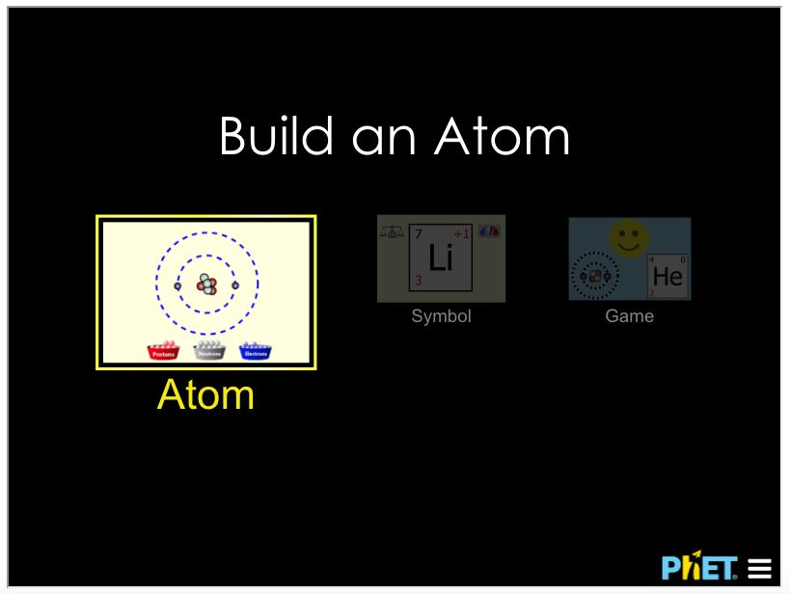
2. Scroll down to the embedded “Build an Atom” phet simulation.

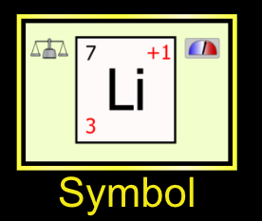
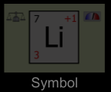
3. Click on the Symbol Button twice.

4. Click the “Stable/Unstable” box.
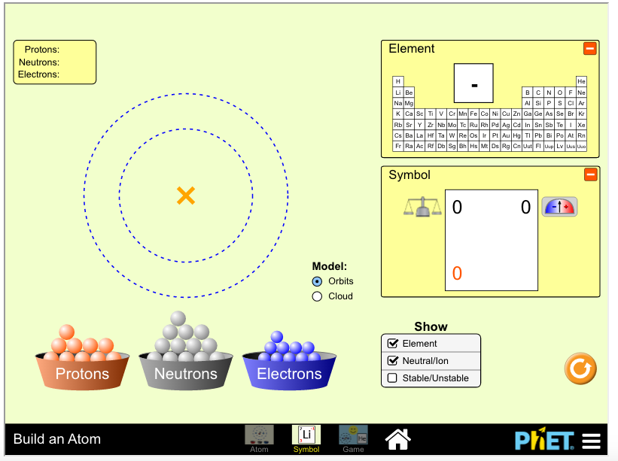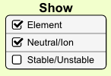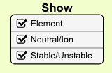

5. Add protons and neutrons to the nucleus and electrons to the circles. Record all STABLE combinations in the table and the appropriate periodic table box. HINT: The number of protons in the nucleus should equal the number of electrons outside the nucleus.
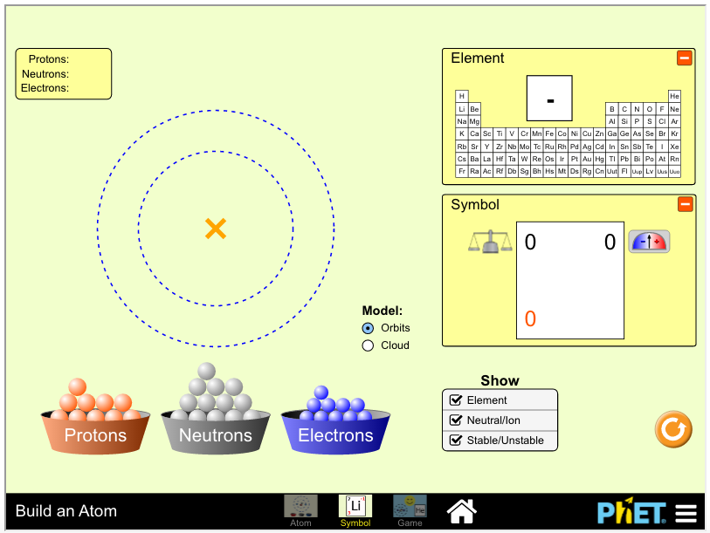
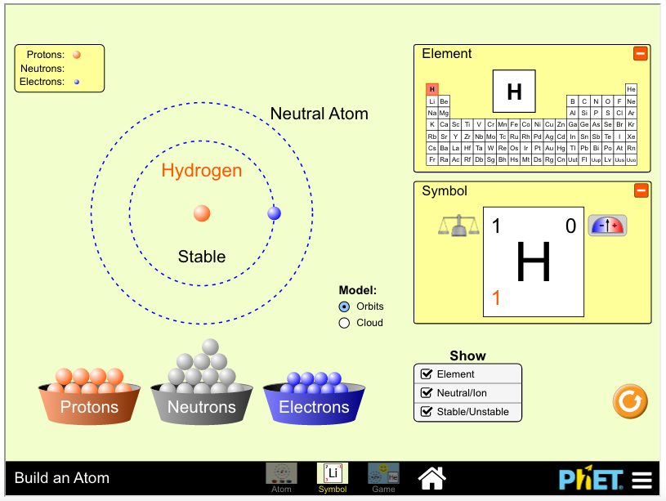

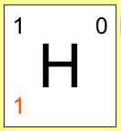

PROTONS | ELECTRONS | NEUTRONS | MASS NUMBER | SYMBOL
1 | 1 | 0 | 1

