Introduction to the PhET Photoelectric Effect Simulation (Playing around with staff).
The simulation can be downloaded from: https://phet.colorado.edu/en/simulation/legacy/photoelectric
- Choose you target metal to be Sodium, then set its Intensity/ Number of photons to 100%. Ensure that the battery voltage is 0.00V. By adjusting the wavelength of the light find the cut-off frequency. [5]

Answer: $f_{0}$ = _____$5.56x{10}^{14}Hz$_____. (you may find this equation useful: $f_{0}=\frac{c}{λ_{0}}$).

- By only changing the target metal, which metal has a cut-off frequency of$1.1364x{10}^{15}Hz$? (you may find this equation useful: $f_{0}=\frac{c}{λ_{0}}$). [5]

Answer: Metal is __Copper____.

- Using copper as your metal surface, what is the current through the circuit for ultra-violet light of wavelength 200nm. [2]

Answer: I = ___1.053A_____.

- a) Using copper as your metal surface, what is the current through the circuit for green light of wavelength 530nm, with only 50% intensity. [2]

Answer: I = ___0.000A_____.

b) What is the current when the intensity is 100%? Why is this the case? (Think about the cut-off frequency ($f_{0}$)). [4]

Answer: I = ___0.000A_____. The reason for this is that the wavelength is higher than the “cut-off wavelength”. OR The frequency is lower than the cut-off frequency of the metal.
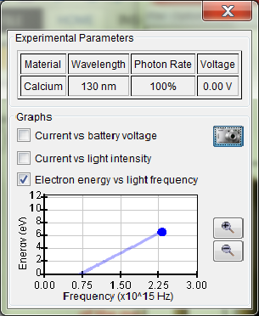
- Using calcium as your target metal, set an ultra-violet wavelength of 130nm. What is the current through the circuit? Plot a graph of “Electron energy vs light frequency” and take a screenshot of it. [3]

Answer: I = 7.500A. +

