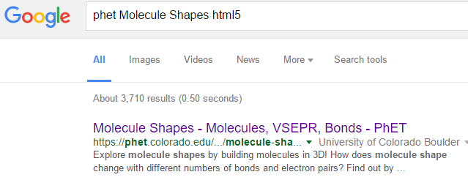
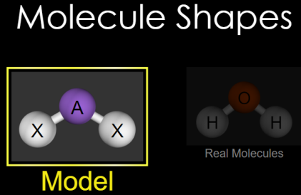
Click to run in
PhET Molecule Shapes html5
CLICK!

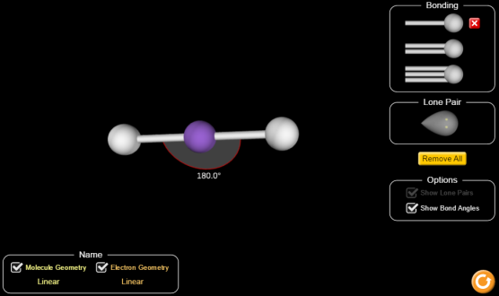
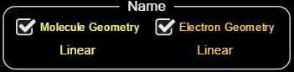
Set-up: Choose “Model”
Check the two “Name” tools and the “Show Bond Angles” box.
Play with the sim adding bonds and lone pairs.
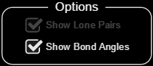

Part 1 Directions: Draw pictures of 4 different molecules you create using bonds and lone pairs. Record geometries and angles, below.
Picture 1 | Picture 2 | Picture 3 | Picture 4
Molecule geometry | Molecule geometry | Molecule geometry | Molecule geometry
Electron geometry | Electron geometry | Electron geometry | Electron geometry
Bond angles | Bond angles | Bond angles | Bond angles
Part 1 Questions:
- How many bonds can you add total? _____________________________
AA31 Labs
- How many lone pairs can you add total? _____________________________
AA31 Labs
- How many bonds and lone pairs can you add total? _____________________________
AA31 Labs
- How can you make the molecule geometry be DIFFERENT than the Molecule geometry?
- Molecules have shape! Drag and rotate them around.
Which molecule geometries are 1D or 2D? (give at least 3!) | Which molecule geometries are 3D? (give at least 3!)  AA31 Labs
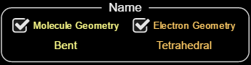
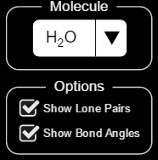
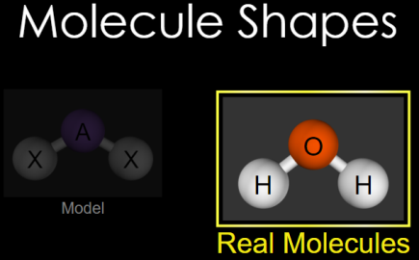
Part 2 Set-up: Click Check boxes:

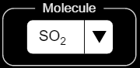

Part 2 Directions: Turn molecules around with mouse. Describe each molecule in the table, below |  |  |  | NH₃
 |  |  |  | CH₄
 |  |  |  | SF₄
 |  |  |  | XeF₄
 |  |  |  | BrF₅
 |  |  |  | PCl₅
 |  |  |  | SF₆

AA31 Labs
Part 2 Questions:
- Can you change the shape of the molecules by twisting them around? Y or N
- What happens to the molecules you dragged and twisted?

- Are the bond angles in part 1 the same as the bond angles in part 2? Why do you think that they are the same/different?

Going Further:
- Why do you think you cannot get more than 6 things around the central atom?

- Organic molecules (like CH₄) have carbon as the central atom. How many bonds can a carbon central atom support?

- Is CH₄ planar (2D)?
- DNA is a large organic molecule that has a shape described as a “double helix” shown in a cartoon, right. Given what you know about the carbon molecule’s geometry (Q6) does this shape make sense? Why or why not?
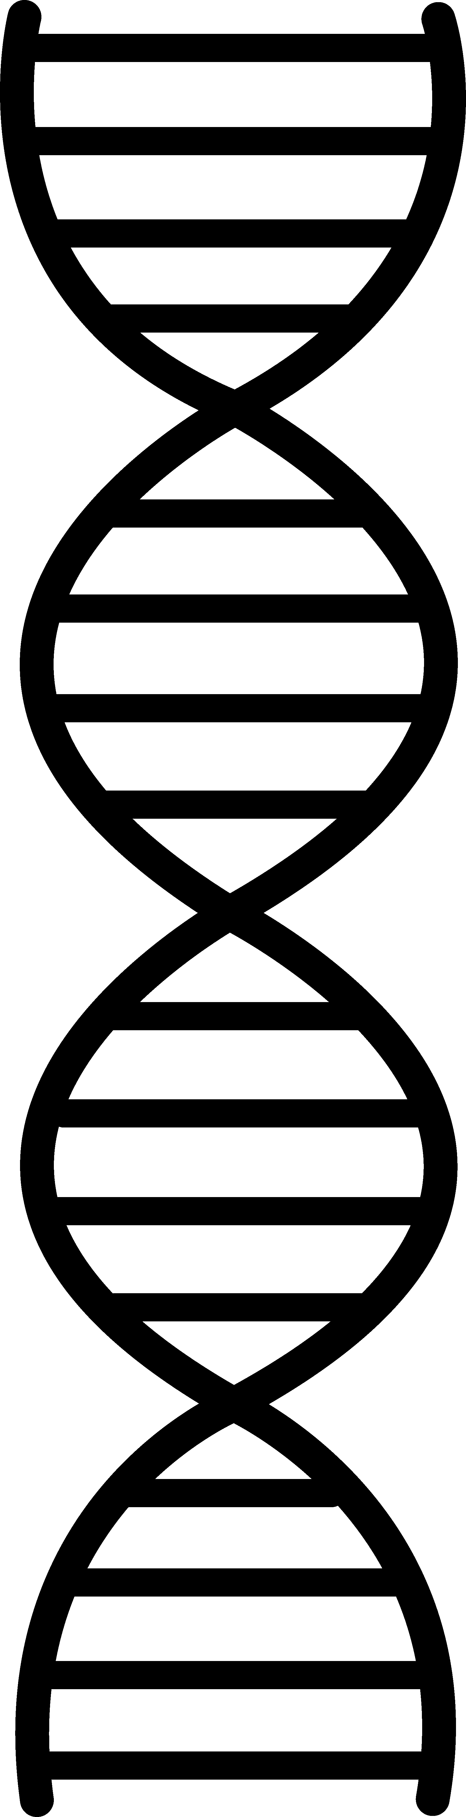
http://www.clipartbest.com/clipart-nTXoXjoEc

Image credit:

AA31 Labs
AA31 Labs

