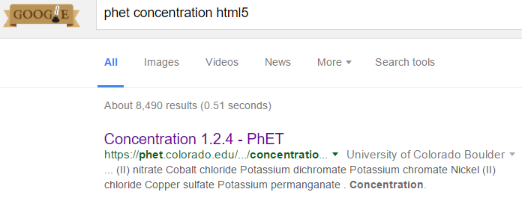
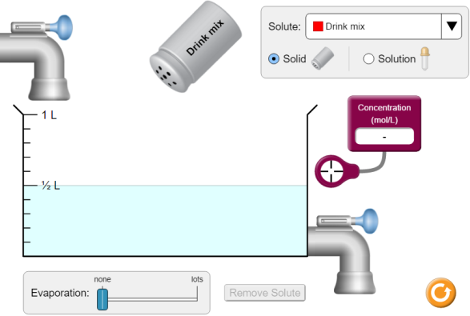
Setting up: The boxes in the picture, right, are pieces that move and affect the concentration and or amount of solution
Move the concentration sensor into the solution (circle, arrow)
PhET Concentration html5
CLICK!
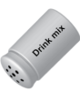
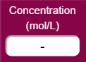
Directions: Add a couple shakes of drink mix to the water then take a couple minutes to see how the moving parts work and affect the Concentration of the solution.
Action | 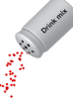  Drink mix is added | 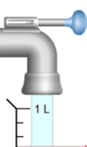  Water is added | 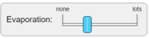  Evaporation occurs | 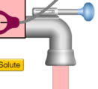  Solution is drained | Solute is removed
What happens to concentration?
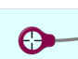
Part 1: Click replace then add a few shakes of drink mix to the solution. Fill in table.
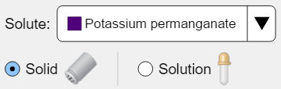
Part 2: Click replace then change drink mix to: and add as much as you can.
- How do you know when a solution is saturated? _____________________________________________________
- When a solution is saturated, and additional solid solute is added, what happens? __________________________
- Why do you think this is? ________________________________________________________________________
- How does adding this additional solute change the concentration of this saturated solution? __________________
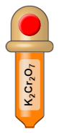
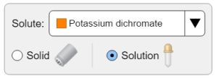
- How does evaporation change the concentration of a saturated solution? _________________________________
Part 3: Click replace and select:

- How can you measure the concentration of the solution inside the dropper? ______________________ ____________________________________________________________________________________ ____________________________________________________________________________________

- How might you get that concentrated solution to become saturated? ____________________________
____________________________________________________________________________________
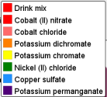
- Does it work? ____________________________________________________
- Do you think it would work for other solutions? Yes or No Why or why not?
AA31 Labs

- Are the concentrations of all of the solutions the same? __________________
AA31 Labs

Post-lab Questions:
- Based on your observations using this simulation, what would your definition of “saturated” be?

- Based on your observations using this simulation, what would your definition of “solute” be?

- Based on your observations using this simulation, what would your definition of “evaporation” be?

- Based on your observations using this simulation, what would your definition of “concentrated” be?

- Adding pure water to a saturated solution (with no solids) would cause the concentration of that solution to increase / decrease / remain the same. (circle)

- Adding pure water to a saturated solution (with some solids) would cause the concentration of that solution to initially increase / decrease / remain the same. (circle)

- Adding a solid salt to a saturated solution causes the concentration of that solution to increase / decrease / remain the same.

- Evaporation acting on an unsaturated solution causes the solution’s concentration to increase / decrease / remain the same.

- Evaporation acting on a saturated solution causes the solution’s concentration to increase / decrease / remain the same.

- Why do you think the concentrations of the concentrated solutions were NOT all the same?

- Based on your experience with this simulation, what do you think your teacher wanted you to learn?

AA31 Labs

