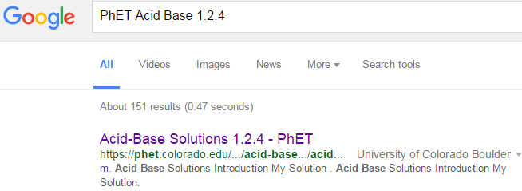
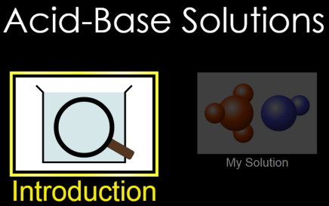
PhET Acid Base html5
CLICK!

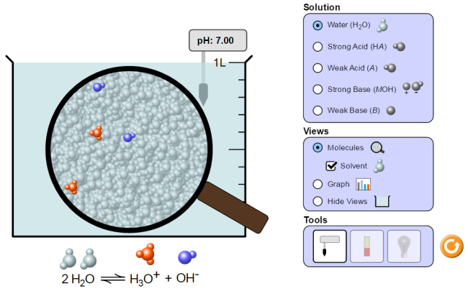
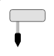
Part 1 Directions: Choose “Introduction”
Drag the pH meter in the solution.
Click “solvent” 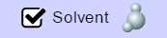.

1. Circle the species that has the most copies in the magnifying glass.

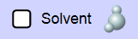
2. Uncheck the solvent box. Fill in the magnefying glasses, reaction equations and pH’s, ions for each box with the given radio buttons clicked:
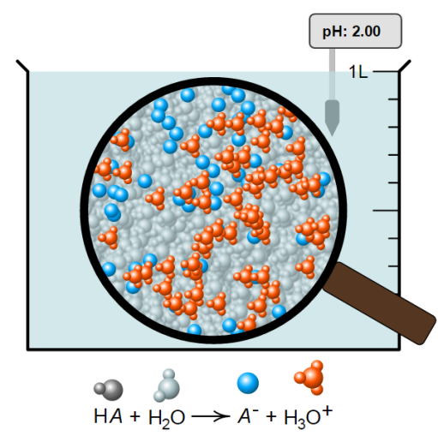  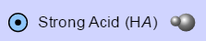  Draw most abundant species:  pH:  Reaction Equation here: | 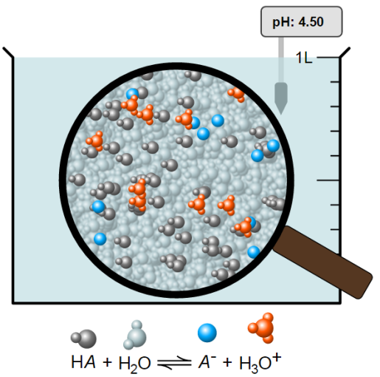  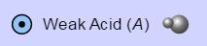  Draw most abundant species:  pH:  Reaction Equation here:
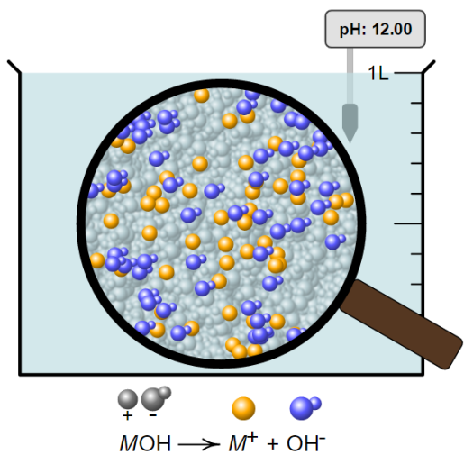  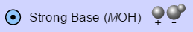  Draw most abundant species:  Draw most abundant species:  pH:  Reaction Equation here: | 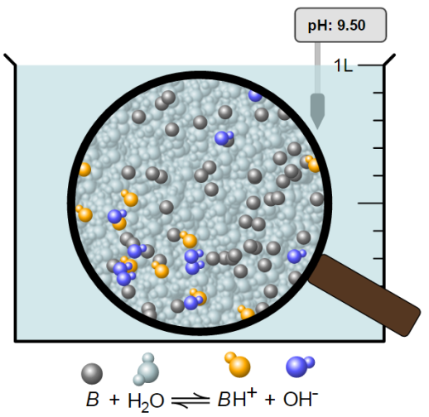  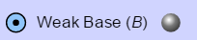  Reaction Equation here:  pH:

AA31 Labs
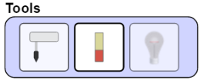
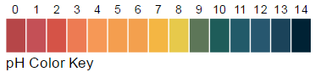
Put the litmus paper in solution: What is the color key for litmus? (fill in last 2 boxes)
Yellow to blue-green

Orange to yellow
Use the litmus to put water, strong acid, weak acid, strong base and weak base in the appropriate boxes, below: For example, Dove soap is a weak acid (pH6) and Ivory soap is a weak base (pH10).
Ivory
Dove

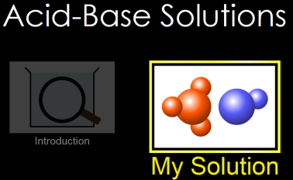
Part 2 – Select “My Solution”
Concentration | pH meter
0.001
0.01
0.1
1.0
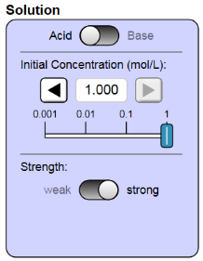
Set solution to a strong acid. Put the pH meter in the solution. Move the slider to each concentration in the table. Record the pH in the table.

Concentration | pH meter
0.001
0.01
0.1
1.0

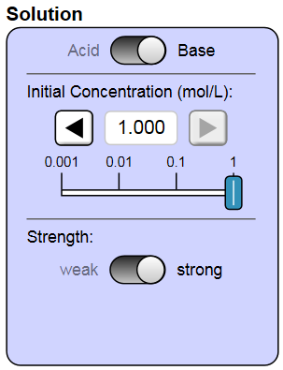
Set solution to a strong base. Put the pH meter in the solution. Move the slider to each concentration in the table. Record the pH in the table.

Describe in one or two sentences what happens to the pH meter readings as concentration changes tenfold (like in the left-hand columns, above):
AA31 Labs
PhET Acid Base 1.2.4
CLICK!

Part 1 Directions: Choose “Introduction”
Drag the pH meter in the solution.
Click “solvent” .

1. Circle the species that has the most copies in the magnifying glass.
2. Fill in the magnefying glasses, reaction equations and pH’s, ions for each box with the given radio buttons clicked:
Reaction Equation:  Draw most abundant species:  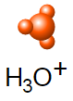 | Reaction Equation:  Draw most abundant species:
Reaction Equation:
Reaction Equation:
Draw most abundant species:
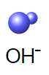
Draw most abundant species:

AA31 Labs
Select the litmus paper tool: What is the color key for litmus? (fill in last 2 boxes)
blue-green to deep blue

Yellow to blue-green

Orange to yellow
Red to orange
Put: water, strong acid, weak acid, strong base and weak base in the appropriate boxes, below: For example, Dove soap is a weak acid (pH6) and Ivory soap is a weak base (pH10).
Weak
base
Strong
base
Weak
acid
Strong
acid

Ivory
Dove
Part 2 – Select “My Solution”
Concentration | pH meter
0.001 | 3
0.01 | 2
0.1 | 1
1.0 | 0
Set solution to a strong acid. Put the pH meter in the solution. Move the slider to each concentration in the table. Record the pH in the table.

Concentration | pH meter
0.001 | 11
0.01 | 12
0.1 | 13
1.0 | 14

Set solution to a strong base. Put the pH meter in the solution. Move the slider to each concentration in the table. Record the pH in the table.

Describe in one or two sentences what happens to the pH meter readings as concentration changes tenfold: The value changes by 1.
AA31 Labs

