Name ________________________________________________ Period ___________ Date ________
pHET Lab: Acid/Base Solutions
Solutions | View  (draw ions) | Equation | Color of pH paper | pH | Strength of Conductivity
Water
Strong acid
Weak acid
Strong base
Weak base

Discussion Questions:
- Which ions are most abundant in an acid? ______________________________

- Which ions are most abundant in a base? ______________________________

- Which ions are most abundant in water? ______________________________

- How does the concentration of ions in a strong acid differ from a weak acid?

- How does the concentration of ions in a strong base differ from a weak base?

- Explain to someone in 3-4 steps how to use pH paper to determine the pH of a substance:

Step 1 –
Step 2-
Step 3-

Custom Solution
- Set Strength to a strong acid. Adjust the concentrations and record the pH of the solutions.
Concentration | pH meter
0.001
0.01
0.1
1

- Set Strength to a strong base. Adjust the concentrations and record the pH of the solutions.
Concentration | pH meter
0.001
0.01
0.1
1

- As concentration increases by a tenth, what happens to the pH?

- As concentration increases, what happens to the number of ions in the solution?

Name: ___________________________ Period _______________
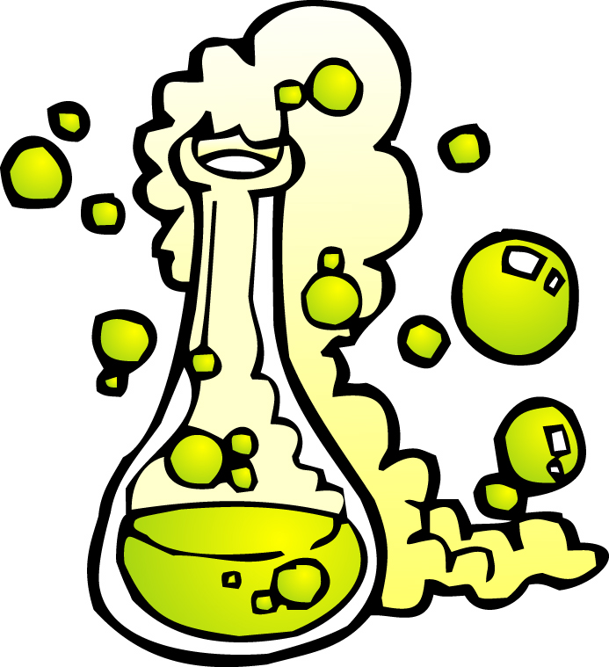
Acid/Base – 3, 2, 1 Exit Ticket
3 | Describe the activity! Give a brief description of the activity that you completed
2 | Things I found interesting when I was playing the game…
1 | Question I have….
What do you think we should do next?

