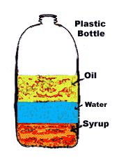
Density Colorado Phet website
Fill in the blanks and answer the questions as you watch the demonstration;
Define density: ____________________________________________________________
Draw a picture of a comparison of 2 objects, one with high density and one with low density:
High density Low density

*What is the formula to figure the density of an object?

Same Mass
Describe the size of the 4 blocks when testing The Same Mass ________________________________________
Draw and explain what happens to each block when put in the water:
Block 1 Block 2 Block 3 Block 4

Explanation of what happens when put in water: _______________________________________________________
_______________________________________________________________________________________________

Same Volume
Describe the size of the 4 blocks when testing The Same Volume ________________________________________
Draw and explain what happens to each block when put in the water:
Block 1 Block 2 Block 3 Block 4

Explanation of what happens when put in water: _______________________________________________________
_______________________________________________________________________________________________

Same Density
Describe the size of the 4 blocks when testing The Same Density ________________________________________
Draw and explain what happens to each block when put in the water:
Block 1 Block 2 Block 3 Block 4

Explanation of what happens when put in water: _______________________________________________________
_______________________________________________________________________________________________

Mystery
Begin by predicting what will happen with each box, A,B,C,D,E (SINK OR FLOAT)
A_______________________ B________________________
C_______________________ D________________________
E_______________________

What can you now say about the boxes that sank vs. the boxes that floated?
__________________________________________________________________________
__________________________________________________________________________
__________________________________________________________________________

