Measuring waves
- Type into your browser https://phet.colorado.edu/en/simulation/wave-on-a-string or Google “Phet Wave on a string “ and you should follow the links until you get to a page that looks like this:

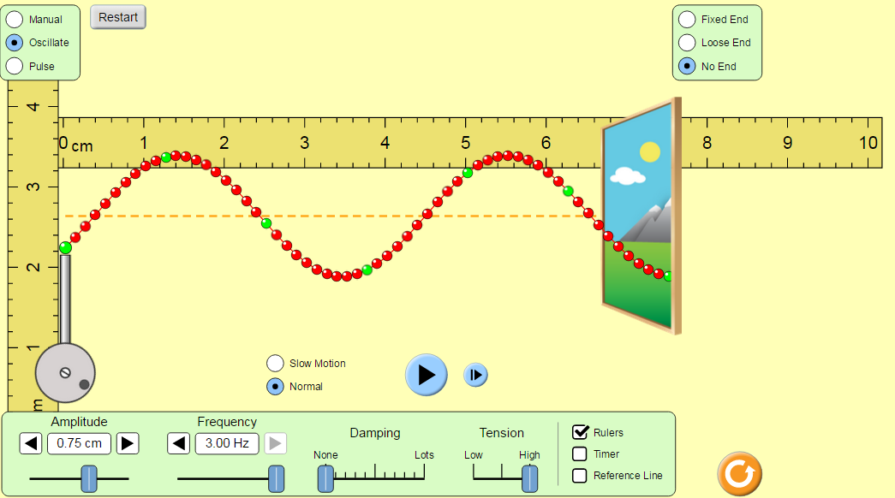
- Set
Left hand side: “Oscillate”
Right hand side: “No end”
Frequency= 1.5 Hz
Damping = 0
Tension = high
- Measure the wavelength of the wave and record it in the table.
- Change the frequency and measure the wavelength again. Record your results in this table:
Amplitude | Frequency (Hz) | Wavelength (m)
25 | 1
50 | 1
75 | 1
100 | 1
- What happens to the wavelength when keep the frequency the same and change the amplitude?
- Set Amplitude to 100, dampening to 0, damping to 0 and tension to “high”
- Pause the animation and use the ruler to measure the wavelength at 0.5 Hz.
- Record the result in the table and repeat step 3-4 until you have completed all of your readings.
Frequency (Hz or 1/s) | Wavelength (cm) | Wavelength (m) | Wave speed (m/s)
0.5
1.0
2.0
2.5
3.0
- Input the data to Microsoft Excel and plot a graph of the wavelength (m) vs frequency (Hz)
- Describe and explain the trend in the graph.
Measuring waves
- Type into your browser https://phet.colorado.edu/en/simulation/wave-on-a-string or Google “Phet Wave on a string “ and you should follow the links until you get to a page that looks like this:

- Set
Left hand side: “Oscillate”
Right hand side: “No end”
Frequency= 1.5 Hz
Damping = 0
Tension = high
- Measure the wavelength of the wave and record it in the table.
- Change the frequency and measure the wavelength again. Record your results in this table:
Amplitude | Frequency (Hz) | Wavelength (m)
25 | 1
50 | 1
75 | 1
100 | 1
- What happens to the wavelength when keep the frequency the same and change the amplitude?
- Set Amplitude to 100, dampening to 0, damping to 0 and tension to “high”
- Pause the animation and use the ruler to measure the wavelength at 0.5 Hz.
- Record the result in the table and repeat step 3-4 until you have completed all of your readings.
Frequency (Hz or 1/s) | Wavelength (cm) | Wavelength (m) | Wave speed (m/s)
0.5
1.0
2.0
2.5
3.0
- Input the data to Microsoft Excel and plot a graph of the wavelength (m) vs frequency (Hz)
- Describe and explain the trend in the graph.

