Gravity Force Lab Basics Remote Lab
(This‌ ‌lesson‌ is designed ‌for‌ ‌a‌ ‌student‌ ‌working‌ remotely‌.)‌

This lab uses the Gravity Force Lab Basics simulation from PhET Interactive Simulations at University of Colorado Boulder, under the CC-BY 4.0 license.
https://phet.colorado.edu/sims/html/gravity-force-lab-basics/latest/gravity-force-lab-basics_en.html

Learning Goal: Students will investigate the variables that affect gravity.

QUESTION: How does gravity affect objects?

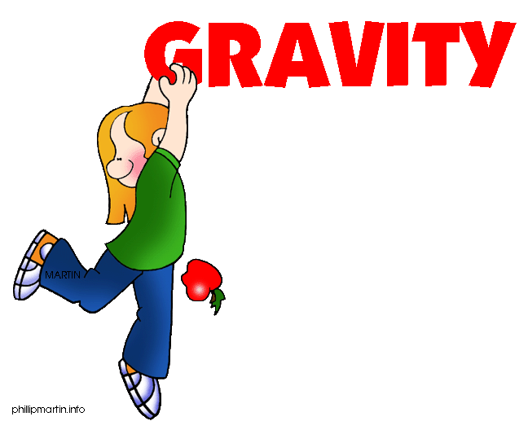

Jasmine and Emily were learning about forces in class. They learned that a force was either a push or a pull. Emily wondered if gravity was a force. She knew that when she dropped her book it was pulled down to the ground. Jasmine knew that the moon had less gravity than the earth, but she wasn’t sure why.

Underline the statements you think are true:

- Gravity depends on the material of the objects.
- Gravity is not a force because it can’t move objects.
- Gravity is a force because a force is a push or a pull.
- The moon has less gravity than the Earth because it has less mass than the Earth.
- The moon has less gravity than the Earth because it has no atmosphere.

Background information:

Variable-A variable is any factor that can be changed or controlled

Independent Variable – something that is changed by the scientist
- What is tested
- What is manipulated

Dependent Variable – something that might be affected by the change in the independent variable
- What is observed
- What is measured
- The data collected during the investigation

INSTRUCTIONS: Open up the Gravity Force Lab Basics simulation on the PhET website.
https://phet.colorado.edu/sims/html/gravity-force-lab-basics/latest/gravity-force-lab-basics_en.html

- Get familiar with the simulation by moving the figures back and forth as well as changing the mass of the spheres.

- Underline the different variables that can be found in this simulation.

Distance between figures Mass of the spheres
Force Size of the figures
Strength of the figures Size of spheres

- What do you think the size of the arrows on top of each sphere represent?

- Pick a variable to manipulate (the independent variable). Summarize what you changed and what happened in the table below:

Manipulated (Independent) Variable | Dependent Variable

- Change a different variable and summarize what happens in the table below:

Manipulated (Independent) Variable | Dependent Variable

Test your understanding:
True or False State the correct answer and provide your reasoning

6. Gravity is a force that can be changed. T/F

7. The bigger an object is, the smaller the force of gravity. T/F

8. As one object gets closer to another object, the force of gravity will increase. T/F

9. The Sun has a greater gravitational force than Jupiter. T/F

- Which of the pairs has greater gravitational force?

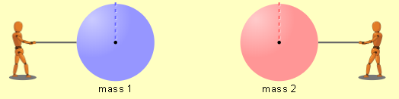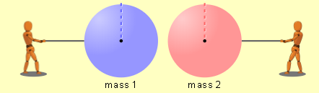

Explain why you chose the diagram you did.

11. Which of the pairs has greater gravitational force?
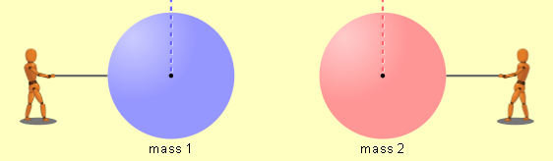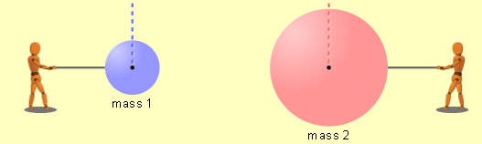

Explain why you chose the diagram you did.

12. Why do you think Saturn and Jupiter have more moons than the other planets in our solar system?

Summarize your understanding

13. Can gravity be considered a force?
CLAIM:

EVIDENCE:

SCIENTIFIC REASONING:

14. What variables affect gravity?
CLAIM:

EVIDENCE:

SCIENTIFIC REASONING:

