Title: Concentration

Introductions
In this activity you will explore how solutions change as chemicals mix with water. You will investigate the ways that you can change the concentration of a solution.

1. Click this link: https://phet.colorado.edu/en/simulation/concentration

This is a screen shot of the Concentration simulation:

2. Click the “Run Now!” button.

3. It will take time to load and then this screen appears:
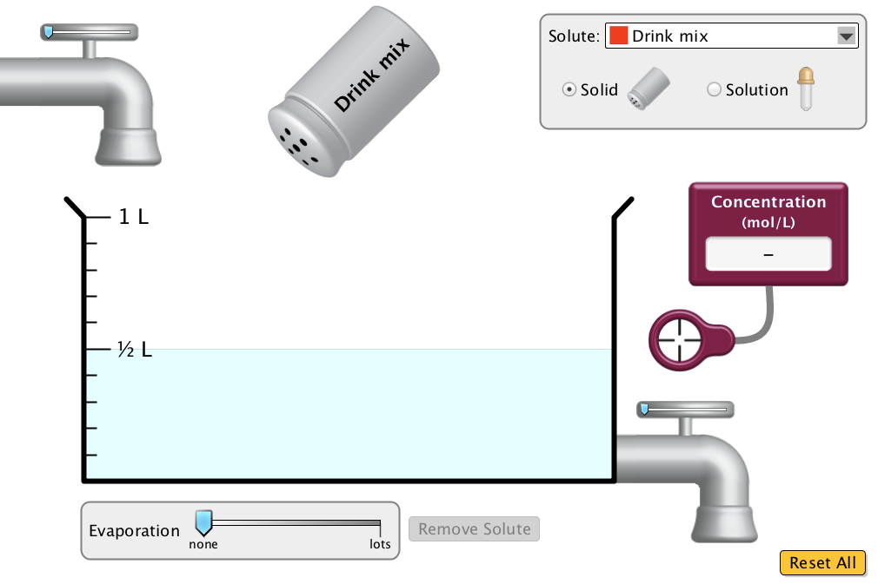

In order to complete the activity, switch back from this document to the simulation.

Exploration Phase

1. Use this time to freely explore the sim.

Here are some useful definitions to get you started:
A solute is the substance that is dissolved.
A solution is the substance that does the dissolving.
Concentration is a measure of the number of particles of the solute in the solution.

2. Add different amounts of the solute “drink mix” to the beaker. There are two ways to add a solute. You can shake in solid from the shaker, which comes out in small grains, or you can add a concentrated solution using the dropper. You may switch between the “solid” shaker or “solution” dropper.

3. Measure the concentration by sliding the purple meter tool into the solution.

4. Observe what happens to the concentration when water is added or taken out of the tank. This is done by sliding the blue knob on the top or bottom faucet.

5. Explore the above options but change the type of solute.

Questions

- What are the visual changes to the solution in the beaker when a solute is added?

- What happens to the concentration when solid drink mix is added?

- What happens to the concentration when water is added and taken away from the beaker?

Explanation Phase

Aim: Create a rule that describes the effect of solutes on solutions.

Which actions will increase the concentration of a solution?

Click on the yellow “Reset All” tab. Your solute should be drink mix. Drag the meter into the beaker. Your screen will look like this:
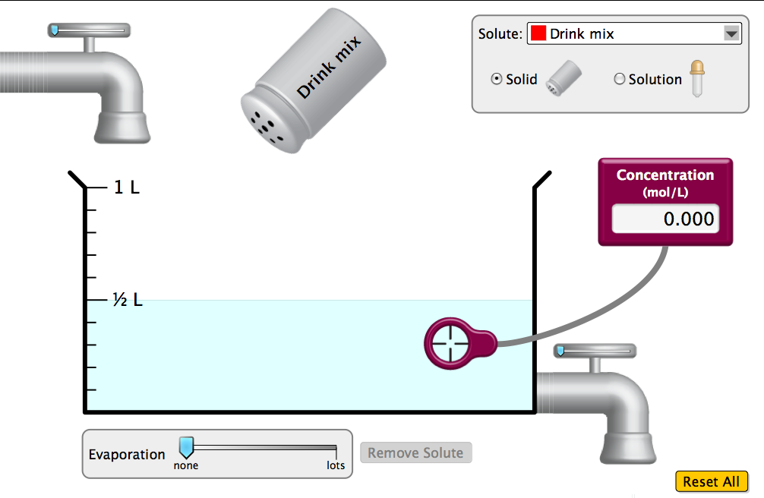

You will be adding a solution in solid form from the shaker.
One proper shake=moving the shaker one time to the left, and one time to the right. This will ensure that each addition is equal.

Add 10 shakes of drink mix. Record the concentration: __________________

Use the faucet to fill the beaker up to 1L. Record the concentration: _____________

Drain the solution so it is back to ½ L. Record the concentration: _______________

Come up with a rule for the effect of a solute on concentration.

Write here:

Use your rule to answer the following question: If 10 shakes of drink mix is added to 1 L of water, what will happen to the concentration when the solution is drained?

Check your answer by performing the task in the sim.

Application Phase

Now you will add different types of solutes to the beaker.
Record your data from the explanation phase in the table below.
Be sure to press “reset all” when adding a different solute.

 | Concentration after 10 shakes in ½ L water | Concentration after beaker filled to 1L water | Concentration after beaker drained to ½ L water
Drink Mix
Potassium Chromate
Cobalt Chloride

Conclusions: Compare the data for the different types of solute:

Which solute has the highest concentration?

Which solute has the lowest concentration?

Does your rule hold true for each type of solute?

Add 10 shakes of each solute to1/2 L water separately.

Rank from lowest to highest concentration:
1.
2.
3.
4.
5.
6.
7.
8.

Note any interesting observations about the deepness of the color of the solution to concentration levels in the beaker after each solute was added:

