Energy Skate Park: Basics Virtual Lab
By: Sophie Lanchez
Introduction:

- In this virtual lab, you will investigate thermal, potential, kinetic, and total energy through a simulation called Energy Skate Park: Basics. While using the simulation, you will observe the relationship between the different types of energy as a skateboarder rides on a half-pipe, curved ramp, and other types of ramps.

After clicking the link, please click Run-Now or Download.
Website link: http://phet.colorado.edu/en/simulation/energy-skate-park-basics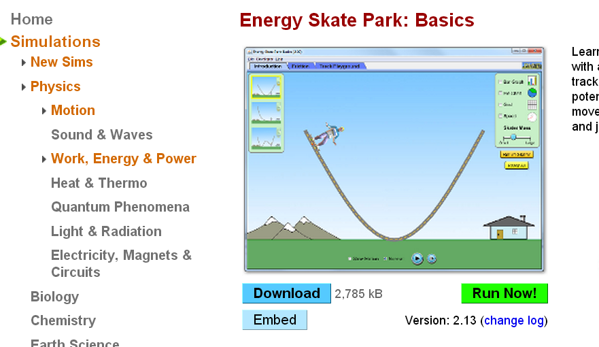

- Each Lab can be completed on different days. Day 1 is Lab 1, and lab 2 is on day 2.
- Lab 1: Predict, Explore, and Explain when investigating the different types of energies in an environment without friction.

- Lab 2: Predict, Explore, and Explain when investigating the different types of energies in an environment with friction.

Lab 1: A Skate Park without Friction
Click the Introduction Tab in the simulation. In this skateboarding park, there is no friction. In this lab, we are going to investigate potential, kinetic, and total energy. Potential Energy is stored energy

Explore Phase:

Questions:
1) Where would the Potential Energy level of the skateboarder be the most on the half-pipe, the ramp, and the wavy ramp? Why?

2) Where would the Kinetic Energy level of the skateboarder be the most on the half-pipe, the ramp, and the wavy ramp? Why?

3) What will the total energy level be on the half-pipe, the ramp, and the wavy ramp?

Directions:
- On the top right corner there is a green box with different types of data and tools. Click and make sure there is a check next to the speed meter and the pie graph.

- Click the slow-motion option at the bottom to make it easier to see the change in the speed meter and the pie graph.

- Click and drag the skater to the top of the ramp’s left side. Release the skateboarder.

Half-Pipe:
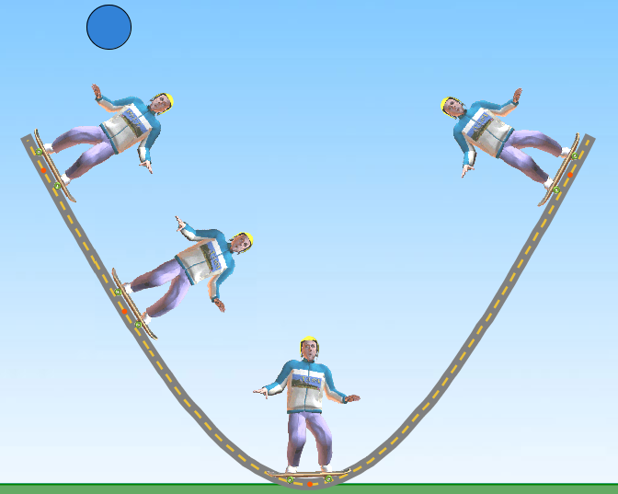
First observe the changes of energy with the pie chart. After observing with the pie chart, observe the changes of energy on the bar graph (make sure there is a check).
C
B
D
A

In the table below, write down whether the quantity of potential, kinetic, and total energy increases, decreases, or stays the same.

Position | Potential Energy | Kinetic Energy | Total Energy
A
B
C
D
Curved Ramp:
First observe the changes of energy with the pie chart. After observing with the pie chart, observe the changes of energy on the bar graph (make sure there is a check).
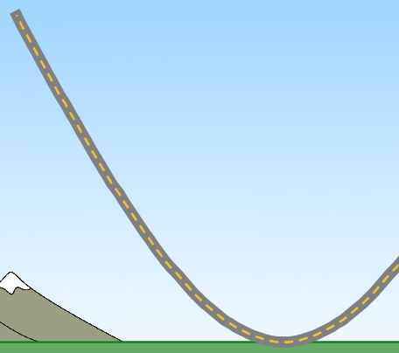

v

A
B
C
D
E
In the table below, write down whether the quantity of potential, kinetic, and total energy increases, decreases, or stays the same.

Position | Potential Energy | Kinetic Energy | Total Energy
A
B
C
D
E

Wavy Ramp:
First observe the changes of energy with the pie chart. After observing with the pie chart, observe the changes of energy on the bar graph (make sure there is a check).
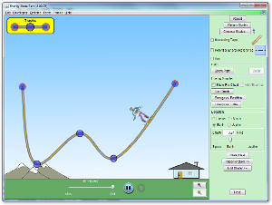
E
D
C
B
A
In the table below, write down whether the quantity of potential, kinetic, and total energy increases, decreases, or stays the same.

Position | Potential Energy | Kinetic Energy | Total Energy
A
B
C
D
E

Explain:
As the speed increases, how does the potential, kinetic, and total energy levels change?

Compare and contrast the energy levels on the half-pipe, the curved ramp, and the wavy ramp. What were the similarities or differences between the potential, kinetic and the total energies on these three ramps?

Application:
Using your knowledge of potential, kinetic and total energy, create your own ramp. After testing your ramp draw a line graph showing how potential, kinetic, and total energy increases, decreases or remains the same as the skateboard goes down your ramp.

Lab 2: A Skate Park with Friction
On the top of the simulation, click on the tab that says Friction. Investigate the different types of energies when friction is present.

Explore Phase:
For this investigation, you will be observing the effects of friction and will gradually increase the amount of friction. Click “On” below Friction to activate friction to the ramp, and make sure the friction level is set to low. Drag the bar to the right to increase the amount of friction.
1) How will friction affect thermal, potential, kinetic, and total energy?

2) Will the energy levels for potential, kinetic, and total energy be similar for the half-pipe, curved ramp, and wavy ramp? Why would the energy levels be similar or different?

Half-Pipe:
First observe the changes of energy with the pie chart. After observing with the pie chart, observe the changes of energy on the bar graph (make sure there is a check).
C
B
D
A

In the table below, write down whether the quantity of potential, kinetic, thermal, and total energy increases, decreases, or stays the same.

Position | Thermal Energy | Potential Energy | Kinetic Energy | Total Energy
A
B
C
D
E

Curved Ramp:
First observe the changes of energy with the pie chart. After observing with the pie chart, observe the changes of energy on the bar graph (make sure there is a check).

v

A
B
C
D
E
In the table below, write down whether the quantity of potential, kinetic, thermal, and total energy increases, decreases, or stays the same.

Position | Thermal Energy | Potential Energy | Kinetic Energy | Total Energy
A
B
C
D
E

Wavy Ramp:
First observe the changes of energy with the pie chart. After observing with the pie chart, observe the changes of energy on the bar graph (make sure there is a check).
E
D
C
B
A
In the table below, write down whether the quantity of potential, kinetic, thermal, and total energy increases, decreases, or stays the same.

Position | Thermal Energy | Potential Energy | Kinetic Energy | Total Energy
A
B
C
D
E

Explain:
What is the relationship between friction and thermal energy?

When you increase the amount of friction, how does this affect potential, kinetic, and total energy?

Compare and contrast the affects of low, medium, and high friction on the half-pipe, the curved ramp, and the wavy ramp.

Conclusion:
- If you were holding a basketball, describe what the energy levels would be for potential, kinetic, and total energy.

- When you drop the basketball, what would the energy levels be for potential, kinetic and total energy?

- If you were to ride a bicycle on a rocky pathway, how much friction would there be and what would be the thermal and friction energy level?

