Title: Building Fractions

Introductions
In this activity you will investigate how to build,and represent fractions from a given whole.

1. Click this link: http://phet.colorado.edu/
This is a screenshot of the website:

2. Click the “Play with sims” button.
3. Click “New Sims” -> Click “Fractions Intro”->Click “Run Now!
4. It will take time to load and then this screen appears: 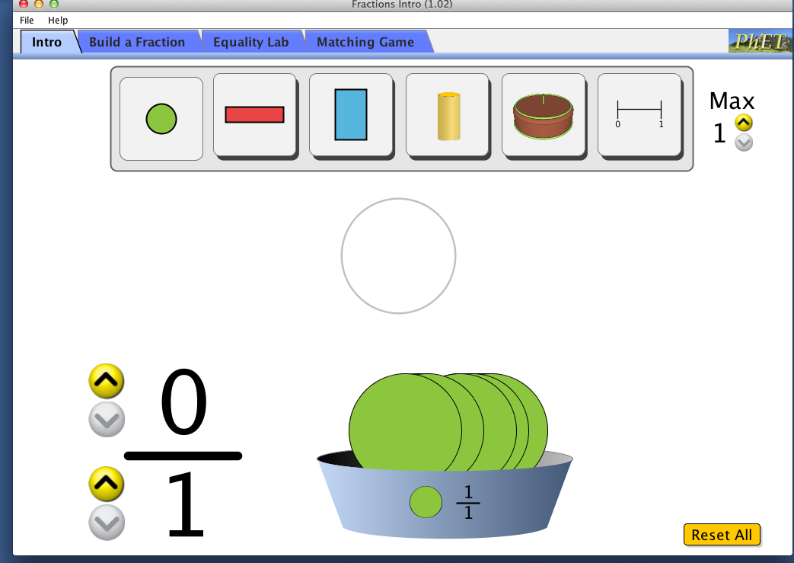

Switch between this document and the sim to complete the activity.

Exploration Phase

1. Click the “Intro” tab on the sim

2. Use the arrows to increase both the number of parts and the number of wholes.

3. Freely explore using the different objects at the top as various wholes. You can also increase and decrease the amount of whole objects by clicking the arrows in the top right corner where it says “Max”.

4. Take note of the size of pieces, and how the fractions are written as you explore.

Questions

1. What happens when the number on top is smaller than the number on the bottom? What does it look like?

2. What happens when the numbers on top and the bottom are the same? What does it look like?

3. What do you think the number on top represents? What does the number on the bottom represent?

Explanation Phase

Aim: Create a definition for a fraction that describes what the number on top of the fraction represents and the number on the bottom represents using the words parts and wholes.
Describe the rule here (and have it checked by the instructor):

Click on the “Build a Fraction” tab and make the screen look like this:

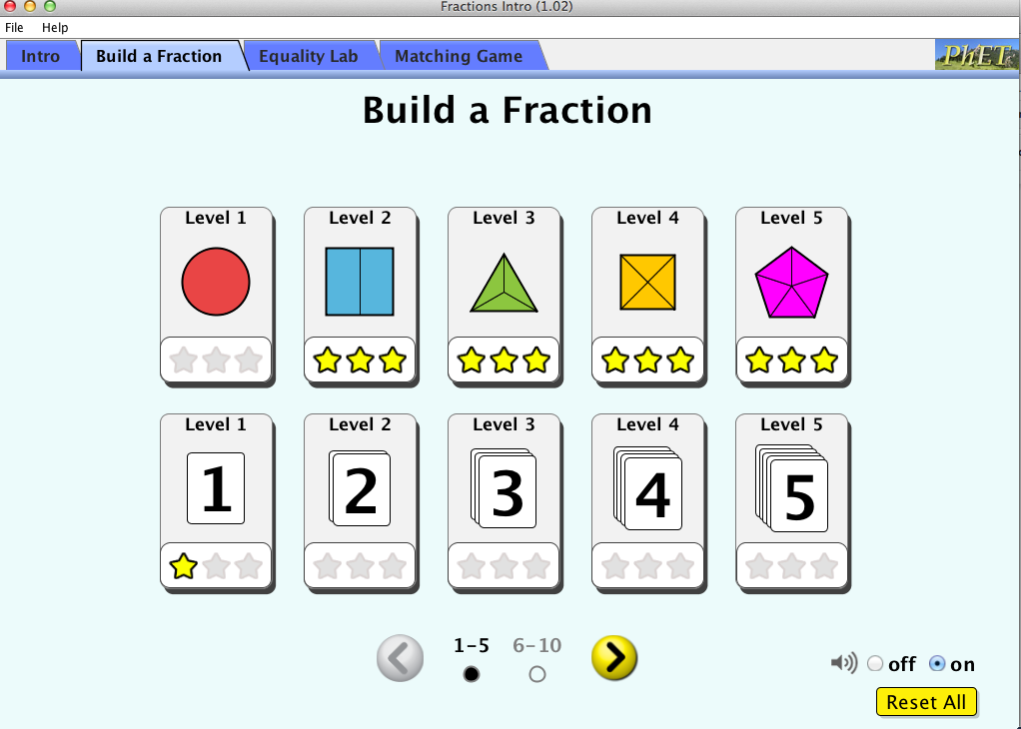

Click on the “Level 1” icon with the red circle. Use the arrow to increase the number of parts inside the whole. Drag the pieces from the bottom to the whole, then drag it to the fractions on the side.

Here are some concepts:

The number on top of a fraction is called a numerator.
The number on the bottom of the fraction is called a denominator.

Use the sim to build each fraction and fill in the blanks of the following tables. Only do the levels that correspond with the tables.

Level 1:
Fraction | Numerator (number on top) | Denominator (number on the bottom) | Draw what it looks like from the Sim
1
1
2
3
1
2

Level 2:
Fraction | Numerator (number on top) | Denominator (number on the bottom) | Draw what it looks like from the Sim
1
4
4
5
2
4

Level 3:

Fraction | Numerator (number on top) | Denominator (number on the bottom) | Draw what it looks like from the Sim
3
4
2
3
1
5

Come up with some rules using the words parts and wholes:
- What does the numerator represent?
- What does the denominator represent?
- Define the word “fraction”.

Write your rules here:

Click back to the intro tab and click Reset All

Use your rule to write a fraction based on these pictures. Write your answers next to each picture.

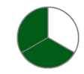 _________ _______________

__________ 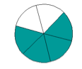____________

Check your answer by building the fraction in the intro tab.

Application Phase
Click back to the “Build a Fraction” Tab at the top and click on Level 5 as seen in the picture below.

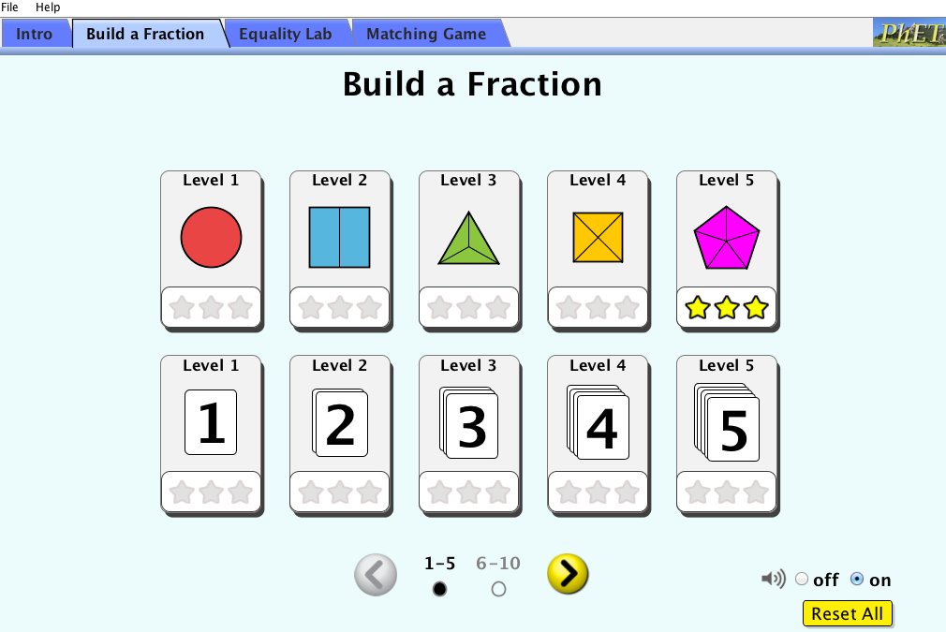

Complete levels 5 and 6 using the chart below.

Level 5:
Fraction | Numerator (number on top) | Denominator (number on the bottom) | Draw what it looks like from the Sim
2
3
1
1
1
4

Level 6:

Fraction | Numerator (number on top) | Denominator (number on the bottom) | Draw what it looks like from the Sim
1
8
5
8
1
4
3
4

Conclusions: Compare the data from different levels and explain:
What does the numerator represent?

What does the denominator represent?

When a denominator is increased what happens to the size of the parts? When a denominator is decreased what happens to the size of the parts?

Create a final definition in response to the following question: What is a fraction?

Finished: Congratulations. You are now fabulous at fractions!

