Conservation of Energy at the Skate Park
Student Prior Knowledge:
- The equations for KE and PE and relationships of these with speed and height.
- Energy cannot be created or destroyed, but it can be transported from one place to another and transferred between systems. (HS-PS3-1)

Connections to NGSS, CCSS-Mathematics, and CCSS-ELA/Literacy are at the end of this document.

Part A: Thermal Energy - student handout page 1
Learning Objective: Draw and explain a molecular model showing what happens to the skater’s molecules at the microscopic level as thermal energy increases, then relate this to what is happening at the macroscopic level of the skater on the ramp.

I. Energy Skate Park Introduction (Open Play)
Challenge prompts then 3-5 minutes open play with the simulation and then share out what students found.
“Challenge Prompts”:
- What can be done with the skater?
- What tools do you have available?
- What is the difference between the three screens (tabs at bottom)?

II. Teacher-Led Discussion after open play:
- Debrief Open-Play time observations: What did you notice about the skater’s energy--where does she get her energy? What happens when she falls?
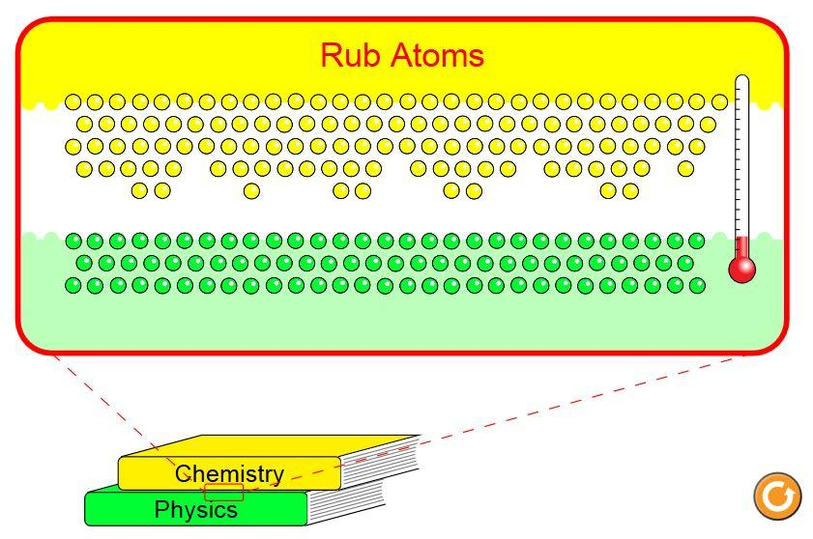
2. Elicit discussion about friction and thermal energy by asking
questions:
  - How is thermal energy useful energy and how is it not useful?
  - When you rub your hands together, describe what is happening (in terms of energy)? Where does the energy come from? How is friction involved?
  - What happens to the objects/molecules in a system when energy is converted to Thermal Energy? (gets hot, have more KE, drop skater and see PE to thermal)
3. Project PhET Friction simulation to support and guide discussion.
4. Demonstrate what is meant by microscopic and macroscopic models (drawing)

III. Possible activities after students complete page 1 of handout
1. In pairs, Students draw their models in the table
2. Each pair of students joins another pair of students to come to consensus about models.
3. One group of 4 puts their model on the board. If there are significantly different models put all up on board.
4. Class discussion about models
What to look for in the microscopic model:
-the molecules should be moving faster in the right image
-the molecules should be the same size
-each model should show the same number of molecules
What to look for in the macroscopic model:
-show that heat is released or molecules are getting warmer
-show change in forms of energy in the skater/system
Relationship between microscopic model & macroscopic model:
- friction causes energy to change forms; as molecules gain thermal energy, they increase in
speed; as the skater’s potential or kinetic energy is converted to thermal energy, there will be an
increase in temperature of the system, and the skater will slow down and not return to the same height on the track
Part B: Energy Changes in the Skate Park System - student handout pages 2 - 4
Learning Objectives:
1. Describe energy changes in a system over time using both words and graphical representations.
2. Explain how each model (bar graph and pie chart) shows the total amount of energy available in the system, and draw each model for a situation with a different amount of initial energy.

I. Activity with simulation:
Students will work in partners to experiment with the sim to observe the forms and quantities of energy in the system at different positions in order to answer probing questions about key ideas regarding conservation of energy and graphical models of energy. Students should answer questions on handout or in their notebook. While students are working on activity, teacher can be checking student work and discussing questions about how to interpret the different graphical models.

Key ideas:
- Total energy should always remain constant during the skater’s run, energy may change between different forms (Kinetic, Gravitational Potential, Thermal). In physics, we say that “energy is conserved”, meaning it cannot be created or destroyed, but can only change forms or move from one object to another.
- In order to give the skater more total (initial, starting) energy, she has to be lifted and dropped from a greater height.
- On a bar graph, the total energy is represented by a bar along with bars for specific forms of energy; that “total energy” represents a sum of specific forms of energy (kinetic, potential, thermal)
  - Because the graph does not have values on the y-axis, you might ask students how they would label this--with percentages or numbers?
  - If the bar graph y-axis has specific quantities, then increasing the total energy will lead to a greater value on the bar graph
  - If the bar graph y-axis has percentages, increasing the total energy will not change the bar graph
- On a pie chart, the total energy is represented by the full pie; an increase in total energy could be represented by a larger pie (if fpie represents specific quantities of energy), or by an identical pie (if pie represents just percentages).
- The total energy in a system limits what the object can do

II. Formative Assessment: Energy Skate Park Clicker Questions (From “Loeblein Physics Clicker Questions”, pg. 76-103)

Part C: Mathematical Model for Conservation of Energy - student handout pages 5 - 7
Learning Objective:
1. Build , explain, and justify (with the sim) equations for total energy, and conservation of energy.
2. Draw scaled graphical models of energy for an object at a specific position using your energy equations.
3. Write equations for the total energy of an object at a specific position using scaled graphical models.

I. Activity
Students will be using their observations from the sim to build three equations:

Equation 1: E_{positionA} = E_{positionB}

Equation 2: E_{tot}= KE + PE + ThE

Equation 3: KE_{A} + PE_{A} + ThE_{A} = KE_{B} + PE_{B} + ThE_{B}

Students will work with their partners, then share with neighbors, and come to consensus on the “best” equations, which they will need to check with their teacher prior to moving on to the next step. After building these three equations, they will use their equations to solve problems, converting between different models (graphical, equation) for total energy.

Part D: Using Conservation of Energy to Solve Real-World Problems - student handout pages 8-9
Learning Objectives:
1. Use your energy model and equation to solve energy related problems.
2. Evaluate claims regarding roller coaster designs using evidence and reasoning from your energy model and the sim to support your conclusion.

I. Student Work Time (or as homework)
Students will work on a variety of practice problems that ask them to apply their understanding of conservation of energy to solve problems, write claims, evaluate claims and make predictions. Students can work individually or in teams to solve these problems.

II. Summarizing Discussion
After students have worked on practice problems, ask students to present their work on a white-board to share in a class discussion. Groups might be responsible for sharing just 1-2 problems, or all groups could share answers for all problems.

NGSS and Common Core Connections
NGSS DCIs | HS-PS3.A  Energy is a quantitative property of a system that depends on the motion and interactions of matter and radiation within that system. That there is a single quantity called energy is due to the fact that a system’s total energy is conserved, even as, within the system, energy is continually transferred from one object to another and between its various possible forms. ((HS-PS3-1), (HS-PS3-2)  At the macroscopic scale, energy manifests itself in multiple ways, such as in motion, sound, light, and thermal energy. (HS-PS3-2), (HS-PS3-3)  These relationships are better understood at the microscopic scale, at which all of the different manifestations of energy can be modeled as a combination of energy associated with the motion of particles and energy associated with the configuration (relative position of the particles). In some cases the relative position energy can be thought of as stored in fields (which mediate interactions between particles). This last concept includes radiation, a phenomenon in which energy stored in fields moves across space. (HS-PS3-2)  HS-PS3.B  Conservation of energy means that the total change of energy in any system is always equal to the total energy transferred into or out of the system. (HS-PS3-1)  Energy cannot be created or destroyed, but it can be transported from one place to another and transferred between systems. (HS-PS3-1)  Mathematical expressions, which quantify how the stored energy in a system depends on its configuration (e.g. relative positions of charged particles, compression of a spring) and how kinetic energy depends on mass and speed, allow the concept of conservation of energy to be used to predict and describe system behavior. (HS-PS3-1)  The availability of energy limits what can occur in any system. (HS-PS3-1)
NGSS Practices | Developing and using models  Using mathematics and computational thinking  Constructing explanations and designing solutions
NGSS Crosscutting Concepts | Energy & Matter: Flows, cycles & conservation  Scale, proportion & quantity  Cause & Effect
CCSS-ELA/Literacy | SL.11-12.5 - Make strategic use of digital media (e.g., textual, graphical, audio, visual, and interactive elements) in presentations to enhance understanding of findings, reasoning, and evidence and to add interest.
CCSS-Mathematics | - HSN-Q.A.1 - Use units as a way to understand problems and to guide the solution of multi-step problems; choose and interpret units consistently in formulas; choose and interpret the scale and the origin in graphs and data displays. (HS-PS3-1), (HS-PS3-3)  - HSN-Q.A.2 - Define appropriate quantities for the purpose of descriptive modeling. (HS-PS3-1), (HS-PS3-3)  - HSN-Q.A.3 - Choose a level of accuracy appropriate to limitations on measurement when reporting quantities. (HS-PS3-1), (HS-PS3-3)  - MP.2 - Reason abstractly and quantitatively. (HS-PS3-1), (HS-PS3-2), (HS-PS3-3), (HS-PS3-4), (HS-PS3-5)  - MP.4 - Model with mathematics. (HS-PS3-1), (HS-PS3-2), (HS-PS3-3), (HS-PS3-4), (HS-PS3-5

NGSS-Aligned Lesson-Level Performance Expectations & Evidence:
Lesson Level PE | Evidence | PhET Learning Objectives
Part A  Use a model to provide a mechanistic account of the nature of thermal energy at the microscopic level and connect it to the macroscopic level. (HS-PS3.A) | Students will be able sketch molecular models demonstrating changes in energy at the microscopic level, and be able to explain what these models mean at the macroscopic level for the skater on the ramp.  Formative: Class discussion, exit ticket  Summative: Draw and explain microscopic and macroscopic models of thermal energy. | Draw and explain a molecular model showing what happens to the skater’s molecules at the microscopic level as thermal energy increases, then relate this to what is happening at the macroscopic level of the skater on the ramp.
Part B.1  Use the graphical models in the simulation to illustrate the relationship between total energy, KE, PE, and ThE. (HS-PS3.B) | Students will qualitatively describe energy quantities and energy changes in a system by completing word descriptions and graphical representations in a graphic organizer.  Formative: Look at student developed tables  Summative: Matching task to match graphs with picture of a situation | Describe energy changes in a system over time using both words and graphical representations.
Part B.2  Evaluate merits and limitations of two different models (pie chart, bar graph) of the same system in order to address energy as a limiting factor. (HS-PS3.B) | Students will be able to compare and contrast how different models depict total energy and specific forms and quantities of energy in a given system.  Formative: Think pair share why does the first hill on a roller coaster have to be the highest?  If two hills are the same height, under what circumstances could the coaster get over the second hill and under what circumstances would the coaster not be able to get over the second hill.  Summative: Given a bar graph and pie chart of one situation, students will draw new graphs and charts to represent a situation with a different quantity of initial energy. Also explain reasoning. | Explain how each model (bar graph and pie chart) shows the total amount of energy available in the system, and draw each model for a situation with a different amount of initial energy.
Part C.1  Use graphical representations in the simulation to create and explain a computational model (equation) demonstrating conservation of energy in a system. (HS-PS3.B) | Students will develop the conservation of energy equation(s), then explain process using evidence from the sim.  E_{tot}= KE + PE + ThE  E_{positionA} = E_{positionB}  KE_{A} + PE_{A} + ThE_{A} = KE_{B} + PE_{B} + ThE_{B}  Formative: Students have 3 correct equations and can explain the different components.  Summative: Apply equation to solve problems. | Build , explain, and justify (with the sim) equations for total energy, and conservation of energy.
Part C.2  Move flexibly between model types by explaining the connection between the computational model and the graphical model. (HS-PS3.B) | Given an equation for an object’s energy at a specific position, students will draw a corresponding graphical model (that is correctly scaled), and also do the reverse.  Equation-> graphical model  Graphical model -> Equation  Formative and Summative: Matching task to match graphs with picture of a situation with specific quantities given to PE KE and ThE. | Draw scaled graphical models of energy for an object at a specific position using your energy equations.  AND  Write equations for the total energy of an object at a specific position using scaled graphical models.
Part D  Apply the mathematical model to make and evaluate claims, solve problems and predict changes in forms and amounts of energy at different configurations of system. (HS-PS3.B) | Students will make and evaluate claims using their model and evidence from the sim to support their reasoning.  Students will apply their model to solve qualitative and quantitative problems, including making predictions about changes in energy at different positions. | Use your energy model and equation to solve energy related problems.  Evaluate claims regarding roller coaster designs using evidence and reasoning from your energy model and the sim to support your conclusion.

