TITLE
Concentration

AUTHORS
Robert Parson (University of Colorado Boulder)
Trish Loeblein (University of Colorado Boulder)

COURSE
Introductory / Preparatory Chemistry

TYPE
Interactive Lecture Demonstration Guide

TEACHING MODE
Lecture Demonstration

LEARNING GOALS
Students will be able to:
- Relate the number of moles, the volume, and the concentration of a solution – given any two, calculate the third.
- Predict qualitatively how actions such as adding solute, evaporating solvent, or draining the solution affect the concentration and number of moles of a solution.
- Calculate the change in the concentration of a solution when a given volume of solvent is added.

COPYRIGHT
This work is licensed under a Creative Commons Attribution 4.0 International License.
This license allows users to share and adapt the materials, as long as appropriate attribution is given (with a link to the original), an indication if changes have been made, and an indication of the original licensing.

Concentration

KEYWORDS
Concentration, molarity, volume, dilution

COURSE
Introductory Chemistry
A 200-300 student first-year college chemistry course intended for students who feel that they are underprepared to undertake first-year general chemistry

PLACEMENT IN COURSE
- Midway through the semester

PRIOR KNOWLEDGE
- Ionic and molecular compounds – bonding, chemical formulas, conductivity in water
- Dissociation of ionic compounds
- Moles and molar mass

LEARNING OBJECTIVES
After this activity, students will be able to… | Simulation Used
- Relate the number of moles, the volume, and the concentration of a solution – given any two, calculate the third.  - Predict qualitatively how actions such as adding solute, evaporating solvent, or draining the solution affect the concentration and number of moles of a solution.  - Calculate the change in the concentration of a solution when a given volume of solvent is added. | Concentration

RESOURCES
Concentration (Choosing Run in HTML5 recommended)
http://phet.colorado.edu/en/simulation/concentration

CONCEPTUAL CHALLENGES
Students at this level are new to the mole concept, which remains relatively abstract compared to measured masses. Bringing in molarity adds another layer of complication. Additionally, students may not be comfortable with using proportional reasoning, and tend to rely heavily on equations such as C₁V₁ = C₂V₂ in order to predict the results of dilutions, and do not always check that their answers are qualitatively reasonable (e.g. ending up with a final concentration that is larger than the initial one).
Activity Timeline and Details
Total time ~ 40-50 min
Section | Approx. Duration | Details
What affects concentration? | 15 min | Section goals  - Define concentration  - Predict qualitatively how different everyday actions affect the concentration and number of moles of a solution.  Demonstration (4 min)  - Explore the simulation beginning with Drink Mix as a solute, and ask students for suggestions of what to try next – students suggestions have previously included adding water, adding solute from the shaker, and inserting the conductivity meter  - If not already suggested, ensure that you demonstrate use of both faucets, adding more solid from the salt shaker, and evaporating some of the solution  - Use the concentration probe to show how concentration increases or decreases in response to these actions  - Note that starting with Drink Mix for initial demonstrations gives students a real-world connection that they often find more intuitive for building an understanding of concentration  - Use sim observations to construct a definition of concentration  LECTURE INTERLUDE (3 min)  - Formalize the definition of concentration by introducing terminology: solute, solvent, molarity  - Show students static images of solutions on a molecular scale.  Concept Questions  individual response with discussion encouraged  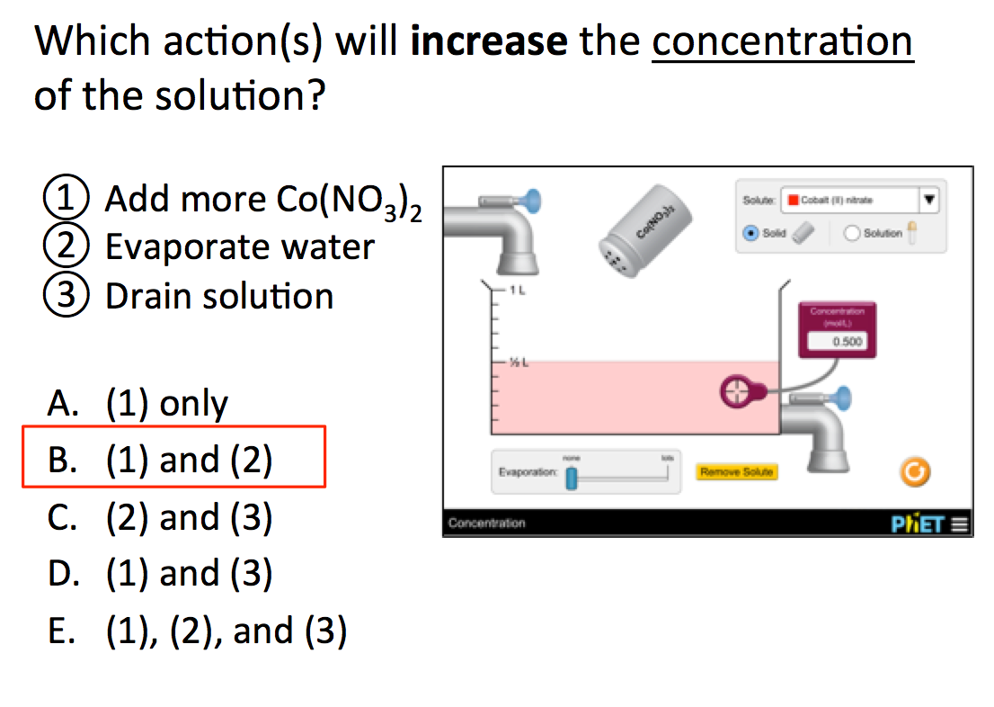  Sample response distribution: 85% correct  Before showing responses or answers, and before any class discussion, move directly to the next question.  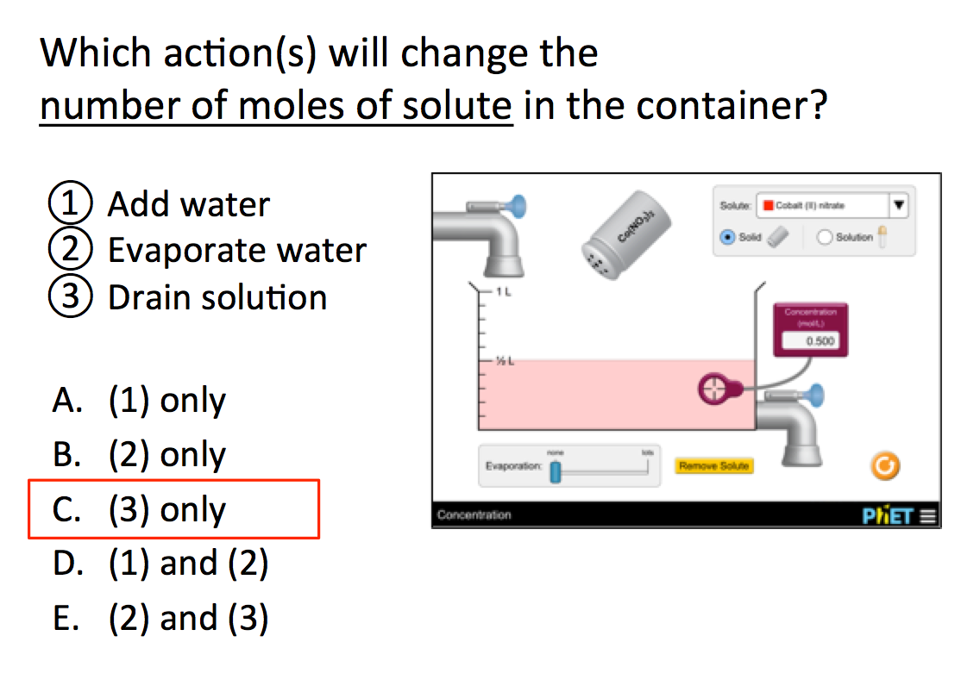  Sample response distribution: 62% correct (21% chose B)  Follow-up Demonstration and discussion (5 min)  - After collecting both sets of students responses, use the sim to demonstrate the answer to the first question  - Note that setting up a specific starting solution is easiest if you create a slightly more concentrated solution and then dilute with water as needed (water faucets have higher precision control), and then drain any excess solution away.  - Discuss the second question as a class and summarize
Calculating Concentrations | 20 min | Section goal  - Relate the number of moles, the volume, and the concentration of a solution – given any two, calculate the third.  Demonstration and Lecture (6 min)  - Use the simulation to setup various sample situations and then solve these as quantitative problems involving concentration, moles and molarity.  Concept Question  individual response with discussion encouraged  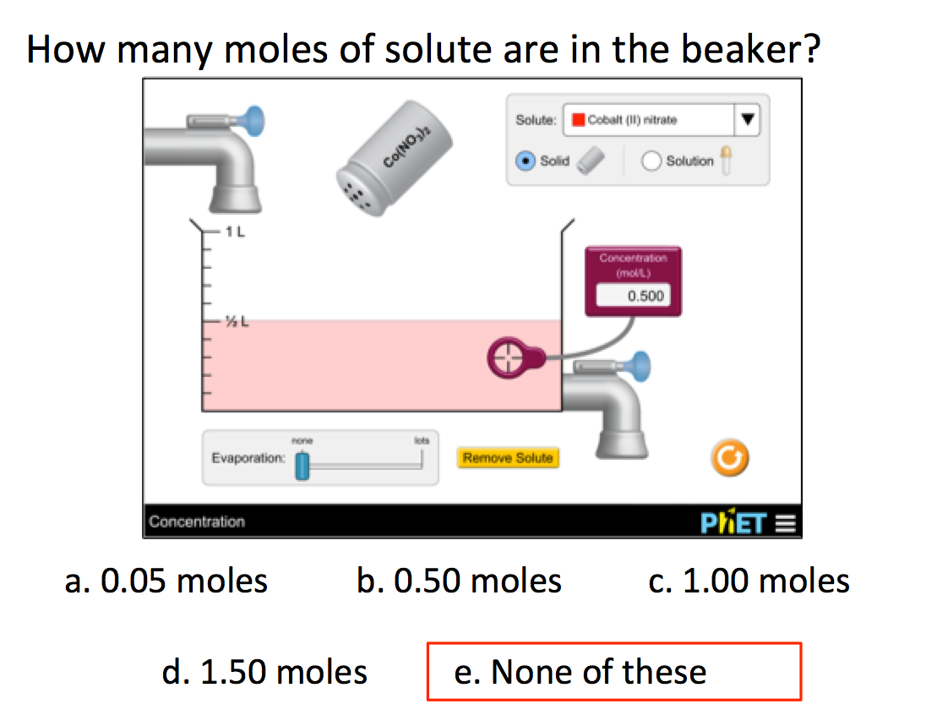  Sample response distribution:  63% correct (B and C are popular alternate answers)  CLASS DISCUSSION  - Ask students if they had learned about any unusual properties of water that made it different from other liquids. If students do not mention any properties about ice expanding on their own, ask about their experiences/observations of ice cubes in water.
Dilutions | 10-15 min | SECTION GOAL  - Calculate the change in the concentration of a solution when a given volume of solvent is added.  Concept Question  individual response with discussion encouraged  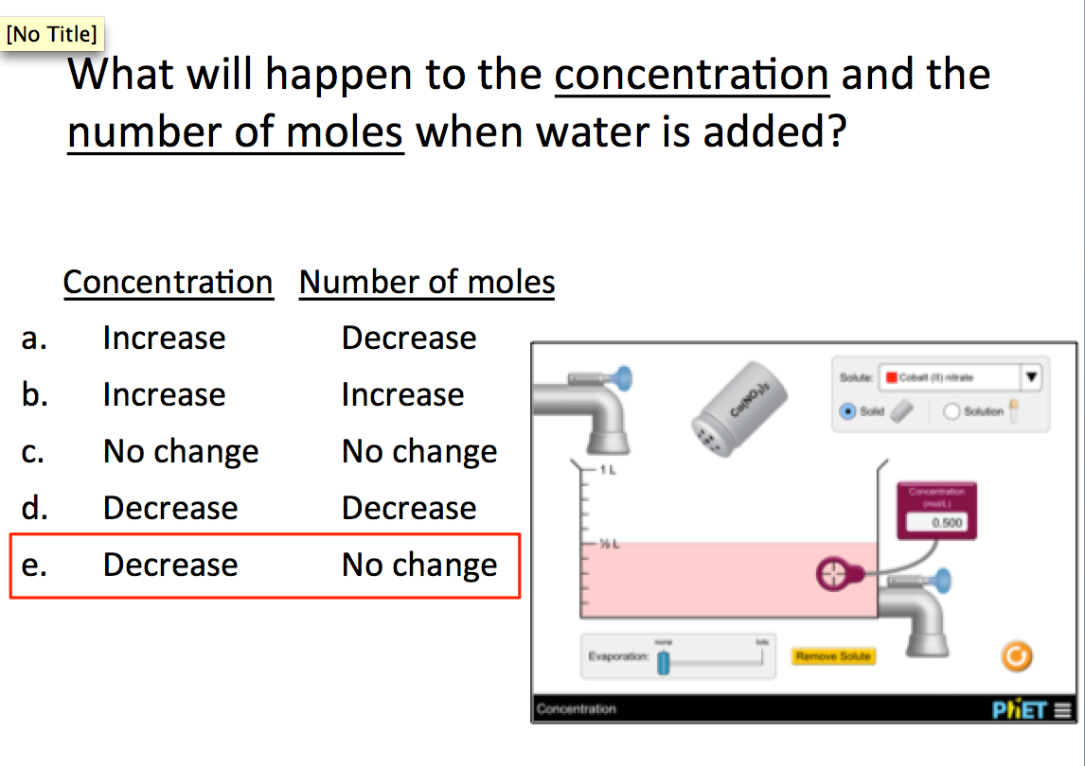  Sample response distribution: 87% correct  Demonstration and Lecture (6 min)  - Use the previous concept question to connect the qualitative ideas in the first section to quantitative dilution calculations by asking a follow-up question about doubling the volume.  - Since students agree that the number of moles is unchanged, use this fact to introduce the “dilution equation” C₁V₁ = C₂V₂  - Demonstrate the step-wise solution of a quantitative dilution that you setup in the simulation  Concept Question  individual response with discussion encouraged  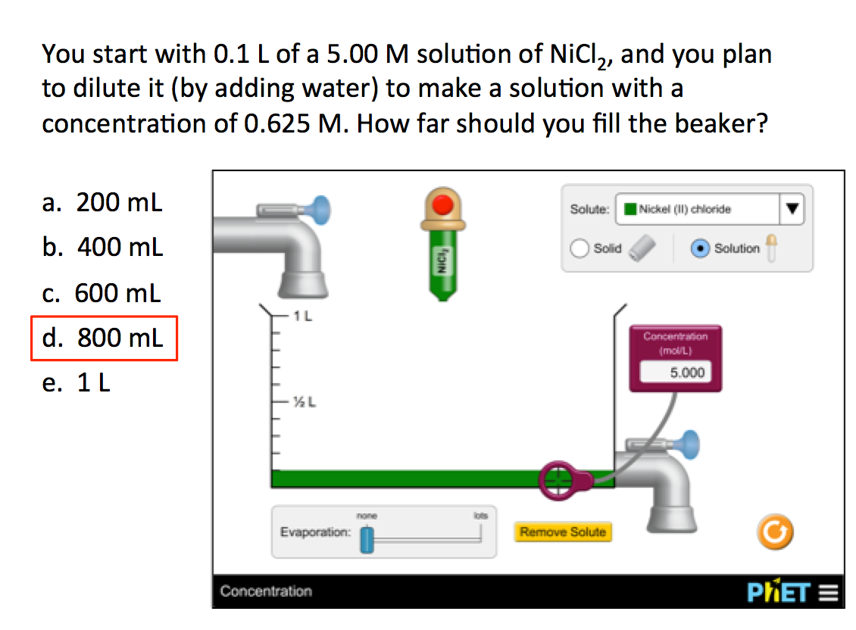  Sample response distribution: 81% correct  Follow-up Demonstration (1 min)  - Use the simulation to demonstrate the answer and discuss. Note that the eyedropper contains a stock 5 M solution of NiCl₂

