TITLE
Beer’s Law Lab

AUTHORS
Susan Hendrickson (University of Colorado Boulder)
Julia Chamberlain (University of Colorado Boulder)

COURSE
General Chemistry II

TYPE
Recitation / Tutorial Guided-Inquiry Activity

TEACHING MODE
Facilitated Group Inquiry

LEARNING GOALS
Students will be able to:
- Describe the relationship between solution concentration and the intensity of light that is absorbed/transmitted.
- Explain how wavelength, solution color, and absorbance are related by comparing different solutions.
- Use a sketch of an absorption spectrum to describe the concept of maximum absorbance wavelength

COPYRIGHT
This work is licensed under a Creative Commons Attribution 4.0 International License.
This license allows users to share and adapt the materials, as long as appropriate attribution is given (with a link to the original), an indication if changes have been made, and an indication of the original licensing.
Beer’s Law LAB

Open the Beer’s Law Lab simulation on your laptop or tablet:
http://phet.colorado.edu/en/simulation/beers-law-lab

Introduction
- Explore the Beer’s Law screen for a few minutes. Try to figure out what all of the controls show and do.

- How does Concentration affect how much light is absorbed and transmitted through the solution?

Investigating Absorption and Concentration
- Predict what a graph of absorbance versus concentration would look like. Sketch your prediction.
Prediction
Concentration
Absorbance
- Choose a solution from the simulation and measure the Absorbance for different concentrations on the preset wavelength setting.

Data from the Simulation
Concentration ________M Abs | 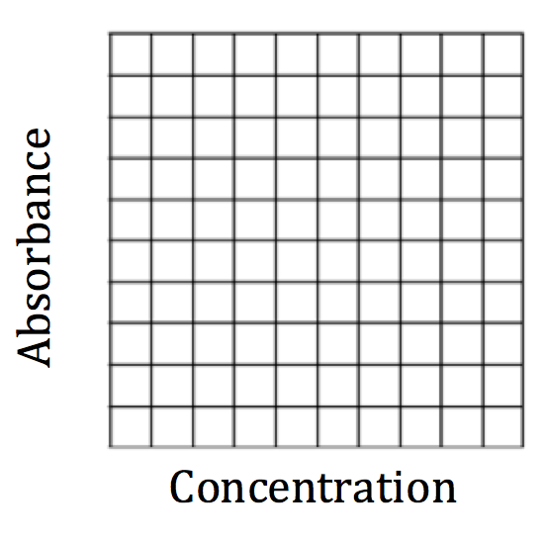

- How does your second graph compare to your prediction?

- Based on Beer’s Law (A = εlC, A = absorbance, ε = molar absorptivity, l = pathlength and C = concentration), do you expect using different wavelengths of light would change the way your previous graph looks? Why or why not?

Investigating Absorption and Wavelength
- a. Compare three solutions of different colors with the same pathlength (width of container).

 |  | Preset Wavelength:  Simulation default setting |  |  | Variable Wavelength:  Set to same color as solution
Solution | Solution Color | Beam Color | Value (nm) | Abs | Beam Color | Value (nm) | Abs

- What combinations give the most absorbance? Why?

- How are beam color, solution color, and absorbance related?

λ(nm) | Abs

- a. Choose a solution and keep concentration and pathlength constant as you graph the absorbance for different wavelengths.

Solution: ____________________________
Absorbance

380 580 780
Wavelength (nm)

- What is the value for the “preset” wavelength for your solution? Mark this point on your graph.

- Why do you think the “preset” wavelength is the best wavelength to use for this solution?

- Compare your absorbance spectrum sketch with a group that chose a different solution. Would you use the same wavelength of light to do spectroscopy experiments with different colored solutions? Why or why not?

- In a lab experiment monitoring the change in concentration of a reddish-brown substance, FeNCS²⁺, a wavelength of 455 nm is used.
  - Does this wavelength agree with your conclusions about beam color, solution color, and absorbance above? Why or why not?

  - What other wavelengths might you consider using for FeNCS²⁺ spectroscopy?

