TITLE
Entropy, Microstates, and Probability

AUTHORS
Ted Clark (The Ohio State University)
Julia Chamberlain (University of Colorado Boulder)

COURSE
General Chemistry II

TYPE
Interactive Lecture Demonstration Guide

TEACHING MODE
Lecture Demonstration

LEARNING GOALS
Students will be able to:
- Explain a spontaneous process – such as air rushing in to an evacuated chamber – using particle motion at the molecular level.
- Distinguish between spontaneous and non-spontaneous processes, and connect these to a probabilistic description of matter.
- Explain how a large number of microstates can produce the same macro-state.
- Perform calculations involving probability.
- Use particle motion and probability to explain heat transfer.

COPYRIGHT
This work is licensed under a Creative Commons Attribution 4.0 International License.
This license allows users to share and adapt the materials, as long as appropriate attribution is given (with a link to the original), an indication if changes have been made, and an indication of the original licensing.

ENTROPY, MICROSTATES, AND PROBABILITY

Expansion of a gas at the molecular level is explained in terms of particle motion and probability.

PLACEMENT IN COURSE:
The 2nd semester of General Chemistry.

PRIOR KNOWLEDGE:
- Kinetic molecular theory of gases.

LEARNING OBJECTIVES:
Simulation | Format | Objectives, Concepts
Reversible Reactions | Instructor-led | - Explain a spontaneous process – such as air rushing in to an evacuated chamber – using particle motion at the molecular level.  - Distinguish between spontaneous and non-spontaneous processes, and connect these to a probabilistic description of matter.  - Explain how a large number of microstates can produce the same macro-state.  - Perform calculations involving probability.  - Use particle motion and probability to explain heat transfer.

RESOURCE:
Reversible Reactions: http://phet.colorado.edu/en/simulation/reversible-reactions

KEYWORDS:
Entropy, spontaneous and non-spontaneous processes, 2nd law of thermodynamics, microstates, Boltzmann

SIM LOGISTICS:
- Raising the bottom platforms and drawing up the central divider makes two distinct chambers.
- Molecules can be added to either chamber. Heating or cooling affects particle motion.
- Removing the central barrier allows the molecules to move between chambers.
- Particle color indicates which chamber the molecules are in.

This demo uses an older PhET sim in a non-standard way. You may encounter bugs if you “test the limits” of the sim (e.g. particles ‘escaping’ to the space below the bottom platforms). If this occurs, we recommend using this opportunity to describe tunneling, and then resetting the sim to continue the demo.

START OF TEACHER-LED ACTIVITY

DEMONSTRATION – DISCUSSION OF AIR ENTERING AN EVACUATED CHAMBER
An evacuated chamber is shown to the class along with a slide to elicit predictions and explanations (Slide 1). The prediction that air will go into the empty chamber will be unanimous. However, explanation for this spontaneous process will be varied. The notion that air is “sucked in” will be common, but this implies an attraction. What in the empty chamber attracts the air molecules? Perhaps the gas molecules outside the chamber repel each other, forcing some into the chamber. However, this does not seem consistent with the behavior of an ideal gas. The phrase, “Nature abhors a vacuum” may be recited by students, but what does this physically mean?

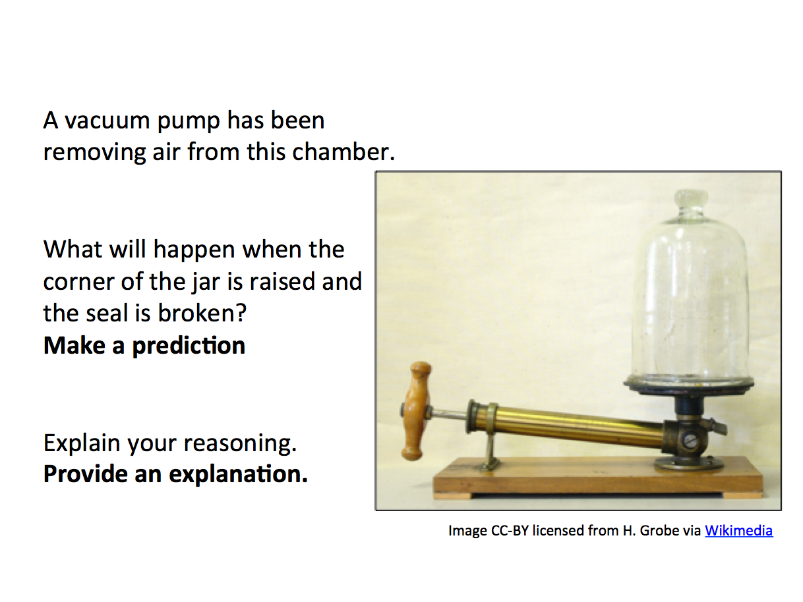
Slide 1: Air Moving into an Evacuated Chamber.

REVERSIBLE REACTIONS:
Set-up the sim so that two gas molecules are in motion in one chamber, with the other chamber empty. Ask the class to predict what happens when the divider is removed. This prompt may be stated when the sim is shown, or summarized on a slide (Slide 2).
- Analysis of sim response: “When the divider is removed, are the gas molecules attracted to the right chamber? Are they sucked into the right chamber? No, random particle motion explains movement across chambers.”
- As the sim runs there will be times when both particles are back in the left chamber. Note this observation (perhaps pausing the sim) and ask the class “why is this not observed with the demonstration? Why does the air rush into the evacuated chamber, but not rush back out?” This question will lead students to consider and suggest that there are more than just two gas molecules outside the empty container, so the situation is different.

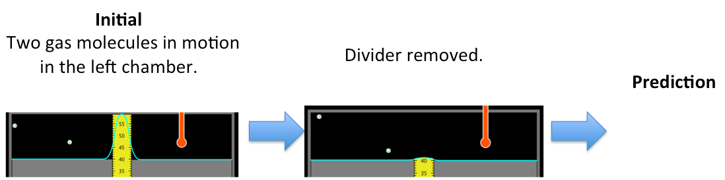
Slide 2: Expansion of a Gas with Two Molecules.

Next, ask students to consider what happens if 50 molecules are in motion in the left chamber, and then the divider is removed. Students make a prediction, which is then tested in the sim (Slide 3).
- This example introduces the idea that spontaneity and the direction of a process are explained at the molecular level by the motion of a large number of particles.

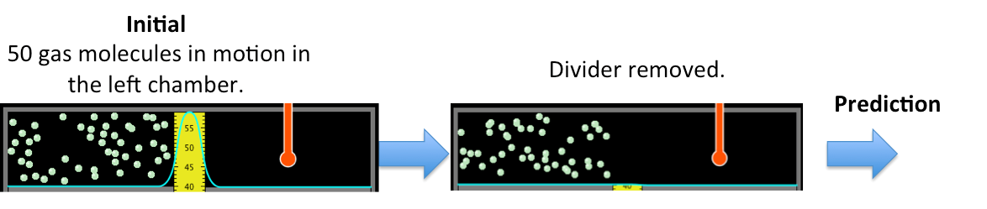
Slide 3: Expansion of a Gas with Fifty Molecules.

When 50 molecules began in the left chamber they became distributed throughout both chambers, with about 25 on each side.
Next, investigate what happens when 25 molecules begin in the left and right chambers. Once again, students make a prediction and then test with the sim. The initial prompt may be stated, or summarized on a slide (Slide 4).
- Particle motion takes place. Molecules once again move from side to side, e.g. the same molecules do not remain in the left chamber.
- The macroscopic observation is the same, with about 25 molecules on each side. Many different microstates can lead to the same macro-state. A microstate is the particular microscopic arrangement of the atoms or molecules, including the position and kinetic energy of each individual molecule. You can illustrate this point by alternating between pausing and playing the sim, noting that each time the sim is paused a different microstate is shown.
- Whether we begin with 50 molecules in one chamber, or 25 in each chamber, we end up with the same final macro-state. In both cases, the number of microstates is the same since the number of particles is the same, and it must be a large number since there are many ways the molecules can be distributed across both sides to produce the same macro-state.

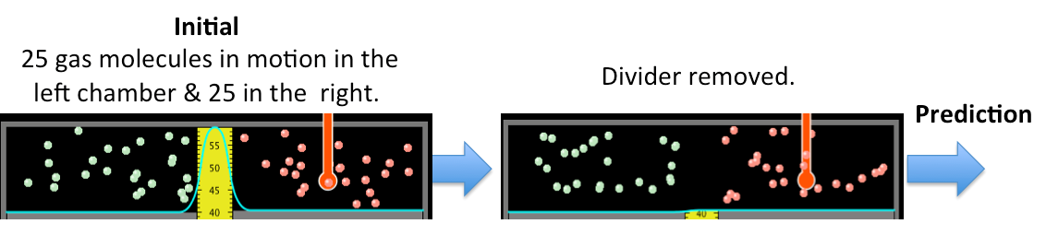
Slide 4: A Macroscopic Observation is Explained in Terms of Particle Motion and Microstates.

At this point students will have a sense that particle motion is leading to the most probable distribution. Introducing how calculations involving probability reinforce this point is a useful connection.
- First, the probability of two particles being found in the same chamber is investigated (Slide 5); given the “before” condition, what are the odds of the “after” occurring?
- The probability of having two molecules in the left chamber is fairly high. To illustrate this, start the sim and ask the class to cheer whenever both molecules are on the left side; the color-coding of the spheres helps to determine this.
- After observing and interacting with the sim for a little while, the calculation may be introduced.
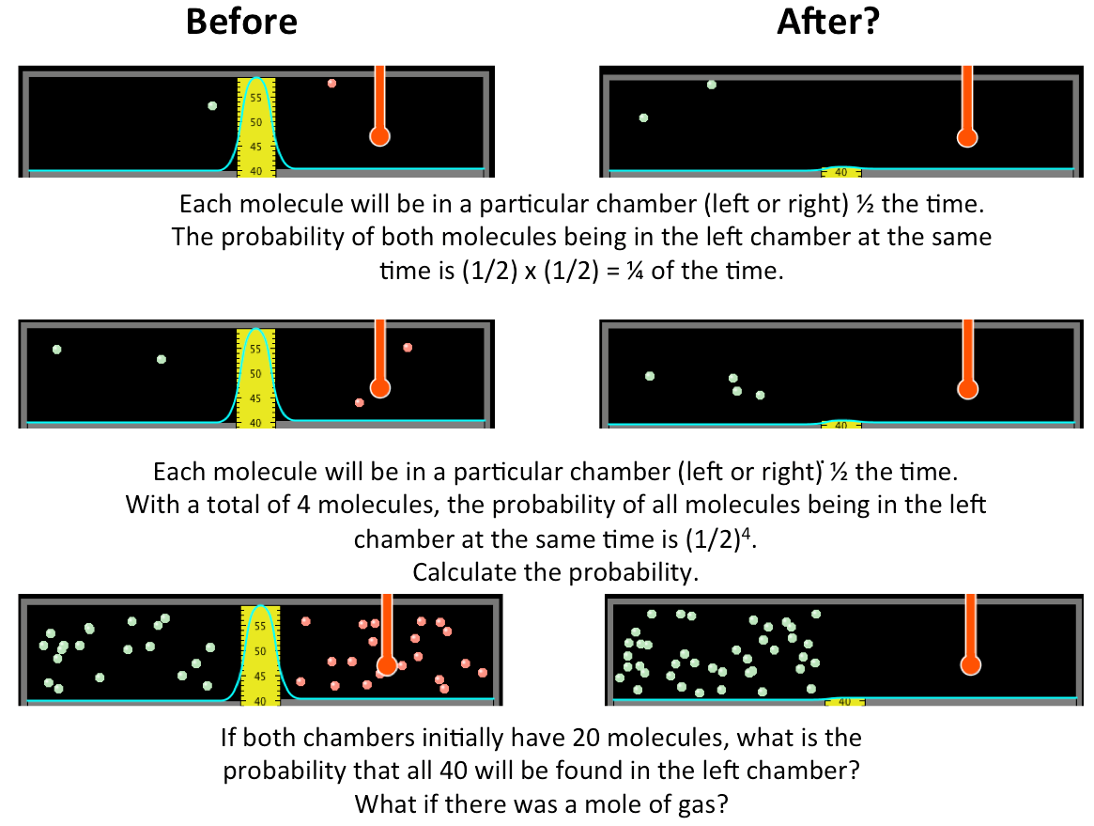
Slide 5: Given the “Before” Distribution, Calculate the Probability of the “After”.

- Move on to four molecules. Is it likely to have all four molecules in the left chamber? Once again, ask the students cheer when (if) this occurs. After observing the sim for a little while, the calculation may be introduced. In this case, the odds are 1-in-16.
- Finally, move on to forty molecules. Once again, start the sim and ask the class to cheer if all of the molecules are in the same side. After a few moments have students calculate the probability.
- Indicate that forty molecules is still an extremely small number. What if a mole of gas were present? That fact that most calculators give an “error message” when performing this final calculation reinforces the fact that the probability for such an event is so low the chance of it occurring spontaneously is essentially zero.
If slide 5 is omitted, a different version may be used to check for understanding (Slide 6) after the concept of probability has been introduced.
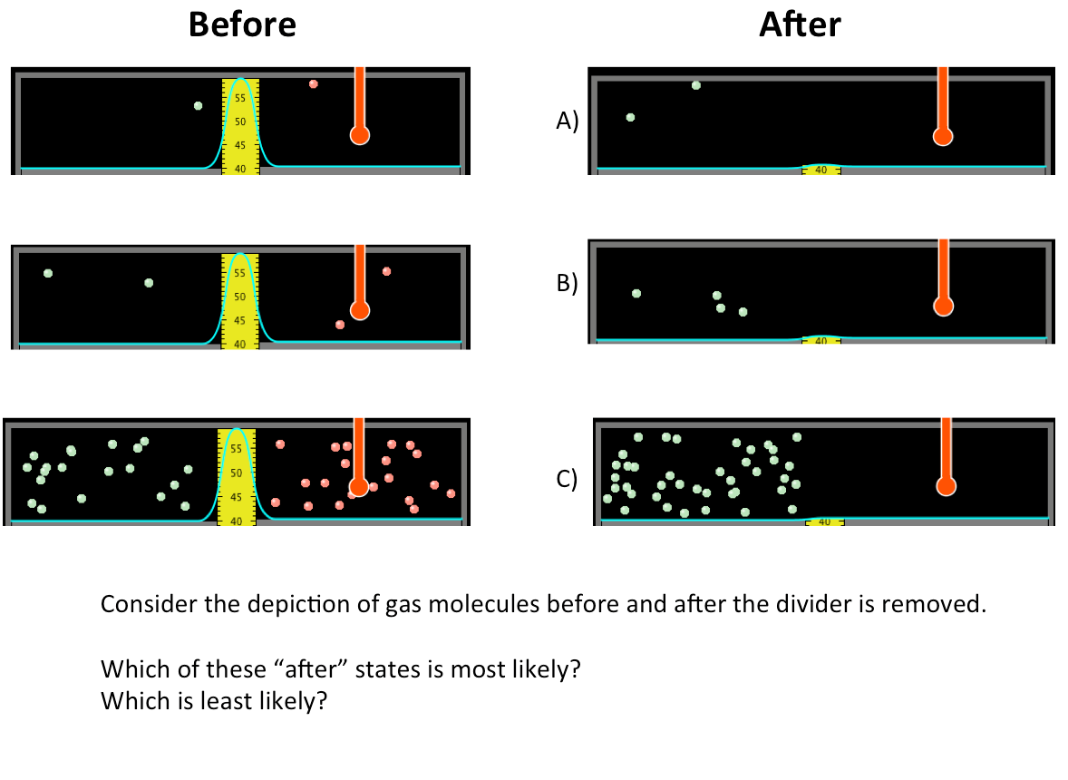
Slide 6: Examining Probability and Spontaneous Particle Motion for Different Number of Molecules.

Images from the sim may be used to connect the concepts of particle motion, heat transfer, and spontaneity and probability (Slide 7).
- In this example, students observe that particle motion increased in the left chamber going from initial to final state, and the right chamber’s thermometer reads 300K in the final state.
- The initial temperature in the right chamber must have been >300K. The spontaneous process, the one leading to the most probable state, has the particle motion increasing in the left chamber and decreasing in the right.
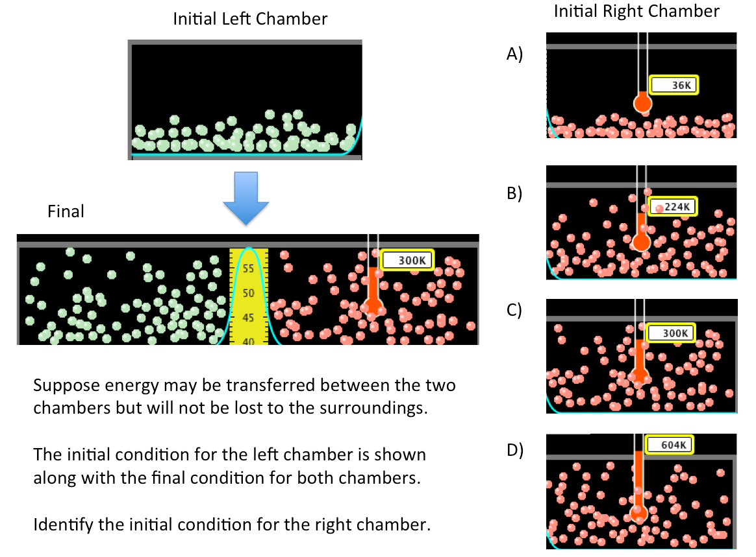
Slide 7: Considering Change in Particle Motion due to Energy Transfer.

