The Advantages of Species Physical Appearance Corresponding to Living Environment
7th Graders

Learning Objective: Students will be able to evaluate and analyze the survival rate of a species fur color depending on the environment they live in. Also, understand the predator and prey relationship.

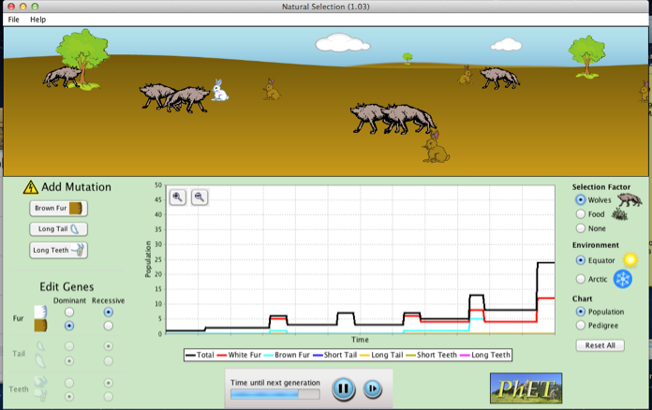
Instruction:
Part 1:
- Select “Equator” environment
- Select “Add a Friend”
- Select “Brown Fur” mutation
- Wait until the population has multiply
- Select “Wolves” under “selection factor”
- Select “Food”
- Observe change in population

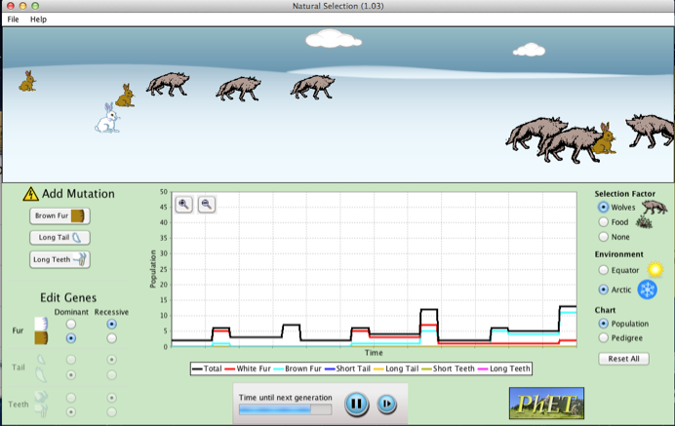
Part 2:
- Select “Artic” environment
- Select “Add a Friend”
- Select “Brown Fur” mutation
- Wait until the population has multiply
- Select “Wolves” under “selection factor”
- Select “Food”
- Observe change in population

Discussion Questions:
- How does the bunnies within the population differ from one another?

- Due to mutation in the white parents what variation occurred in the offspring’s fur color?

- Which species of bunnies survived under the “Equator” environment?

- Which species of bunnies survived under the “Artic” environment?

- What is the advantage of having a mutation involved in that specific population?

- What traits inherited from parents to offspring increase their survival rate?

Answer Key

- The bunnies within the population differ from another in the fur color.
- Variations in fur color of the offspring changed from white to brown due to mutations in the white fur parents.
- Under the equator environment the brown bunnies survived.
- Under the artic environment the white bunnies survived.
- The advantage of fur color helped disguised the bunnies from the wolves because they camouflaged with their living environment.
- The inherited trait of fur color helped the bunnies adapt and survive in their environment.

