Exploring Slope

PRE-PLANNING | PRIOR KNOWLEDGE
- Determine if a graphed line has a positive, negative, zero, or undefined slope
- Know that any two points define a line
- Know that coordinate points have two components, x and y
 | LEARNING GOALS
- Explain how the slope of a line is computed
- Determine the slope of a graphed line
- Calculate the slope of a line given two points on the line
 | Common Core Standards | Common Core Practices
 | CCSS.Math.Content.8.EE.B.6  Use similar triangles to explain why the slope m is the same between any two distinct points on a non-vertical line in the coordinate plane; derive the equation y = mx for a line through the origin and the equation y = mx + b for a line intercepting the vertical axis at b.  CCSS.Math.Content.HSF.LE.A.1.a  Prove that linear functions grow by equal differences over equal intervals. | 1. Make sense of problems and persevere in solving them  2. Reason abstractly and quantitatively  5. Use appropriate tools strategically  7. Look for an make use of structure
 | MATERIALS
- PhET Graphing Lines simulation:
https://phet.colorado.edu/sims/html/graphing-lines/latest/graphing-lines_en.html
- Computers/tablets for each student
- Notecards for each student
- “Exploring Slope” Activity Sheet for each student (see below)
LESSON CYCLE | WARM-UP 5 minutes
Activate prior knowledge by leading a discussion or having students journal about the following questions:
- What does slope measure about a line?
- What are the four different types of slope? What do these types tell us about the appearance of the line?
 | INTRO 7 minutes
 | Teacher will… | Students will…
 | - Distribute and collect notecards.  - Distribute activity sheets. | Explore the Slope screen of the sim and write down 1–3 questions on a notecard.
 | GUIDED EXPLORATION 15 minutes
 | Teacher will… | Students will…
 | - Circulate the room to be available for questions and ask probing/pushing questions, such as:  - How does the slope calculation relate to the type of slope?  - Why are the tickers and the points on the line the same color?  - Compare your sketches with your neighbor. What do they have in common? What is different about them?  #2–3 Pair-Share: Have students turn and share with their partner their answers to questions 2–3. Instruct students to collaborate on their response to #4. Call on some pairs to share their response with the class.  #7-8 Pair-Share: Have students turn and share with their partner their answers to questions #7-8. Call on some students to share with the class. | Work on the front of the activity sheet while interacting with the Slope screen of the sim.  Discuss #2–3 with their partner. Collaborate to define slope in #4.  Be attentive when sharing out #4. Update or modify answer to #4 based on class discussion.  Continue working on the back of the activity sheet, discussing #5-6 with partners.  Share with their partner their answers to question 7.
 | DISCUSSION 15 minutes
 | Teacher will… | Students will…
 | - Facilitate a class discussion to bridge an understanding across representations. Remind students to close their laptops or turn around so that the sim does not distract them from listening. Use an established teaching strategy such as popcorn discussion (one student answers, calls on the next student to talk), think-pair-share (pose question, allow time to think, turn and talk to partner), or group discussions (print out questions and have groups talk to each other and write down consensus to share aloud with class). Sample questions include:  - What is the connection between the top of the fraction and the graphed line (or points on the line)?  - What is the connection between the bottom of the fraction and the graphed line (or points on the line)?  - Why did some lines have a slope that was not a fraction?  - Which lines don’t have a slope at all? Why don’t they have a slope? What did the slope equation look like?  - What is the relationship between lines with the same slope? (Refer to #5–6.)  - Why is it useful to have a formula to calculate slope?  - Redistribute notecards to individual students. Facilitate a discussion about notecards:  - Did anyone answer a question that they had at the beginning of the activity? What was it?  - Did anyone not answer a question? Share out and call on someone who can answer it. | Share responses to discussion questions.  Share out answered and unanswered questions and call on another student who can answer.

Name: ___________________________________ Class: __________________ Date: ____________________

Exploring Slope
Learning Goals
- Explain how the slope of a line is computed
- Determine the slope of a graphed line
- Calculate the slope of a line given two points on the line

- Explore the slope screen for 5 minutes and write down 1–3 questions that you have.
- Create three lines with different slopes. Sketch your lines and complete the table below.
 | 1 | 2 | 3
Sketch | 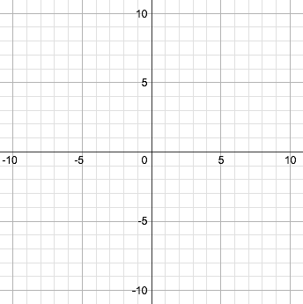
Coordinates of two points on line | ( , ) and ( , ) | ( , ) and ( , ) | ( , ) and ( , )
Calculate slope | 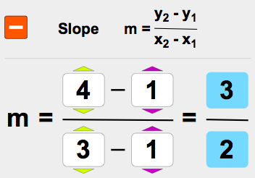
Type of slope | ☐ Positive  ☐ Negative  ☐ Zero  ☐ Undefined | ☐ Positive  ☐ Negative  ☐ Zero  ☐ Undefined | ☐ Positive  ☐ Negative  ☐ Zero  ☐ Undefined

- In the fraction that represents slope, describe how the top and bottom numbers (numerator and denominator) relate to the graph.

- Compare with your responses for #2–3 with your partner. Write a description of slope that relates the fraction and the graph:

- Use the 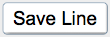 feature to find two distinct lines whose slopes are the same. Sketch both lines and record your findings below.
Sketch both lines | Coordinates of two points on each line | Calculate slope | Observations to discuss with your partner
Line 1

( , )
and
( , )
Line 2

( , )
and
( , )

- Find two different sets of points on the same line. Sketch the line and record your findings below.
Sketch | Coordinates of two points on each line | Calculate slope | Observations to discuss with your partner
Line 1

( , )
and
( , )
Line 2

( , )
and
( , )

- Calculate the slope of a line between the points (-5, -3) and (1, 6).

- Describe how to calculate the slope of a line between any two points.

