Day 1: What is a Fraction?
Introduction to Fractional Parts

Target Group: Adaptable for 2-4th grades; Meets 3rd grade CCSS

Prior Knowledge: Students should have an understanding that fractions are equal parts of a whole.

Lesson Objective: Students will be able to define a fraction by explaining the meaning of its top and bottom parts.
- CCSS.Math.Content.3.NF.A.1
Understand a fraction 1/b as the quantity formed by 1 part when a whole is partitioned into b equal parts; understand a fraction a/b as the quantity formed by a parts of size 1/b.

Time: 45 minutes – 60 minutes
Materials:
- Activity Sheet for each student (see below)
- Laptop/Computer for each student
- Fractions Intro Simulation: http://phet.colorado.edu/en/simulation/fractions-intro
- Projector/document camera (optional)

Time | Procedure | Teaching Tips
5 minutes | - Activate Background Knowledge: Ask students to brainstorm what they know about fractions with a partner. Have you heard of any common fractions like “one-fourth” or “one-half?” When might people use fractions in daily life? (time, cooking, eating, sharing). Share ideas with whole class. | - “Turn and Talk” or “Think-Pair-Share” routines are in place so students know the norms and engage in discussion effectively.
5 minutes | - Distribute Activity sheets and have students access the Fractions Intro sim: http://phet.colorado.edu/en/simulation/fractions-intro  - Explore (#1): Tell students that they will have 5 minutes to explore the features of the sim. Throughout this time, they may share their findings with their partner.  - While students are exploring, monitor discussions and findings so that you can call on certain students to share features with the whole group.  - Share important features. | - Set up student laptops with sim prior to lesson to save time; if not possible, create a link so students may just click rather than typing in the URL. The sim can also be downloaded directly to the computer.  - Project the sim for the class to see as you highlight features  - If students don’t bring it up, show that the fractions in the sim can be represented different ways – these are representations. You can show a fraction in numbers, different shapes, a cake, on a # line, etc.
10 minutes | - Review today’s learning objective: Read learning objective with students or tell students “Today we’re going to learn what the top # and the bottom # of a fraction mean. You’ll be using the sim and following along on your activity sheet.”  - Review the directions on the activity sheet (Students will be working on the first tab and the Max should be set at 1). Provide students with 10 minutes to work through #2 – 5 on their activity sheets.  - Monitor student work as you walk around. Ask questions and have students make predictions that will extend their thinking. For example: “What would happen if I increase the (bottom/top) number even more?” | - Encourage students to talk with their partner if they are having difficulty
15 minutes | - Share the Learning:  - 3 minutes: Display the first part of question #6 and read with students. Have students take a minute to think/write down their ideas. Then have students turn and talk with their partner. Again, monitor discussion so you can highlight key understandings or misconceptions.  - 3 minutes: Repeat procedure for the second part of number 6.  - 8 – 10 minutes: Call students’ attention back to whole group to share ideas together. Project the sim, if possible, and ask students what they learned about the top number in a fraction.  - “How would you describe the top number in a fraction?” “How does changing the top number change the amount?”  - Repeat for the bottom #.  - Introduce vocabulary: Once students have demonstrated an understanding of the top/ bottom #s in a fraction, introduce and define the terms numerator and denominator. | - Students can talk with their partner at their desks with the sim in front of them for Turn/Talk. When discussing with whole class, I like to pull the kids to a different part of the room. The change in location keeps kids from engaging with computer, allows them a quick moving break, and shifts their focus. We have a class meeting area where I have kids move to.  - Use the projected sim to reinforce the ideas that students share.
10 minutes | - Students will apply their understanding of numerators and denominators as they play the game “Build a Fraction” on the second tab. While they will start at level 1, the game will differentiate itself for students as they progress through the levels.  - Encourage partners to share strategies and work through challenges together.  - After 10 minutes, wrap up today’s lesson with a discussion of student strategies, successes, and challenges from the game. | - Keep track of how students are doing and if some students have different ways of representing a fraction (i.e. 3/3 = 1)

Name _____________________________________________________________ Date_____________________

I. What is a Fraction?
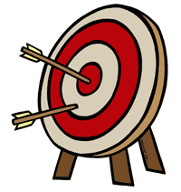
Lesson Objective: We will be able to define a fraction by explaining the meaning of its top and bottom parts.

- Explore: Take 5 minutes to explore the sim before beginning this worksheet.

First Screen: Intro
Keep the “Max” button set to 1.
2. Choose a representation and make a fraction. Then write and sketch the fraction.
Fraction Name:
Sketch/Drawing:

- Increase or decrease the top part of the fraction. What happens? Write and sketch the new fraction.

Fraction Name:
Sketch/Drawing:

- Go back to your original fraction (from #2). Increase or decrease the bottom part of the fraction. What happens? Write and sketch the new fraction.

Fraction Name:
Sketch/Drawing:

- Try different representations of the fractions above. Observe how the amount changes when the numerators & denominators are increased or decreased.
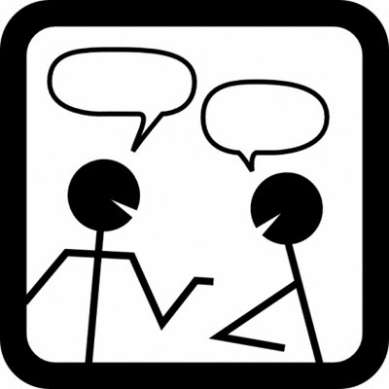
- Think-Pair-Share:

- What do you notice about the size of the pieces in any given fraction?

- How would you describe the top part of a fraction? How does changing the top number change the amount? Do you and your partner agree on the meaning of the top part?

- How would you describe the bottom part of a fraction? How does changing the bottom number of a fraction change the amount? Do you and your partner agree on the meaning of the top part?

Second Screen: Build a Fraction

- Click on the second tab. Select “Level 1” in the top row to begin the activity. Using your knowledge of the top/bottom parts of a fraction, build fractions that match the numeric representations.

