Middle School Energy Skate Park Lesson-Teacher Notes

Name_________________________________Date____________Period____________

ENERGY SKATE PARK

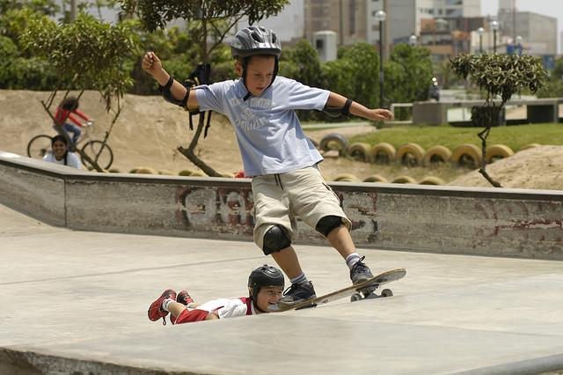

Activity Overview:
This activity is designed to guide students to understand the relationships between stored energy and the energy of motion. Students will use a model to visualize and describe the interactions of the skater with the track (MS-PS3-2). The graphs in the simulation will provide students with a visual representation of the relationship between PE, KE and ThE as the skater travels along the track.

Grade Level:
6-8

NGSS PEs, DCIs, Practices, and CCCs

PEs | DCIs | CCs | Practices
MS-PS3-1 Construct and interpret graphical displays of data to describe the relationships of kinetic energy to the mass of an object and to the speed of an object. | Motion energy is properly called kinetic energy; it is proportional to the mass of the moving object and grows with the square of its speed. (MS-PS3-1) | Proportional relationships (e.g. speed as the ratio of distance traveled to time taken) among different types of | Construct and interpret graphical displays of data to identify linear and nonlinear relationships. (MS-PS3-1)
MS-PS3-2 Develop a model to describe that when the arrangement of objects interacting at a distance changes, different amounts of potential energy are stored in the system. | A system of objects may also contain stored (potential) energy, depending on their relative positions. (MS-PS3-2) | Quantities provide information about the magnitude of properties and processes. (MS-PS3-1), (MS-PS3-4) | Develop a model to describe unobservable mechanisms. (MS-PS3-2)
 | When two objects interact, each one exerts a force on the other that can cause energy to be transferred to or from the object. (MS-PS3-2) | Models can be used to represent systems and their interactions—such as inputs, processes and outputs—and energy and matter flows within systems. (MS-PS3-2)

Clarification Statement: Emphasis is on relative amounts of potential energy, not on calculations of potential energy. Examples of objects within systems interacting at varying distances could include: the Earth and either a roller coaster cart at varying positions on a hill or objects at varying heights on shelves, changing the direction/orientation of a magnet, and a balloon with static electrical charge being brought closer to a classmate’s hair. Examples of models could include representations, diagrams, pictures, and written descriptions of systems.
- Assessment Boundary: Assessment is limited to two objects and electric, magnetic, and gravitational interactions
Phet Learning Goals
- Explain the Conservation of Mechanical Energy concept using kinetic and gravitational potential energy.

Learning Goals:Develop a model to describes how when distance changes, different amounts of potential energy are stored in a system.
- Examine how kinetic and potential energy interact with each other.
- Interpret graphical displays of data to describe the relationships of kinetic energy to to the speed of an object
- Describe how energy can be transformed and apply to real world situation.
- Examine how friction affects the motion of objects

Instructions: Open up the PhET simulation “Energy Skate Park Basics.”
Either type in http://www.colorado.edu/physics/phet/dev/html/energy-skate-park or Google “PhET Energy Skate Park Basics.”

PART A-Designing a Skate Park

- Click on the “Playground” tab. Explore the simulation by clicking and dragging the tracks in order to make different loops and hills.

- List what variables you are able to change in the simulation:

______________________________________________________________________________

- Create a track with at least on hill and one loop. Draw your design in the space below. DO NOT start your skater on your track until you draw it!

- Place your skater at the top of the track. Did your skater complete the track? Explain what happened in the space below:

______________________________________________________________________________
______________________________________________________________________________
______________________________________________________________________________
______________________________________________________________________________

PART B-Potential Energy and Kinetic Energy

- Click on the “Intro” tab. Explore the simulation. List the variables that you can change in the space below:

______________________________________________________________________________

- Using the simulation, describe or draw how you can change the amounts of potential energy in the table below. (make sure that you have either the pie chart or bar graph checked):

Most Potential Energy | The top of the track/highest point on the track
Least Potential Energy | The bottom of the track/lowest part of the track

- Using the simulation, describe or draw how you can change the amount of kinetic energy in the table below:

Most Kinetic Energy | Bottom of the track/lowest part of the track
Least Kinetic Energy | Top of the track/highest part of the track
- In the table below, describe what happens to the potential and kinetic energy of the skater when he is on different parts of the track (make sure that you have either the pie chart or bar graph checked):

Position of Skater | Amount of Potential Energy | Amount of Kinetic Energy
High on the track | IncreasesDecreases | IncreasesDecreases
In the middle of the track | IncreasesDecreases | IncreasesDecreases
At the bottom of the track | IncreasesDecreases | IncreasesDecreases

- What claim can you make about the relationship between the relationship between kinetic energy and potential energy?:

______________________________________________________________________________
______________________________________________________________________________
______________________________________________________________________________

- What is your evidence?

______________________________________________________________________________
______________________________________________________________________________
_____________________________________________________________________________

SPEED, POTENTIAL ENERGY, KINETIC ENERGY

- On the diagram below, label where you think the speed of the skater will be the greatest.

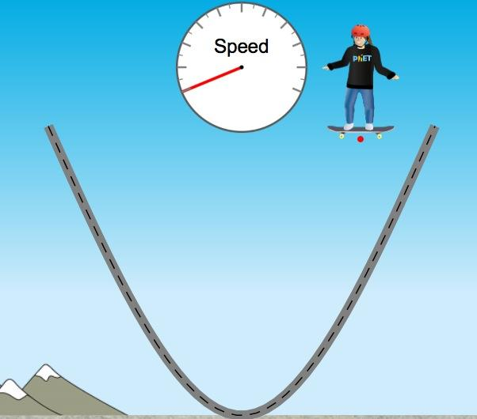

- In the table below, describe what happens to the speed of the skater when he is on different parts of the track (make sure that you have speed checked):

Position of Skater | Amount of Potential Energy | Amount of Kinetic Energy | Speed of Skater
High on the track | IncreasesDecreases | IncreasesDecreases
In the middle of the track | IncreasesDecreases | IncreasesDecreases
At the bottom of the track | IncreasesDecreases | IncreasesDecreases

- What claim can you make about the relationship between the relationship between potential energy, kinetic energy, and speed?

______________________________________________________________________________
______________________________________________________________________________
______________________________________________________________________________

- What is your evidence?

______________________________________________________________________________
______________________________________________________________________________
_____________________________________________________________________________

TOTAL ENERGY

- In the space below, find ways you can change the total energy in the simulation.

______________________________________________________________________________

PART C-Friction

- Click on the “Friction” tab. Explore the simulation. List the variables that you can change in the space below:

___________________________________________________________________________

- In the table below, describe the motion of the skater when you change the amount of friction (make sure that you have either the pie chart or bar graph checked):
:
Action | Motion of Skater | Observations
Lots of friction | IncreasesDecreases
No friction | IncreasesDecreases

- Make a claim about how friction affects the motion of the skater in the space below:

______________________________________________________________________________
______________________________________________________________________________
______________________________________________________________________________

- What is your evidence?
______________________________________________________________________________
______________________________________________________________________________
______________________________________________________________________________

PART D-Designing a Skate Park

- Click on the “Playground” tab. If the skater was not able to complete the track, revise your design. Make sure to include on hill and one loop. Draw your revised design in the space below:

- On your design, label the points on the track where the potential energy of the skater is the greatest (PE).

- Label the points on the track where the kinetic energy of the skater is the greatest (KE).

- Label the points on the track where potential and kinetic energy are equal (PE=KE).

- Label the points on the track where speed is the greatest (S).

- In the space below, explain how potential energy, kinetic energy, and friction affected your track design:

______________________________________________________________________________
______________________________________________________________________________
______________________________________________________________________________
______________________________________________________________________________
______________________________________________________________________________
______________________________________________________________________________
______________________________________________________________________________
______________________________________________________________________________
______________________________________________________________________________

