Name _______________________________________________________________ Date _______________________

Using Objects to Complete a Circuit

Objective: We will use our knowledge of electric circuits to identify common objects that complete a circuit.

1. Explore: Take 5 minutes to explore the sim. Make several different circuits that light 4 light bulbs. Draw one working circuit below.

2. Turn and Talk: Share your working circuit with your partner.
- What type of circuit did you make?
- Is there more than one way to design a circuit that will light several bulbs?

3. Predict: What will happen if you split the junction between 2 wires in a working circuit?

Inquiry Question: Can common objects be used to complete a circuit?

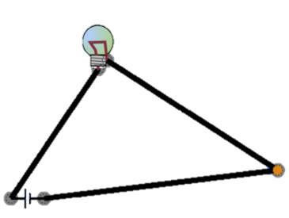
4. Let’s test it! Using 3 wires, a battery, and a bulb, create the following series circuit:

5. Open your circuit by disconnecting two of the components. Click on “Grab Bag.”
Try to close the circuit using each item and complete the table below.
Grab Bag Item | Did the bulb light?
Dollar | Yes | No
Paper Clip | Yes | No
Penny | Yes | No
Eraser | Yes | No
Dog | Yes | No
Hand | Yes | No
Pencil Lead | Yes | No

6. What do the materials that were able to light the bulb have in common?

7. What other objects would complete the circuit?

These objects are called conductors because they conduct electricity by allowing it to flow through them. Objects that do not allow electricity to flow through them are called insulators.

*8. Look around our classroom. What objects do you see that you are conductors?

9. Using our classroom circuit materials, design a circuit that would allow you to test these classroom objects. (Think about how you tested the grab bag objects!)

My Design:

10. Build the circuit and test the classroom objects that you predicted!

Conductors: Insulators:

