PhET Interactive Chemistry Simulations
Aligned to an Example General Chemistry Curriculum

Alignment is based on the topics and subtopics addressed by each sim. Sims that directly address the topic area are in the middle column; sims that relate to the topic area are in the “supplemental” column.

Topic Areas and  Sub-topics | PhET Simulations | Supplemental PhET Simulations
Measurement, Significant Figures, and Uncertainty | Density  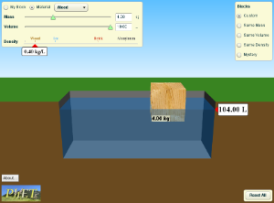  - Measurement and unit conversions | Curve Fitting  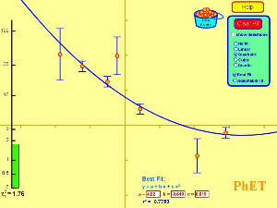  - Measurement and uncertainty
Properties of Matter  - Phases of matter, mixtures and pure substances, chemical and physical change, temperature as a measure of average kinetic energy | States of Matter  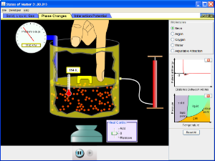  - Phases of matter, physical change | Density (above)  - Properties of matter: density, mass, volume  Gas Properties  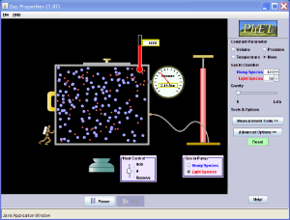  - Temperature as a measure of average kinetic energy
Components of Matter: Atoms and Isotopes  - Atomic number, mass number, atomic symbol, atomic mass, isotopes, isotopic abundance  - Atomic masses; determination by chemical and physical means | Build an Atom  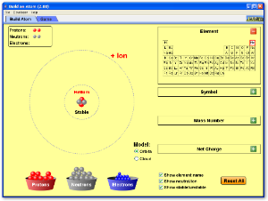  - Atomic number, mass number, atomic symbol, protons, neutrons, and electrons  Isotopes and Atomic Mass  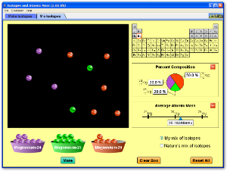  - Atomic number, mass number, atomic symbol, atomic mass, isotopes, isotopic abundance
Development of the Atomic View of Matter / Evidence for the Atomic Theory  - Dalton’s atomic theory, discovery of the electron (Millikan and Thompson), discovery of the atomic nucleus (Rutherford) | Rutherford Scattering  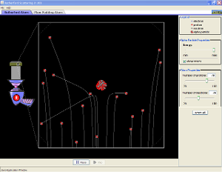  - Discovery of the atomic nucleus (Rutherford)
Atomic Structure of Matter and Quantum Theory  - Electromagnetic spectrum, interference, blackbody radiation, photoelectric effect, Rydberg Equation, Bohr model, atomic line spectra, wave-particle duality, de Broglie wavelength, Heisenberg’s uncertainty principle, Schrodinger equation, atomic orbitals, quantum numbers and energy levels | Blackbody Spectrum  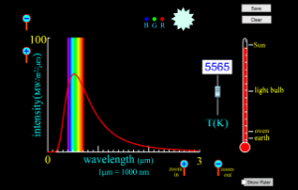  - Electromagnetic spectrum, blackbody radiation  Photoelectric Effect  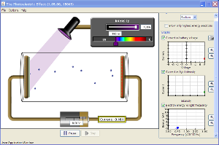  - Electromagnetic spectrum, photoelectric effect  Models of the Hydrogen Atom  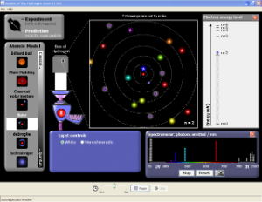  - Electromagnetic spectrum, Rydberg Equation, Bohr model, atomic line spectra, wave-particle duality, Schrodinger equation, atomic orbitals, quantum numbers and energy levels | Neon Lights and Other Discharge Lamps  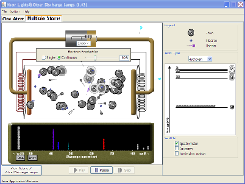  - Atomic line spectra, atomic orbitals, quantum numbers and energy levels  Wave Interference  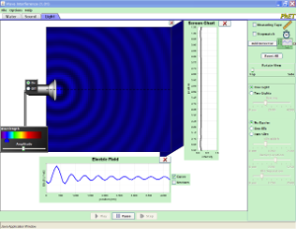  - Electromagnetic spectrum, interference  Quantum Wave Interference  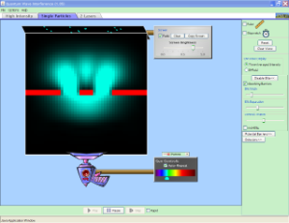  - Electromagnetic spectrum, interference, wave-particle duality, de Broglie wavelength
Electron Configuration and Periodic Trends  - Pauli exclusion, Aufbau principle, and Hund’s rule; electron configuration; orbital diagram; shielding; periodic trends (atomic size, ionization energy, electron affinity); periodic trends (electronegativity, metallic behavior, ion size) |  | Build an Atom (above)  - Periodic trends (atomic number, number of electrons)  Neon Lights and Other Discharge Lamps (above)  - Ionization energy  Balloons and Static Electricity  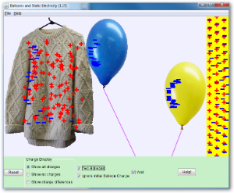  - Electrostatic attractions, effective nuclear charge, electron affinity
Components of Matter: Elements and Compounds  - Periodic table, metals, nonmetals, metalloids, molecules from atoms, general bonding, ionic and covalent bonding, formulas, molecular mass, molecular models, mixtures and pure substances | Build a Molecule  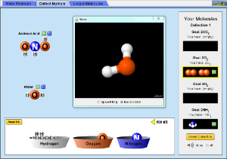  - Periodic table, molecules from atoms, covalent bonding, formulas, molecular models | Sugar and Salt Solutions  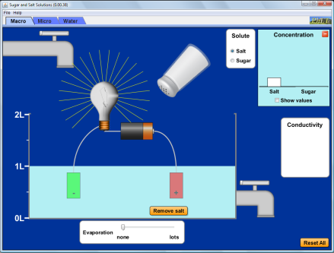  - Ionic and covalent bonding, formulas, mixtures and pure substances
Nomenclature  - Binary ionic compounds, binary covalent compounds, polyatomic ions, oxoanions, hydrates, acids and bases, organic molecules |  | Sugar and Salt Solutions (above)  - Binary ionic compounds, polyatomic ions  Salts and Solubility  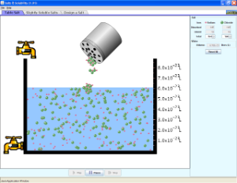  - Binary ionic compounds, polyatomic ions
Chemical Bonding  - Lewis dot structures, octet rule; ionic bonding model, covalent bonding model; covalent bond order, bond length, lone pairs; electronegativity and bond polarity, partial ionic character, metallic bonding (electron sea model)  - Binding forces (types; relationships to states, structure, properties; polarity and electronegativity) | Atomic Interactions  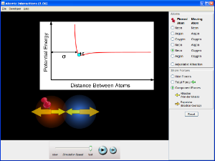  - Covalent bonding model, binding forces | Molecule Polarity (Tab 1)  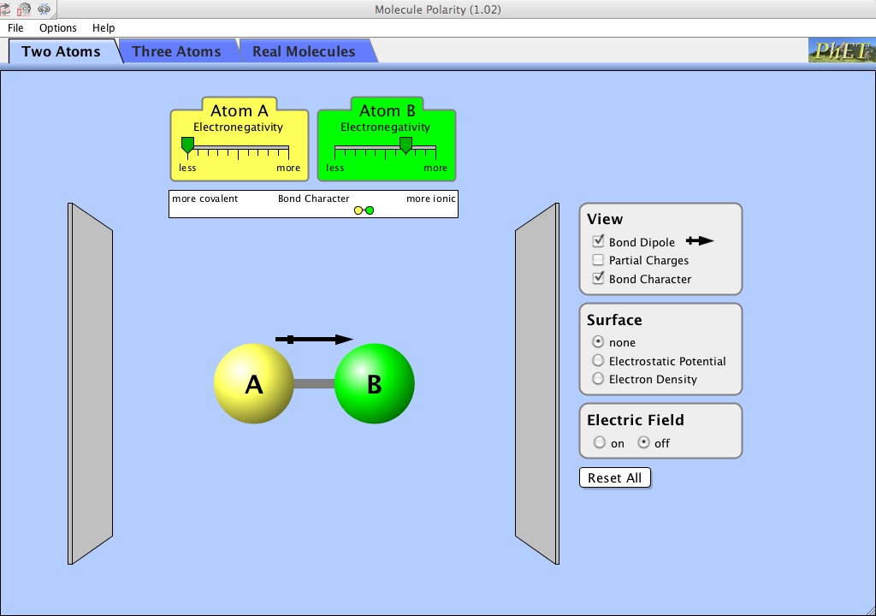  - Electronegativity and bond polarity, partial ionic character, partial covalent character  - Binding forces (polarity and electronegativity)
Molecular Geometry and Polarity, Molecular Structure, Molecular Models  - Lewis dot structures and geometry, resonance, formal charge, VSEPR, shape and molecule polarity  - Geometry of molecules and ions, orbital hybridization, dipole moments of molecules; relation of properties to structure | Molecule Shapes  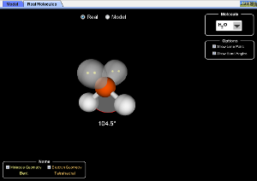  - Geometry of molecules, VSEPR  Molecule Polarity  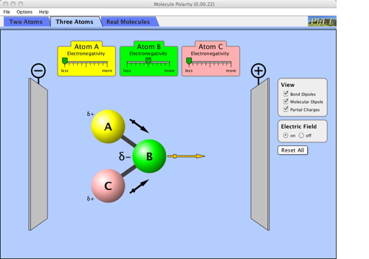  - Shape and molecule polarity  - Dipole moments of molecules; relation of properties to structure | Build a Molecule (above) (Tab 3)  - Geometry of molecules  Vector Addition  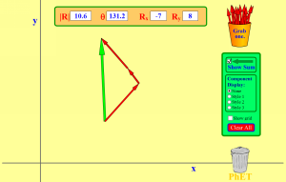  - Bond dipoles and molecular dipoles (polarity supplement)
Organic Compounds  - Nomenclature, structures, hydrocarbons, alkanes, functional groups, structural isomerism of simple organic molecules |  | Build a Molecule (above)  - Geometry of small organic molecules

Chemical Equations and Stoichiometry  - The mole and molar mass, amount-mass-number conversions, mass percent, empirical formula/combustion analysis, balancing chemical equations, limiting reactants, theoretical and actual percent yields, aqueous ionic reactions  - Conservations of mass | Balancing Chemical Equations  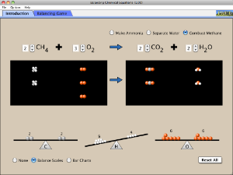  - Balancing chemical equations, mole ratios, conservation of mass  Reactants, Products and Leftovers  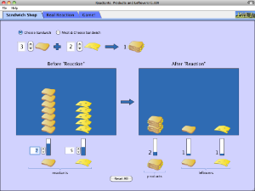  - Balancing chemical equations, limiting reactants, mole ratios, conservations of mass
Chemical Reactions and Solutions  - Dissociation, strong and weak electrolytes, polyprotic acids, titrations, precipitation reactions, acid-base reactions, redox reactions, solution concentration and units of molarity | Concentration  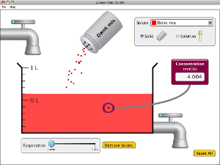  - Solution concentration and units of molarity  Sugar and Salt Solutions  - Dissociation, strong and weak electrolytes, solution concentration | Molarity  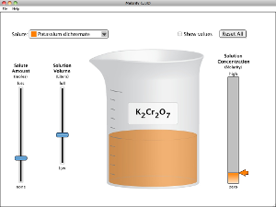  - Solution concentration and units of molarity  Acid-Base Solutions  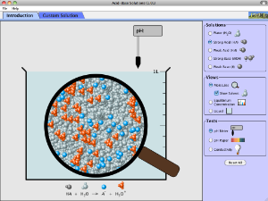  - Acid-base reactions, dissociation, strong and weak electrolytes, solution concentration  Beer’s Law Lab  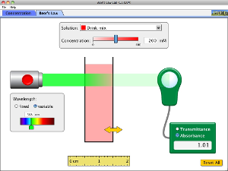  - Solution concentration and units of molarity
Thermochemistry  - Energy, heat and work, 1st law of thermodynamics, state functions and path functions, enthalpy, endothermic and exothermic processes, heat capacity, calorimetry, thermochemical stoichiometry, Hess’ law, standard enthalpies of reaction  - Endothermic and exothermic physical processes, bond dissociation energy | Energy Forms and Changes  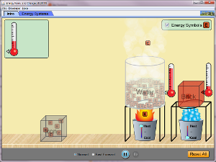  - Energy, heat, and work, endothermic and exothermic processes, heat capacity | Reactions & Rates  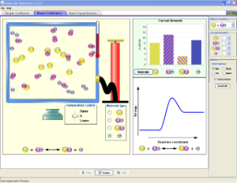  - Endothermic and exothermic chemical processes  Molecules and Light  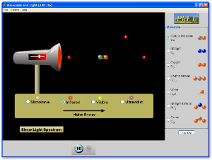  - Bond dissociation energy, endothermic chemical processes, chemical bonds  Energy Skate Park  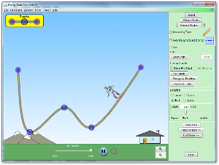  - Energy, 1st law of thermodynamics,
Gases  - States of matter, gas laws, partial pressure, gas stoichiometry, kinetic-molecular theory, RMS speed, effusion and diffusion, mean free path/collision frequency, real gases | Gas Properties  - Gas laws, partial pressure, kinetic-molecular theory RMS speed, mean free path/collision frequency  States of Matter  - Real gases, states of matter | Balloons and Buoyancy  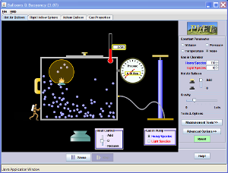  - States of matter, gas laws, partial pressure, gas stoichiometry, kinetic-molecular theory of gases, RMS speed, effusion and diffusion, mean free path/collision frequency, real gases  Membrane Channels  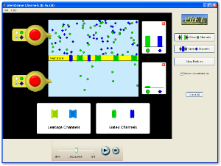  - Effusion and diffusion
Intermolecular Forces  - Dipole-dipole interactions, hydrogen bonding, dispersion forces, consequences for properties of matter (vapor pressure and boiling points) |  | Sugar and Salt Solutions (above)  - Hydrogen bonding, dipole-dipole interactions  States of Matter (above)  - Hydrogen bonding, dispersion forces, consequences for properties of matter  Charges and Fields  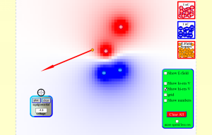  - Dipole-dipole interactions, dispersion forces, electrostatic attractions  Balloons and Static Electricity (above)  - Electrostatic attractions, dispersion forces
Chemical Kinetics, Reactions, and Rates  - Reactions and rates, rate laws, integrated rate laws, temperature and activation energy, reaction mechanisms, catalysis  - Collision theory, reaction rates, factors influencing reaction rate | Reactions & Rates  - Reactions and rates, kinematics, temperature and activation energy, collision theory, factors influencing reaction rates  Reversible Reactions  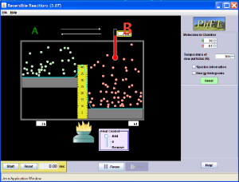  - Reaction rates, temperature and activation energy, factors influencing reaction rates
Equilibrium  - Concept of dynamic equilibrium, reversibility of reactions, equilibrium expressions  - Quantitative treatment:  equilibrium constants of gas phase reactions, equilibrium constants for reactions in solution  - Le Chatelier's principle, reaction quotient (Q vs. K), effect of temperature and pressure on equilibrium | Salts and Solubility  - Concept of dynamic equilibrium, reversibility of reactions  - Quantitative treatment, equilibrium constants for reactions in solution  - Le Chatelier's principle  Reactions & Rates (above)  - Concept of dynamic equilibrium: reversibility of reactions  - Le Chatelier's principle, effect of temperature and pressure on equilibrium | pH Scale  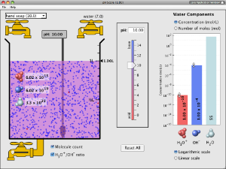  - Concept of dynamic equilibrium, reversibility of reactions  Acid-Base Solutions (above)  - Concept of dynamic equilibrium: reversibility of reactions
Acids, Bases, and Acid-Base Equilibria  - Acids and bases, proton transfer reactions, autoionization and the pH scale, weak acids and bases, equilibrium calculations, molecular properties and acid strength, acid-base properties of salts  - Arrhenius acids and bases, hydrogen ions, hydroxide ions, Bronsted-Lowry acids and bases, hydronium ions, concentration, acid-base reactions, buffering, Le Chatelier’s principle | Acid-Base Solutions  - Acids and bases, proton transfer reactions, autoionization and the pH scale, weak acids and bases, equilibrium calculations, molecular properties and acid strength, acid-base properties of salts  - Arrhenius acids and bases, hydrogen ions, hydroxide ions, Bronsted-Lowry acids and bases, hydronium ions, concentration

Acids, Bases, and Acid-Base Equilibria, continued. | pH Scale  - Acids and bases, proton transfer reactions, autoionization and the pH scale, weak acids and bases, equilibrium calculations, molecular properties and acid  strength  - Arrhenius acids and bases, hydrogen ions, hydroxide ions, Bronsted-Lowry acids and bases, hydronium ions, concentration
Solubility Equilibria  - Liquid state, solutions, ionic bonds, ions, complex ions, solubility, diffusion, osmosis | Salts and Solubility (above)  - Liquid state, solutions, ionic bonds, ions, complex ions, solubility, diffusion  Sugar and Salt Solutions (above)  - Solutions, ionic bonds, ions, complex ions, solubility | Beer’s Law Lab (above)  - Solutions, solubility  Membrane Channels (above)  - Diffusion, osmosis
Buffers and Titrations
- Qualitative and quantitative aspects of buffers, capacity and range, titrations, acid-base indicators
Entropy and the Second Law of Thermodynamics  - Concept of a "spontaneous" process, entropy, the 2nd law of thermodynamics, entropy and probability, Gibbs Energy ("Gibbs Free Energy"), connection to equilibrium. |  | Reversible Reactions (above)  - Concept of a "spontaneous" process, entropy, the 2nd law of thermodynamics, entropy and probability, Gibbs Energy ("Gibbs Free Energy"), connection to equilibrium.
Oxidation-Reduction Reactions and Electrochemistry
- Oxidation/reduction reactions, electrochemical cells, standard cell potentials, Gibbs energy and electrical work, batteries and corrosion, electrolysis
- Voltaic cell, oxidation-reduction reactions, electrochemical reaction, current, voltage, electrodes, half-reactions, fuel cells, efficiency
Transition Metals and Coordination Compounds  - Chemistry of the transition metals, coordination compounds, geometric structures of coordination compounds and optical isomers, crystal field theory, coordination compounds in biology  - Solid state, alloys, metals, crystals, manipulation of physical structure to achieve specific properties, mole concept |  | Molecule Shapes (above)  - Geometric structures of coordination compounds and optical isomers  Beer’s Law Lab (above)  - Chemistry of the transition metals  Conductivity  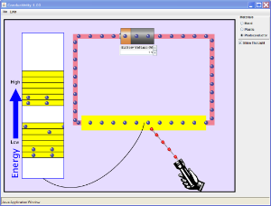  - Solid state, metals, manipulation of physical structure to achieve specific properties  Semiconductors  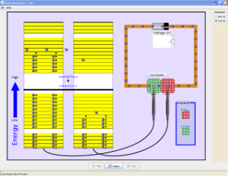  - Solid state, metals, manipulation of physical structure to achieve specific properties

Nuclear Chemistry  - Nuclear equations, half-lives, radioactivity, isotopes, radioactive decay series, band of stability  - The atomic nucleus and radioactivity, kinetics of radioactive decay  - Alpha particles, beta particles, gamma rays, alpha decay, beta decay  - Nuclear fusion, nuclear fission, nuclear strong force  - Chemical applications, biological effects of radiation | Alpha Decay  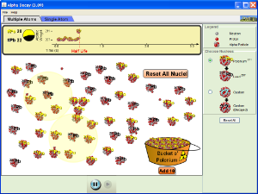  - Nuclear equations, half-lives, radioactivity, isotopes, radioactive decay series  - The atomic nucleus and radioactivity, kinetics of radioactive decay  - Alpha particles, alpha decay, nuclear strong force  Beta Decay  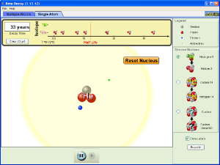  - Nuclear equations, half-lives, radioactivity, isotopes, radioactive decay series  - The atomic nucleus and radioactivity, kinetics of radioactive decay  - Beta particles, beta decay, nuclear strong force  Nuclear Fission 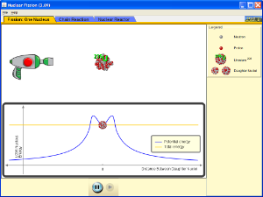  - Radioactivity, isotopes  - The atomic nucleus and radioactivity, kinetics of radioactive decay  - Nuclear fission, nuclear strong force  - Chemical applications, nuclear reactor

Nuclear Chemistry, continued. | Radioactive Dating Game  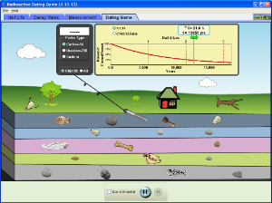  - Nuclear equations, half-lives,  radioactivity, isotopes, radioactive decay series  - The atomic nucleus and radioactivity, kinetics of radioactive decay  - Chemical applications
Light and Matter Interactions and Spectroscopy  Topic may be discussed throughout the curriculum. | Models of the Hydrogen Atom (above)  - Line emission spectrum  - Electromagnetic spectrum  Beer’s Law Lab (above)  - Absorbance, transmittance, molar absorptivity  - Visible spectrum  The Greenhouse Effect  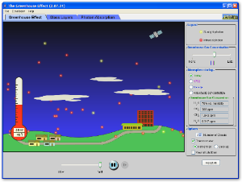  - Environmental chemistry  - Rotational, vibrational, and emission spectroscopy, bond energy, electromagnetic spectrum  Molecules and Light  - Environmental chemistry  - Rotational, vibrational, and emission spectroscopy, bond energy, electromagnetic spectrum | Bending Light  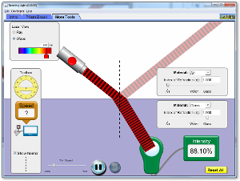  - Diffraction, refraction, reflection  Color Vision  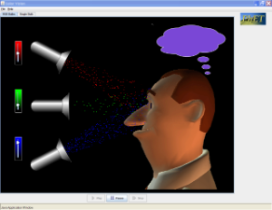  - Electromagnetic spectrum  - Visible spectrum  Microwaves  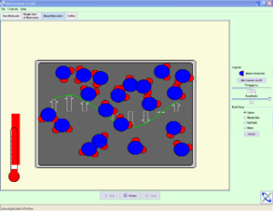  - Polarity, intermolecular forces, rotational spectroscopy, temperature

